[Essence of linear algebra - YouTube](https://www.youtube.com/playlist?list=PLZHQObOWTQDPD3MizzM2xVFitgF8hE_ab)

What is a vector.? – A vector is a line of particular length/magnitude pointing in a direction with arrow in space. (we consider them to be in coordinate system and so we give them numbers are coordinates to represent as matrix) Point are represented as (x,y) while vectors are represented as column in matrix with []

[x

Y]

Vector addition

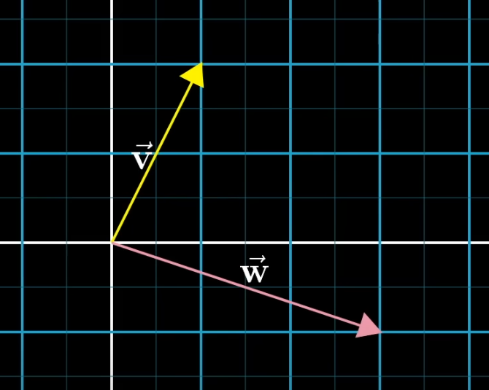 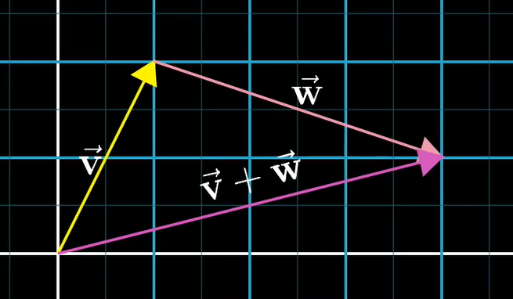

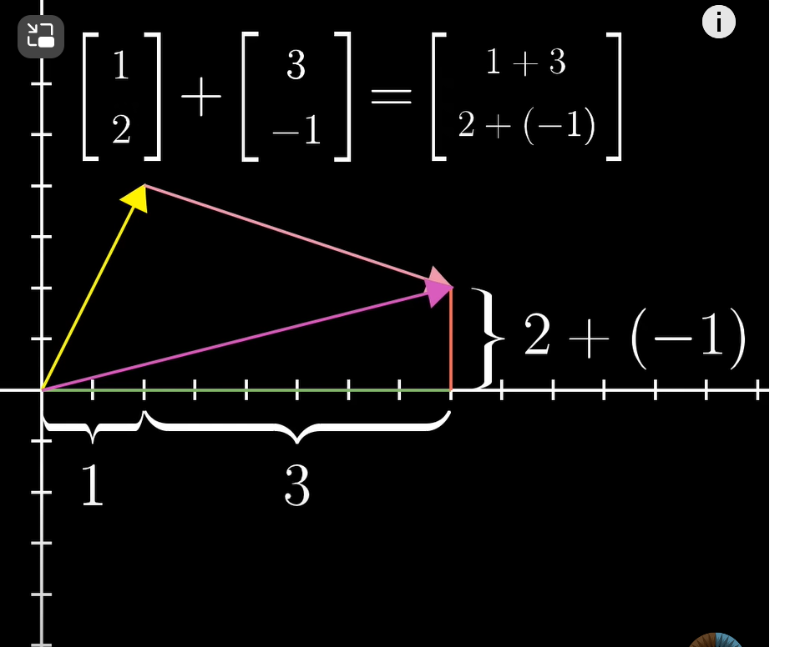

**Every vector is a sum of the scaled basis vectors - this is a crucial point**

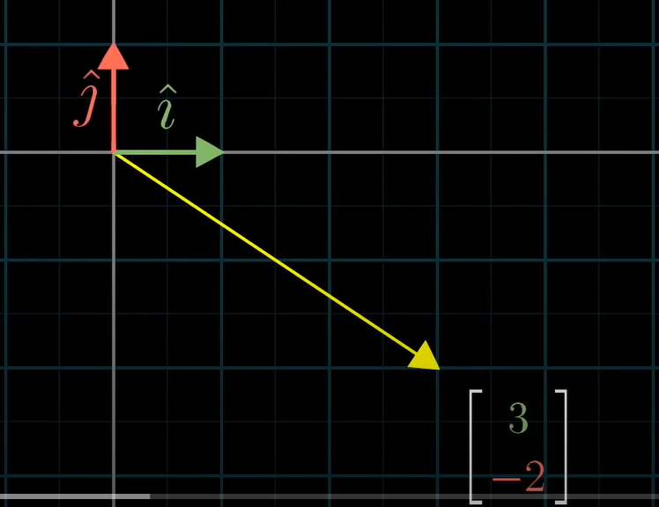

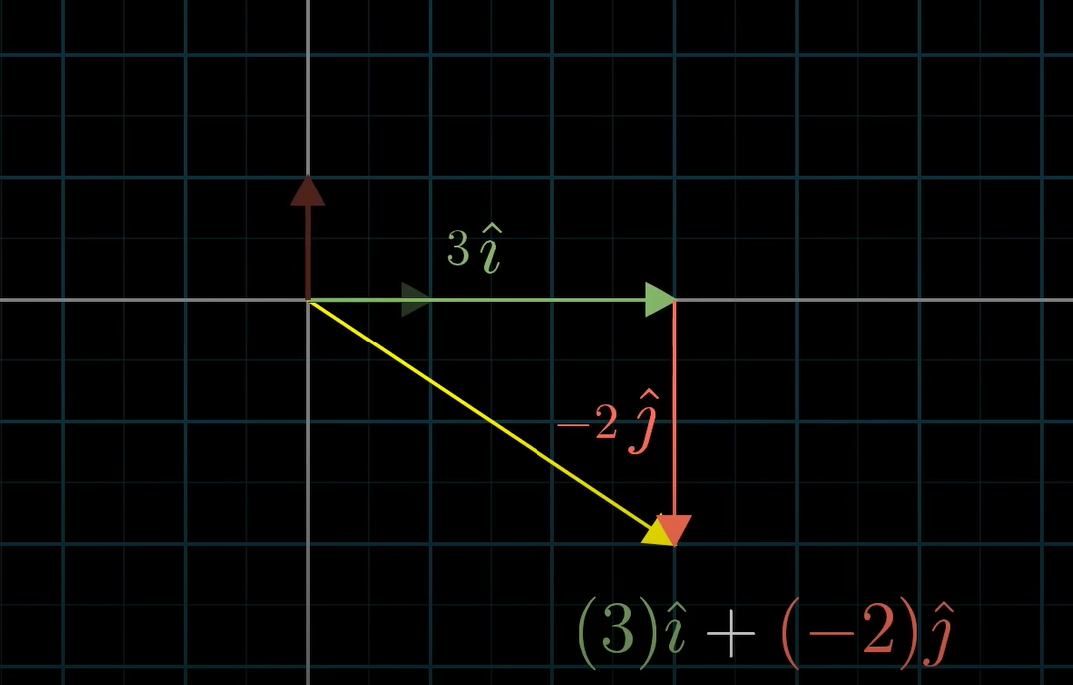

By changing the scalr value of the vector , the resultant vector can span the entire coordinate space.

In cases where the vectors are pointing in the same direction, the span of the vector would just be the straight line as there is no different dimension it can add up tp.-🡪1 dimensional span of the linearly dependent vector

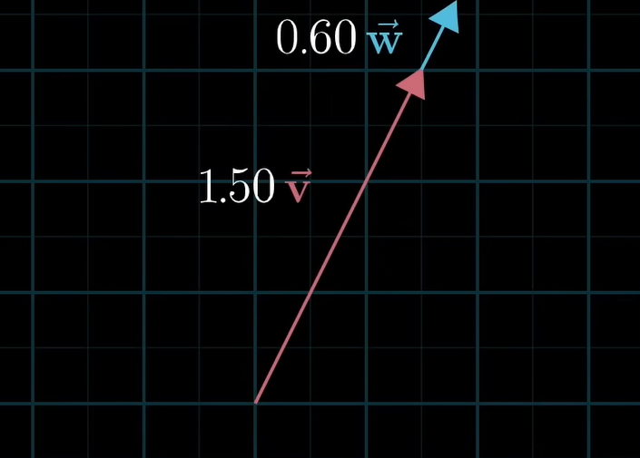

In case where both vectors are points, the span is just stuck at origin.

Thus, the unit vecotrs/baiss vectors are linearly independent (means one cannot be expressed as a linear combination of other, you cant derive one from the other and they both are unique) and the unit vector span the entire space

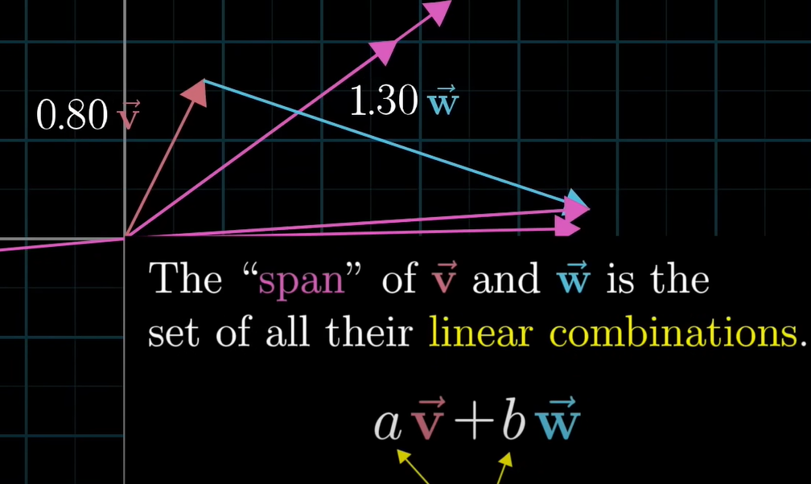

When we deal collection of vectors , it is convenient to consider them as points and that is how the grid lines in the coordinate system originate from the unit vectors span

In case of 3d, then 2 vectors in the 3d space have a span of vectors whose tips lie on the points ina flat sheet/plane like this.

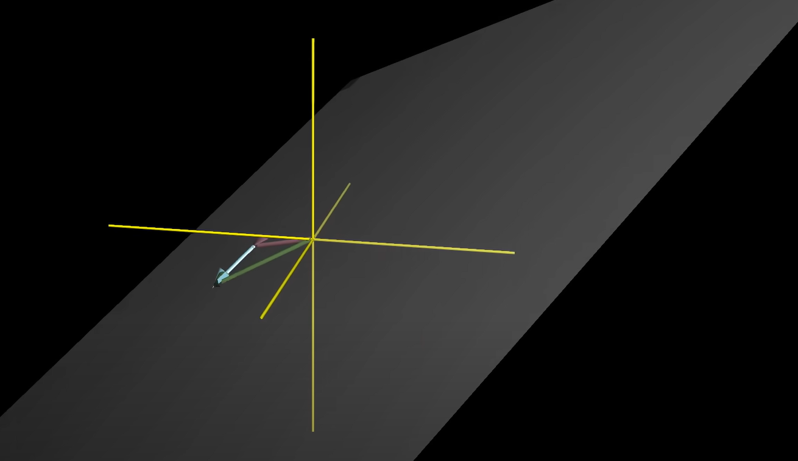

In case of 3 vectos in 3d space, the 2d plane would be moving if the 3rd vector had a diff dimension

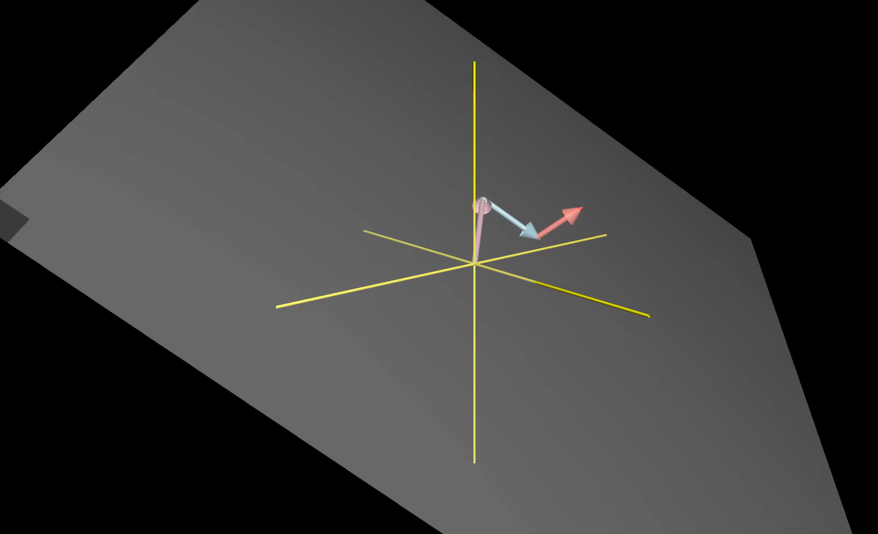

If each vector add another dimension to the span, then they are said to be linearly independent

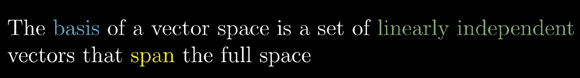

Matrix multiplication: - Linear transformation

Linear transformation means transforming or moving the coordinate system linearly to a different position. However, the origin cannot be changed and the grid lines should be parallel and evenly spaced.

Shear is a type of transformation where one unit vector remains fixed while the other transforms/moves to a different position.

So, to know where a vector in original coordinate system moves to the transformed one, we just have to know how the unit vectors/basis vectors were transformed. When we find that, we just have to scale the unit vectors according to the original vector and add them up to get the linear transformation of the original vector.

Because - **Every vector is a sum of the scaled basis vectors**

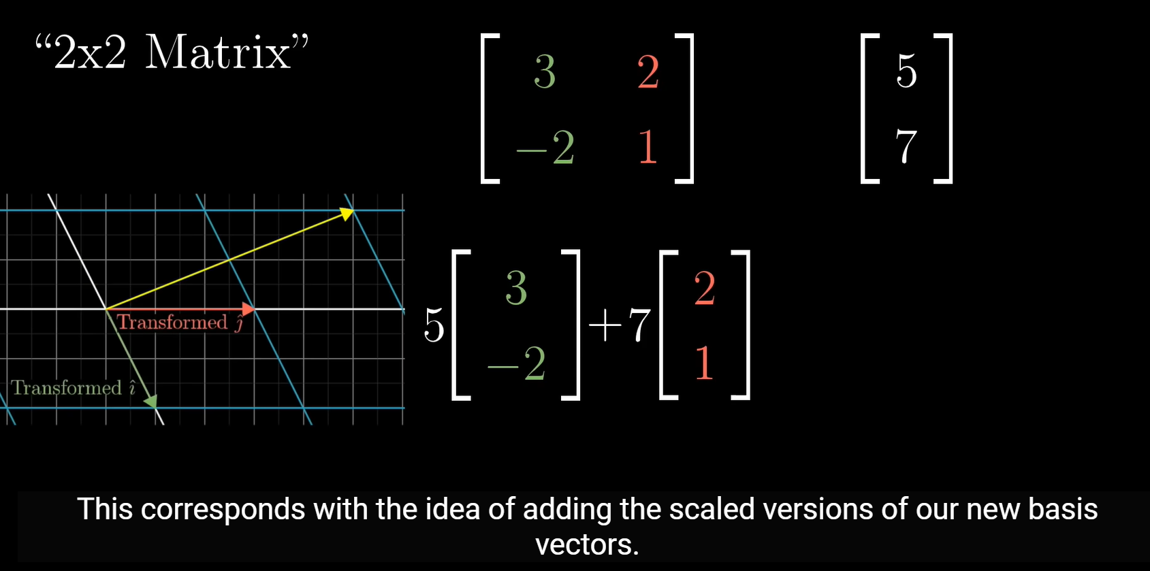

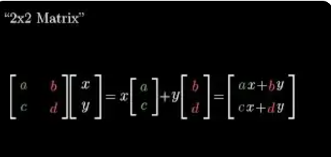

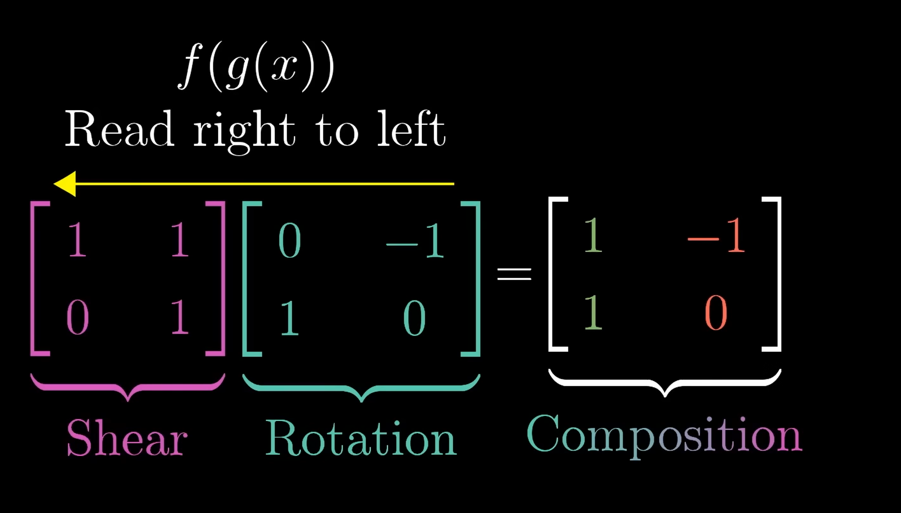

Determinant 🡪it says by what factor (scalar value) the area covered has changed due to transformation

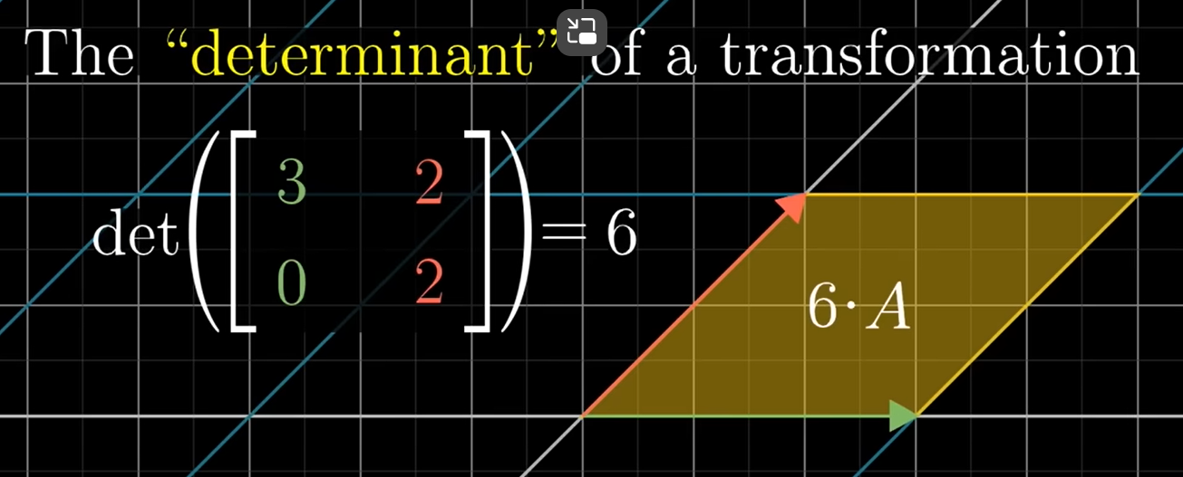

Transforming i vector from 1,0 to 3,0 and j vector from 0,1 to 2,2 rseults in increasing the area of a 1x1 square to the are of a paraellogram of side 6.---so the factor is 6 which is th edeterminnant

The change in area is uniform across the coordinate system, so we just have to know the change in are of one smaller portion (1x1)

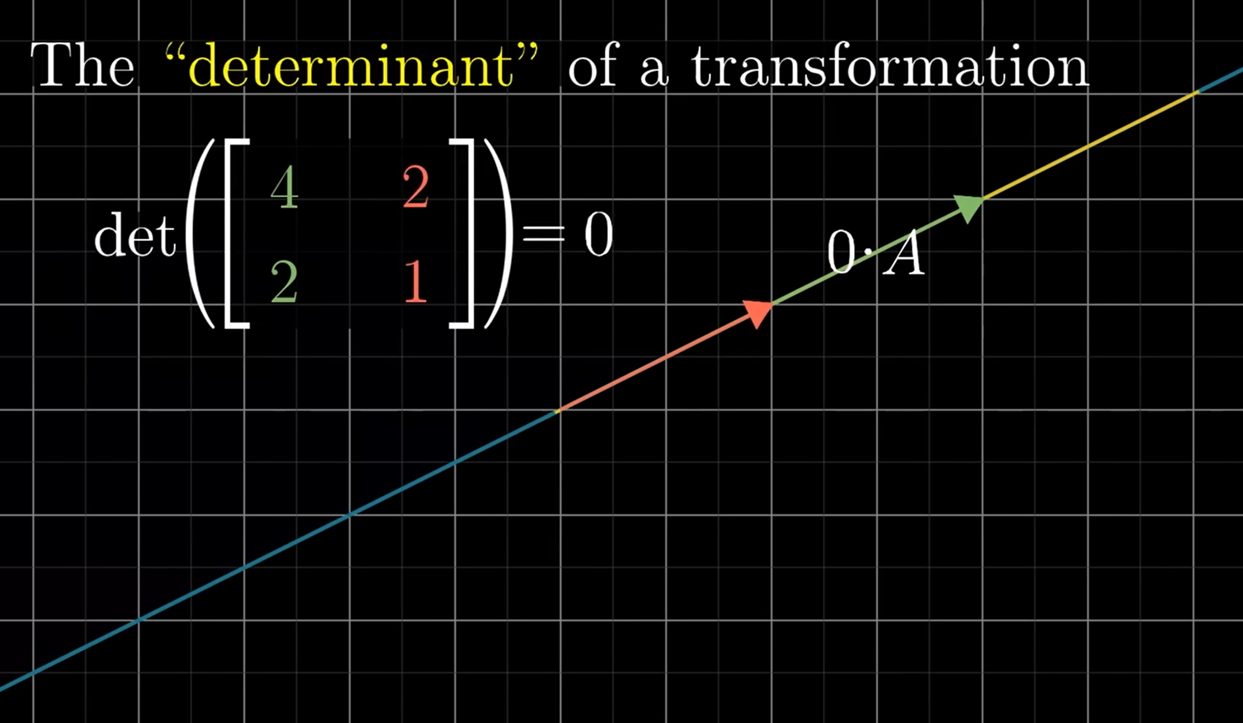

Transforming equations to matrices

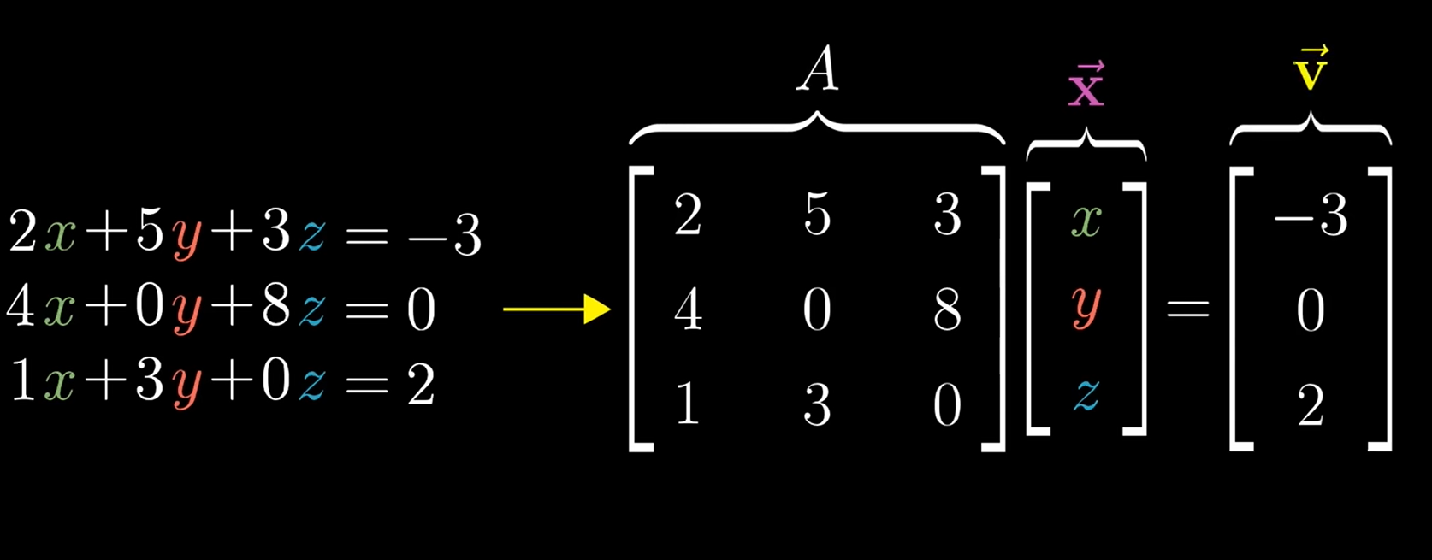’

Given a trsnaformation matrix and the resultant vector, find the original vector

Inverse matrix ->reversal of the transformation 🡪it exists only if the determinant is non -zero.becaues if the area was squished to zero, we cannot reverse it back to the original form

The solution exists only if the vector lies in the plane of the transformed space. Ifthe vector lies in a different direction, nosolution exisits

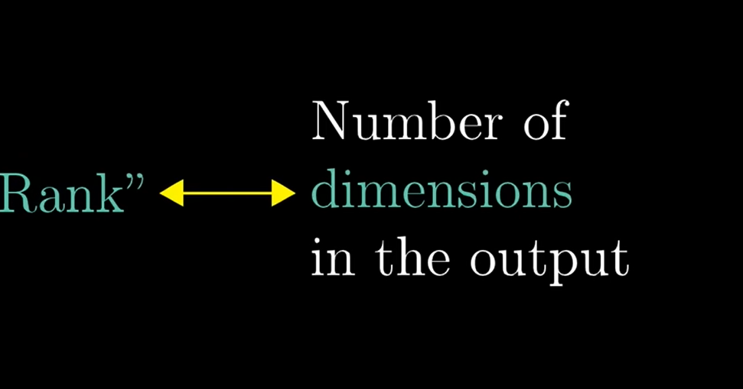

2D, When det is not zero,

the result vectors were not squished/area did no shrink to zero🡪result is in 2D🡪RANK 2 🡪Full rank

When det is zero, the result vectos were squished to a single line , results in 1D 🡪Rank 1

3D, When det is not zero-🡪RANK 3 🡪full rank

Det is zero🡪shrinking the area to 2Dplane or 1D line 🡪RANK 2 and 1

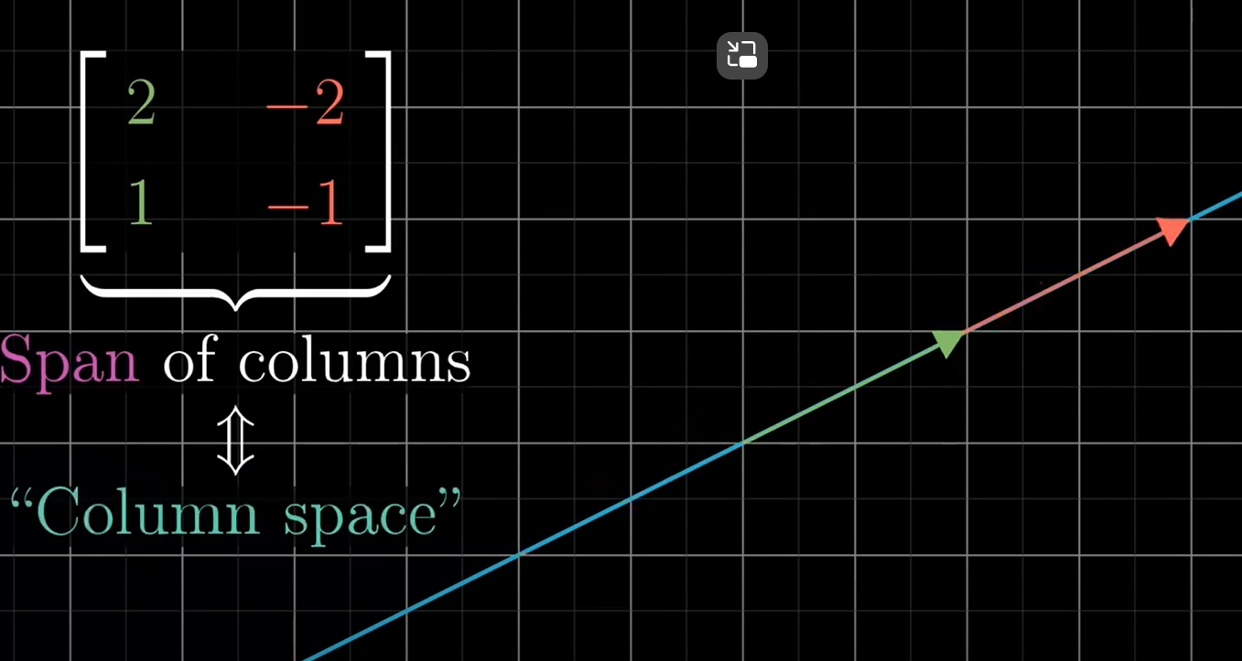

Column space is the set of all possible outputs Av

RANK🡪no.of dimensions in the column space.

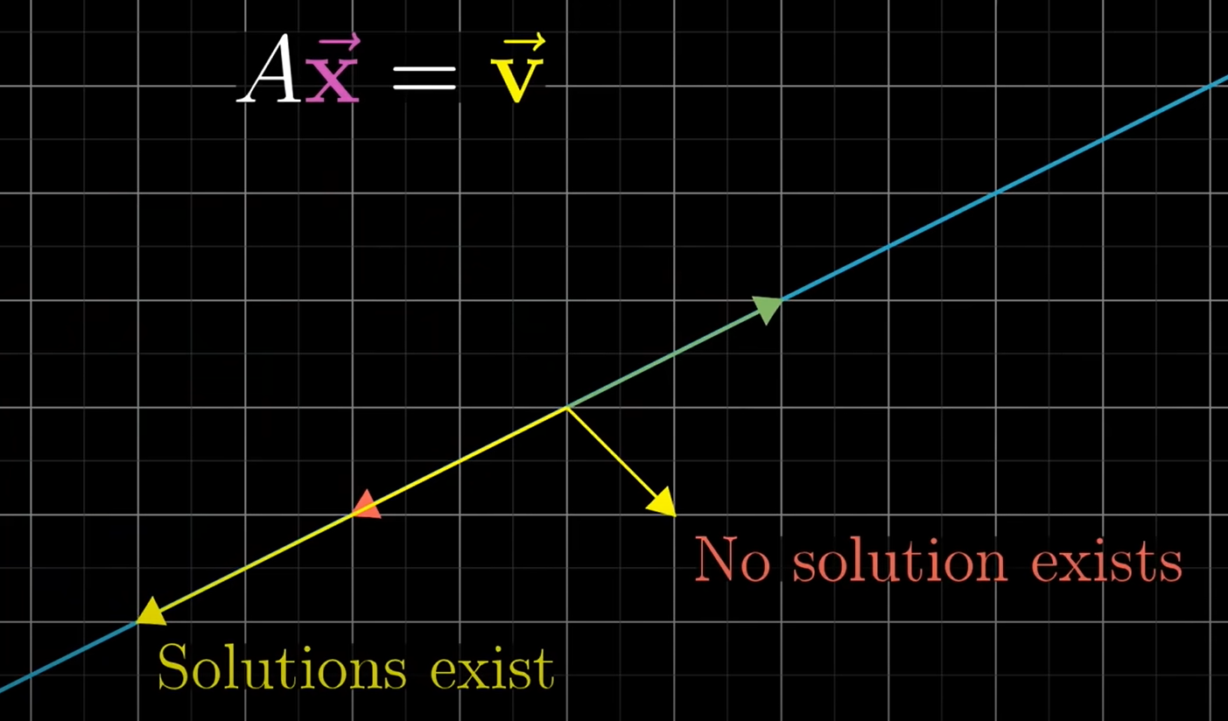

Null space/Kernel – Set of all possible solutions – set of vectors that lands on the origin making the shrinkage in the area.

In Full rank, only the vecto [0,0] lands in origin. In rank 1 for a 2D, a bunch of vectors that were all in a single line collapsed into a single point at the origin.

If AX=0, then null space is the solution

Notes 1

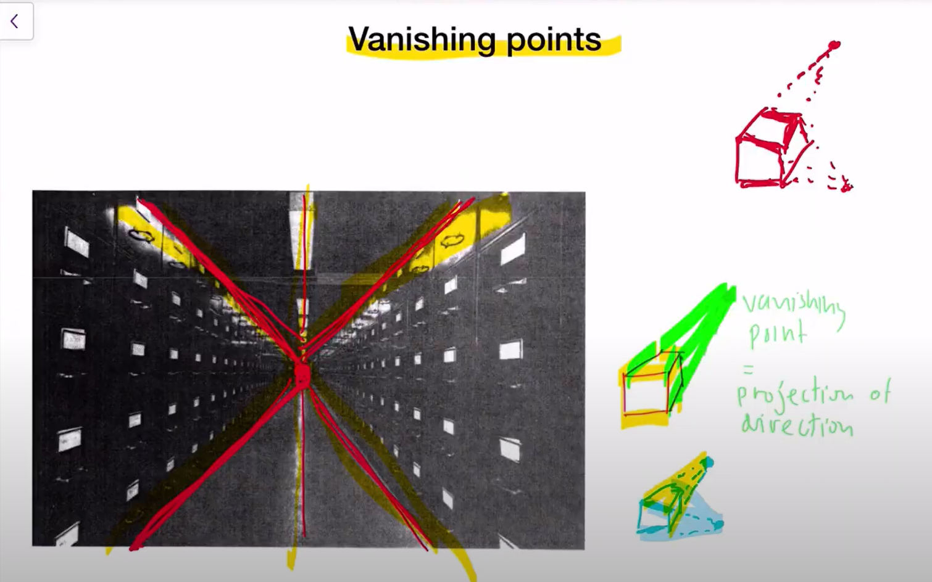

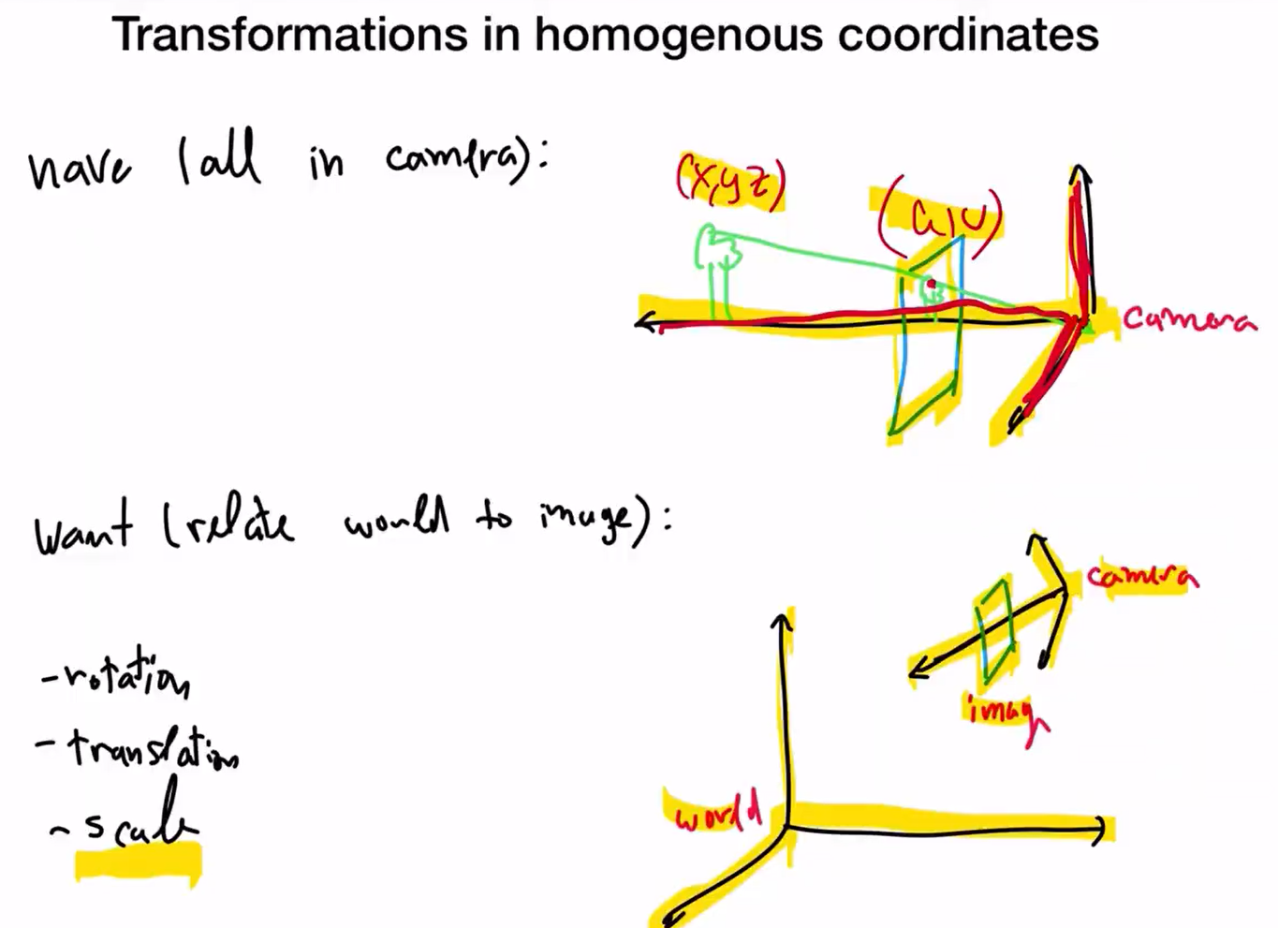

**Notes 2**

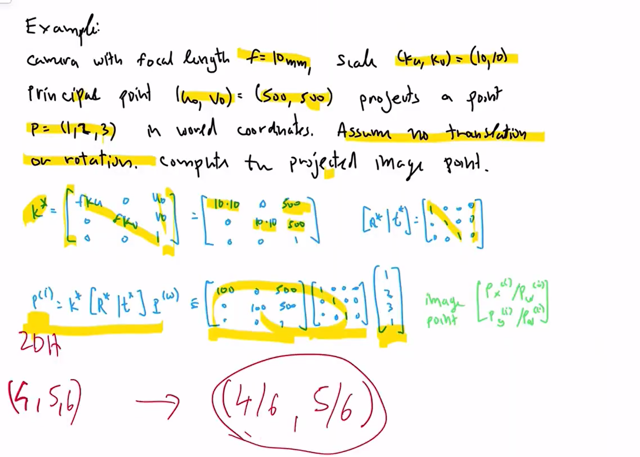

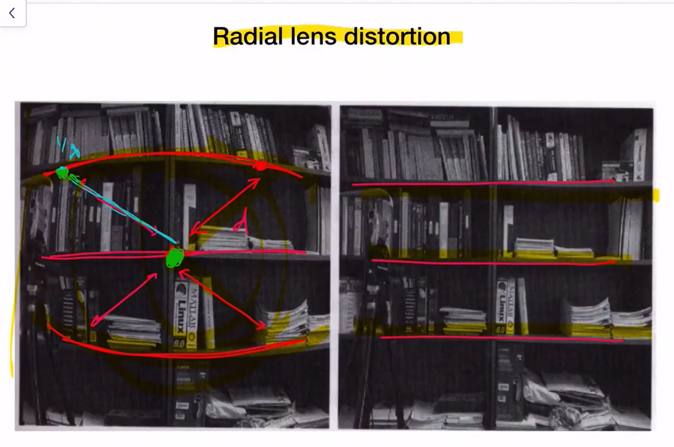

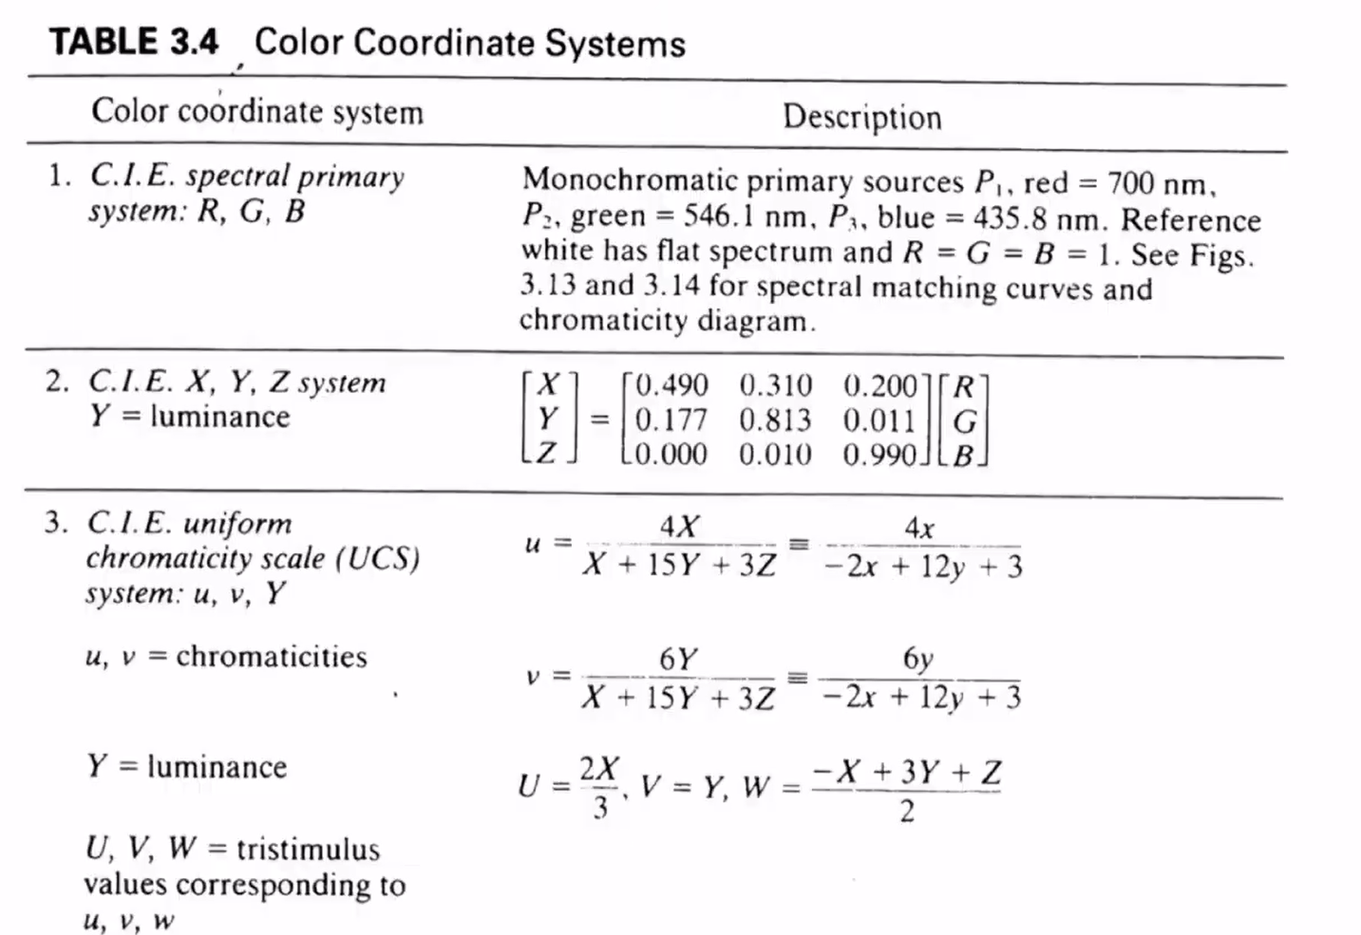



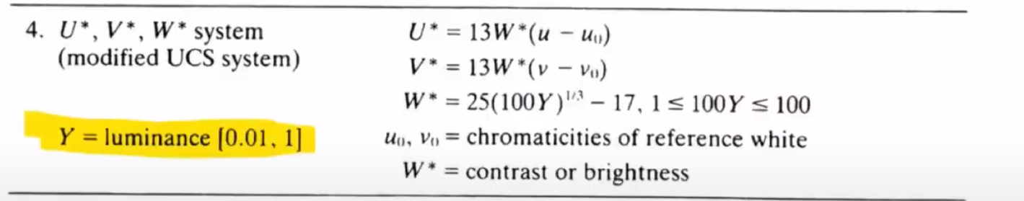

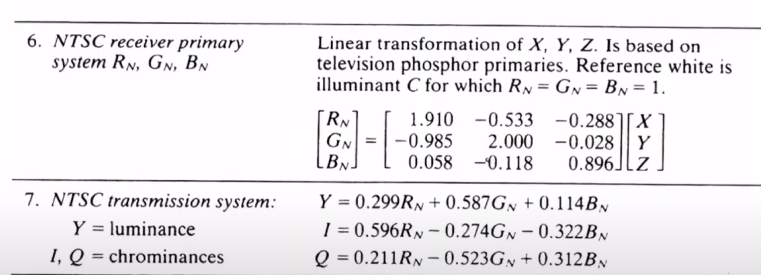



The above one is the analog TV color pattern where if the device/TV is blac&White, Y alone will be used, Otherwise all three wil be used (Y,I,Q)

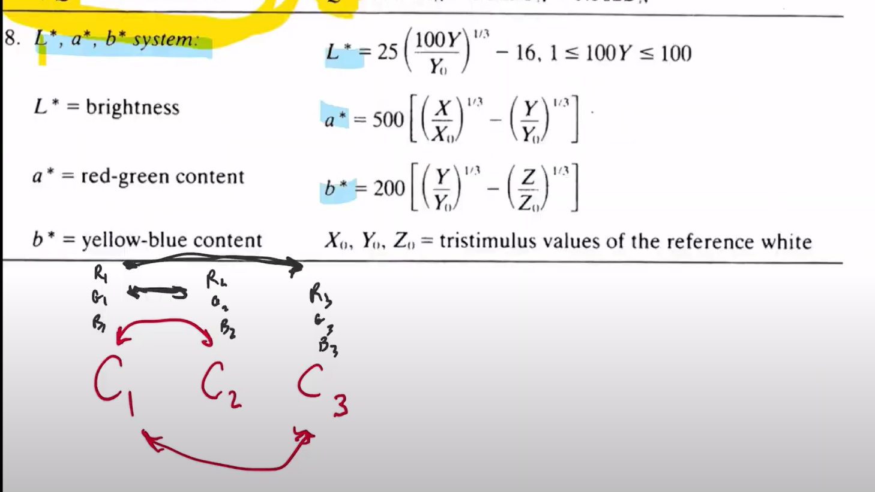

L,a,b system refers to the way how humans perceive colors . The light red and dark red may not necessarily be close to each other in RGB and may not reflect almost same. But, as human we perceive shades of colors to be closer to each other. L,a,b system does the color transmission in the way humans perceive it.

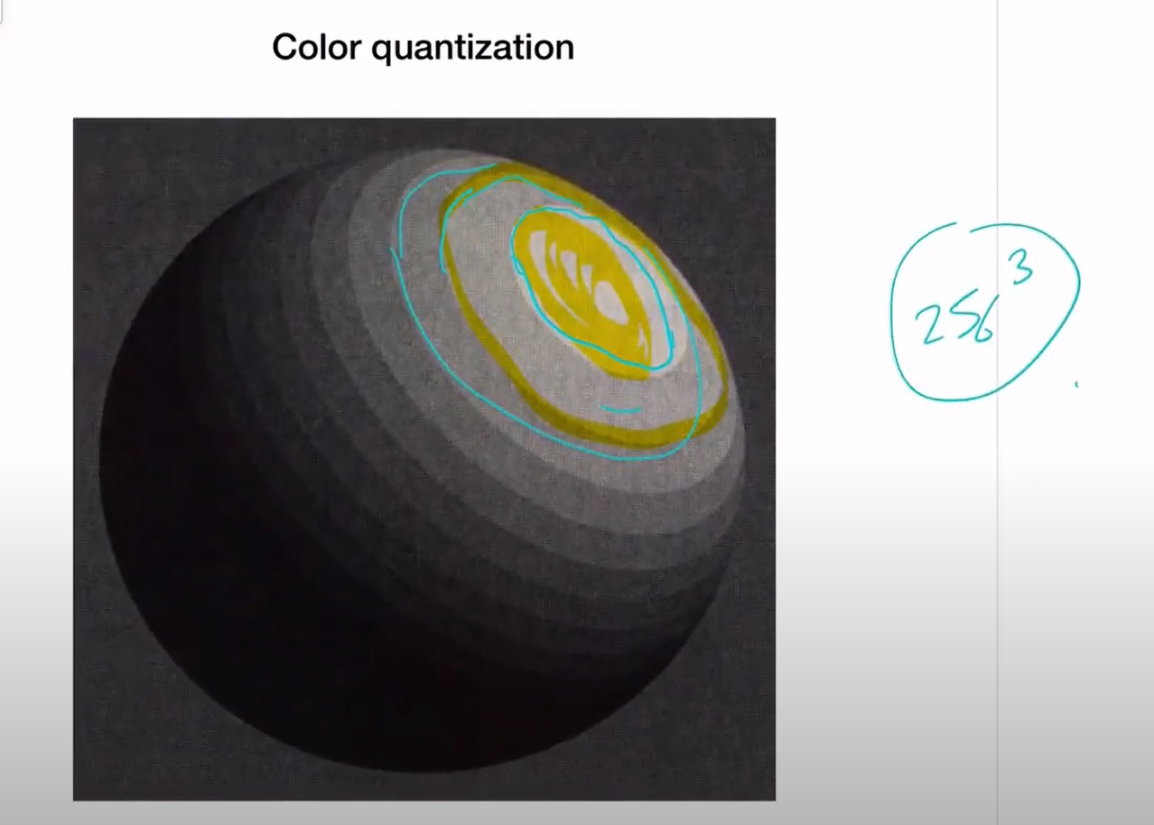

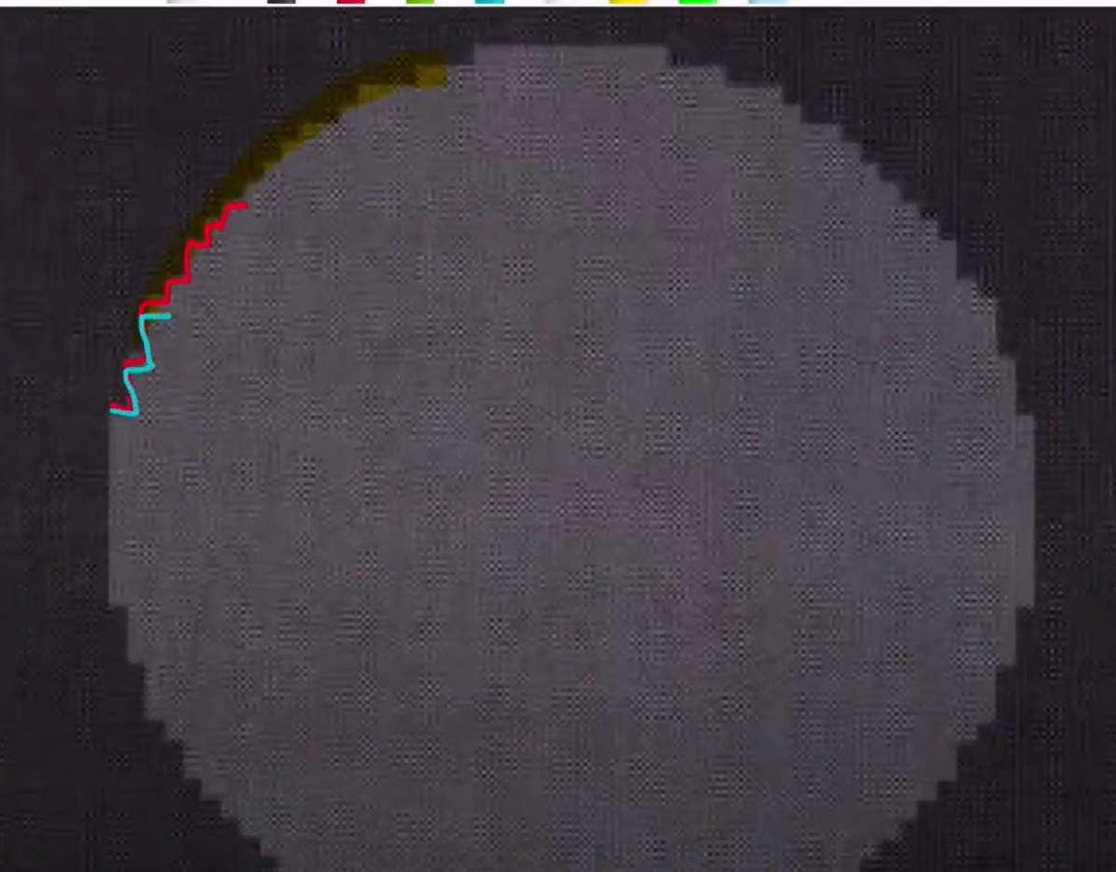

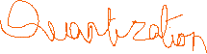

The edges are not smooth because of discrete values-this happens when we zoom a lot

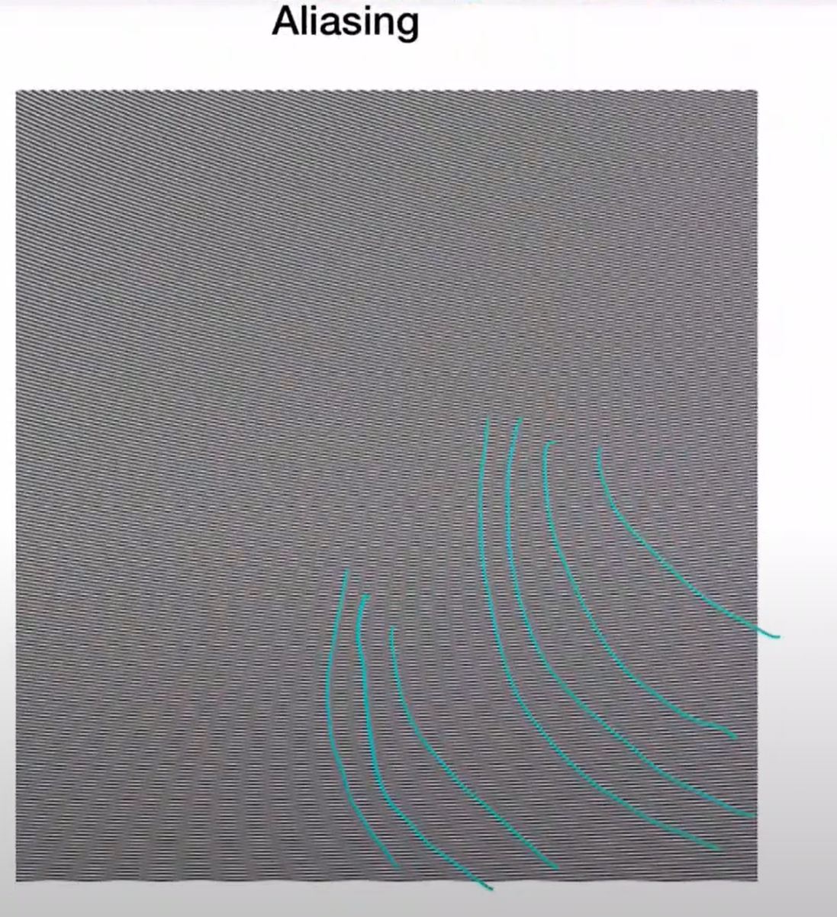

They are all actually vertical lines, but we see curved lines due to sampling

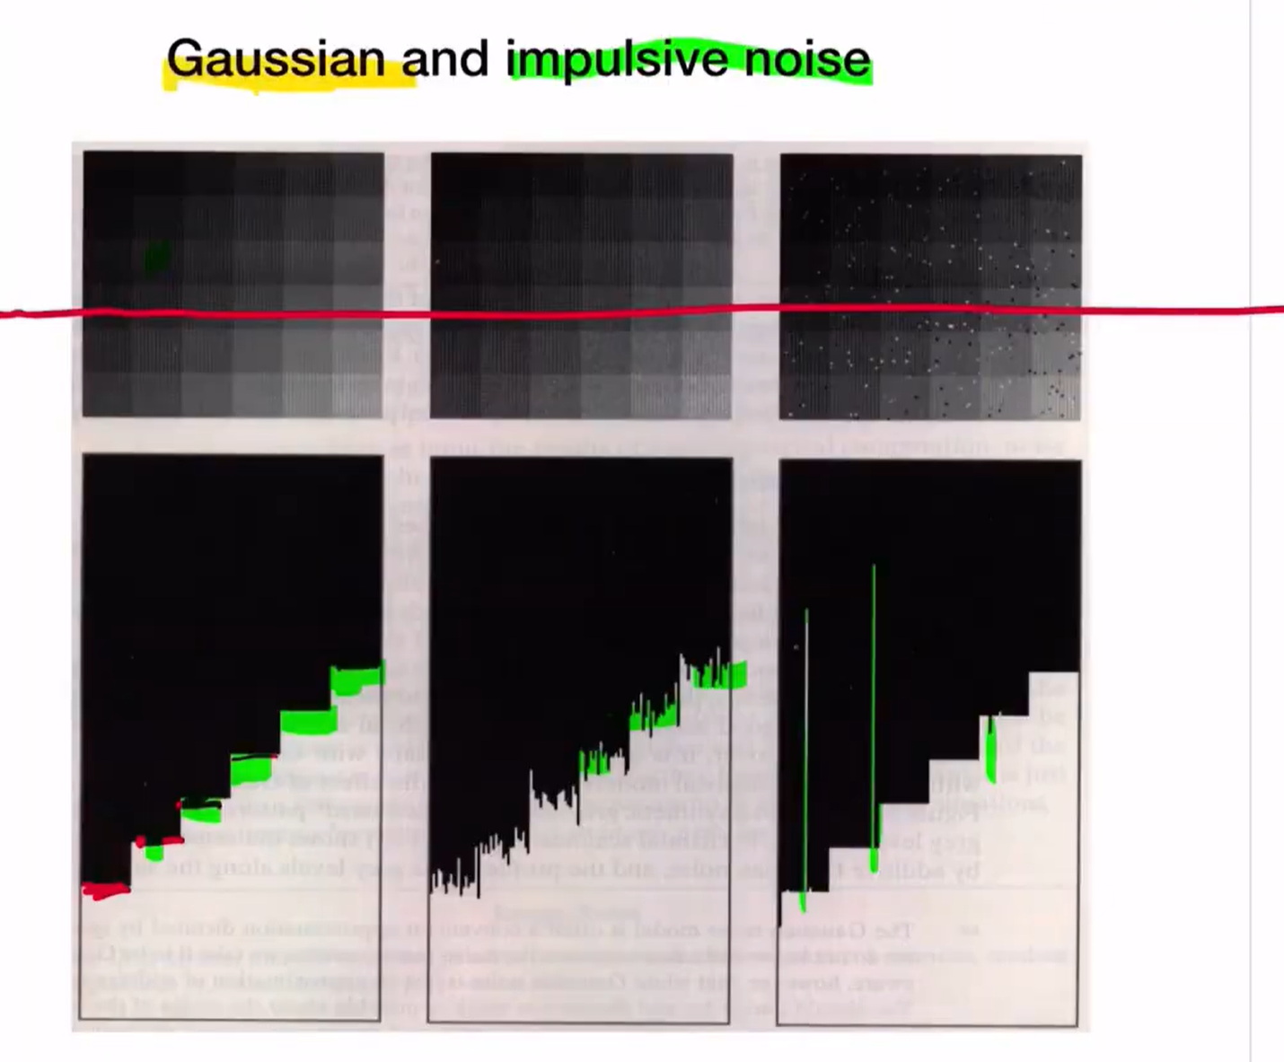

Picture without noise Gaussian noise Impulsive noise

(clean transition) (Not bad, but still could see noise) (too much noise,salt&pepper noise)

Film graininess noise- due to quantization

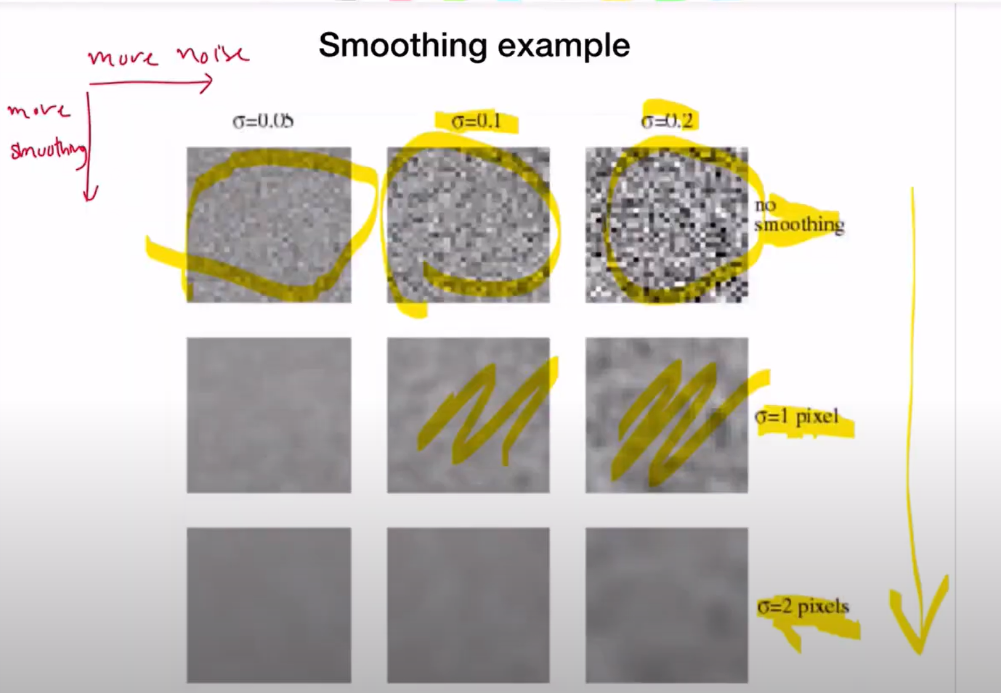

Sigma - SNR ratio

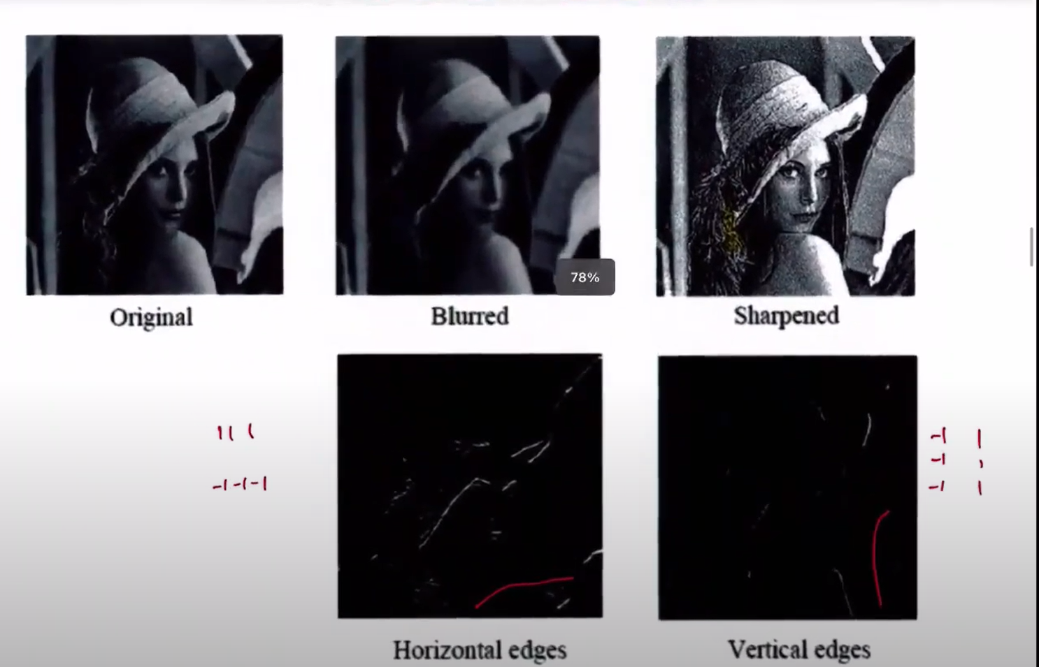

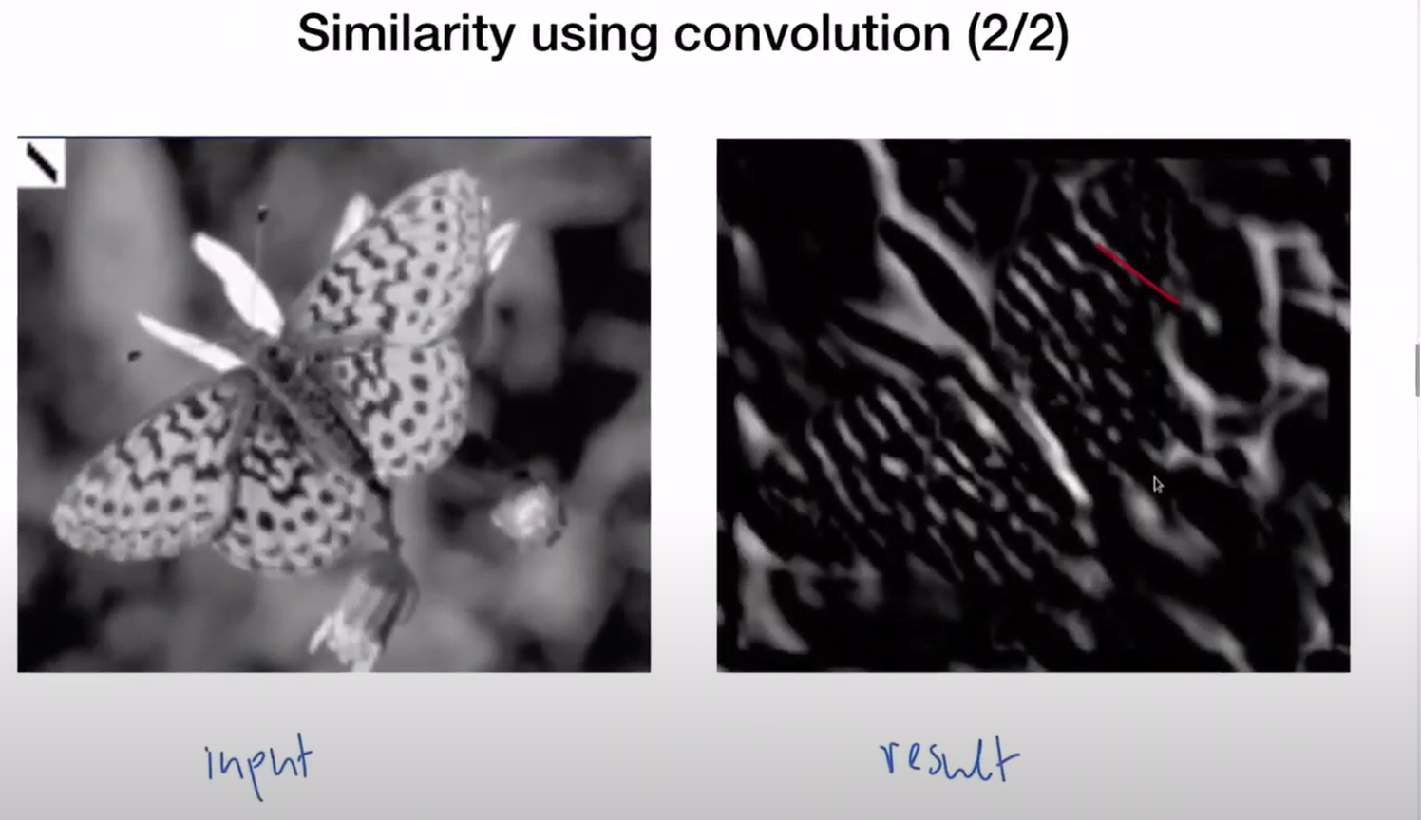

**Notes 6**

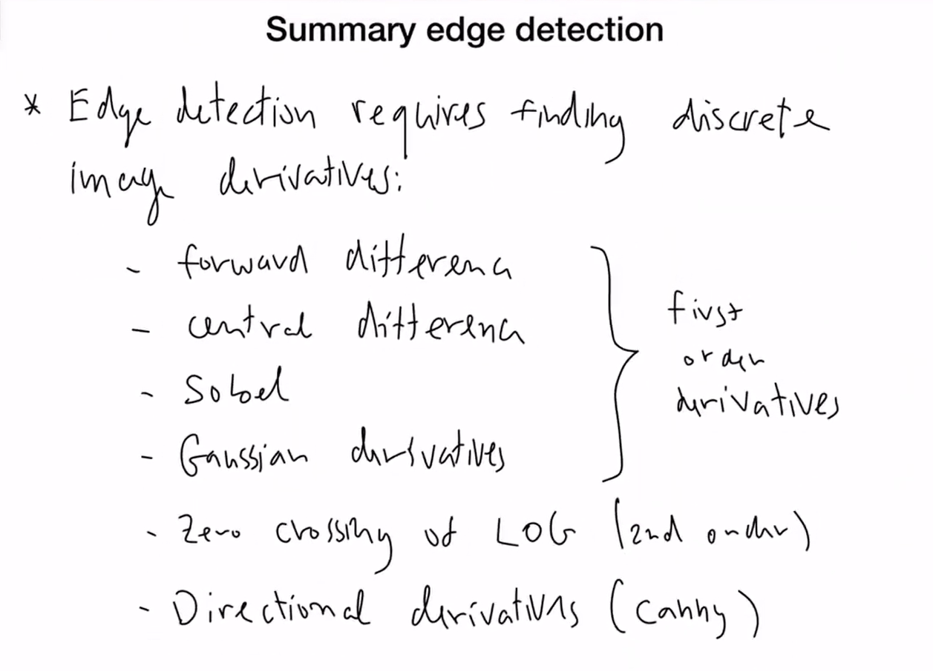

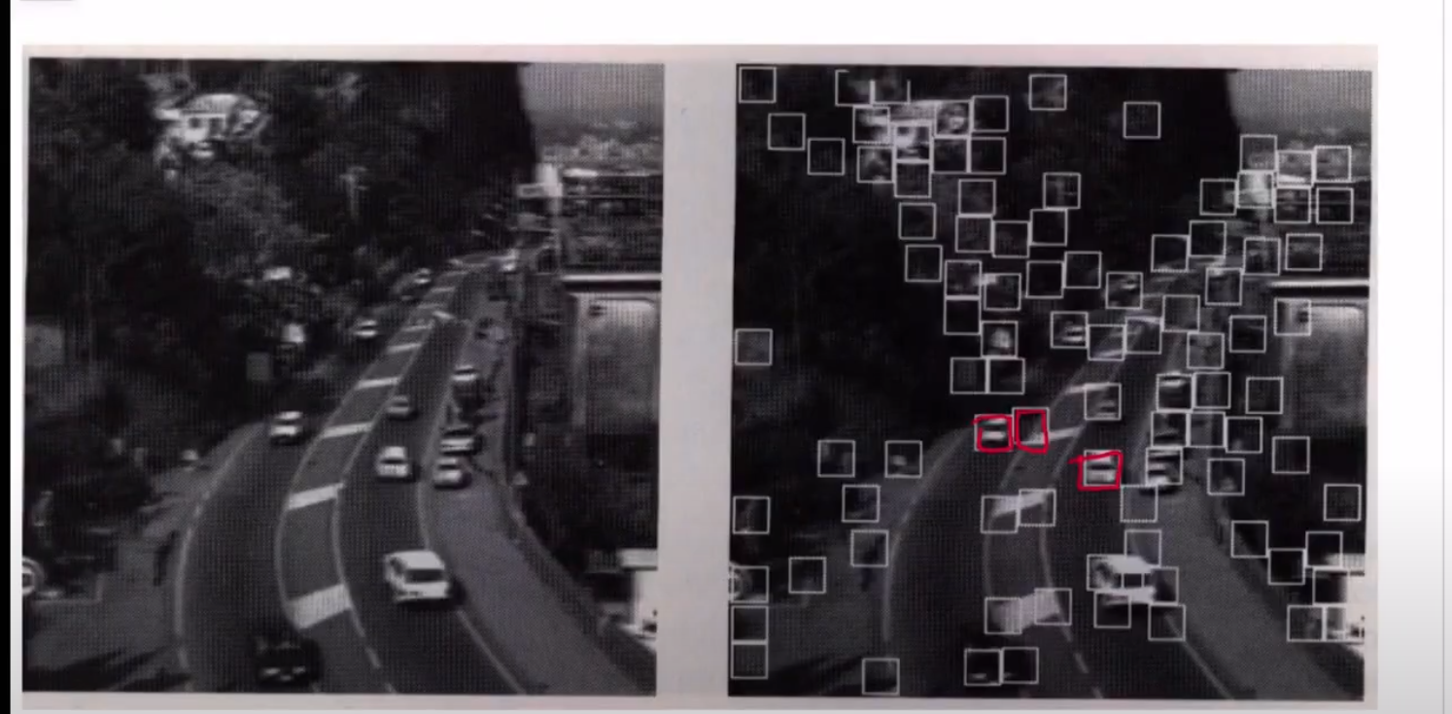

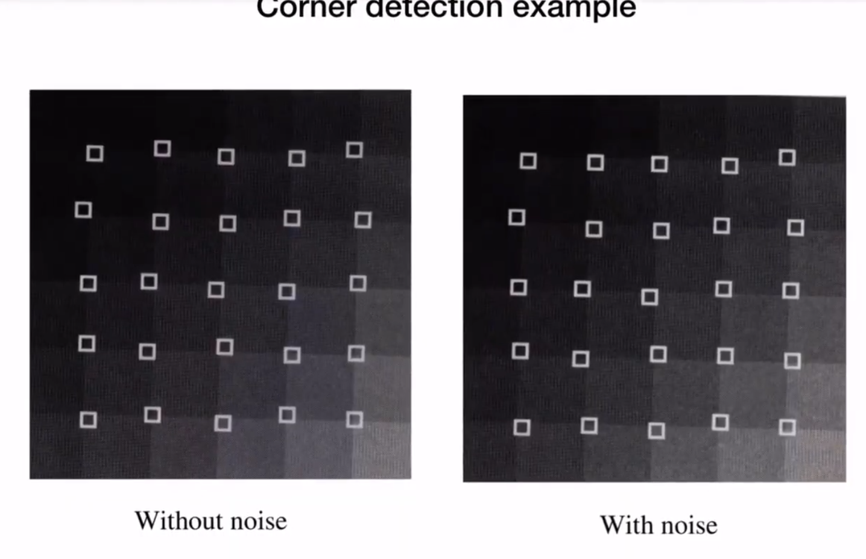

**After properties**

**Illumination invariance – the gradients are same in both**

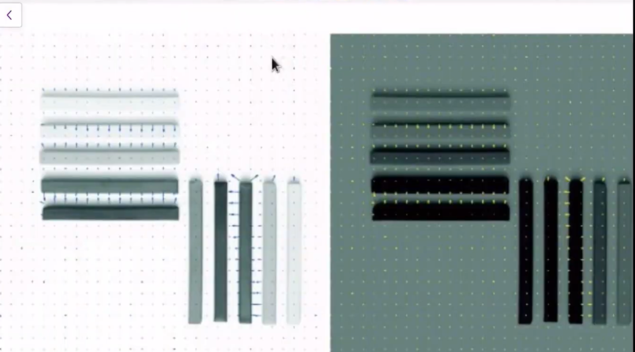

Color diff but the gradient direction din change in above pic

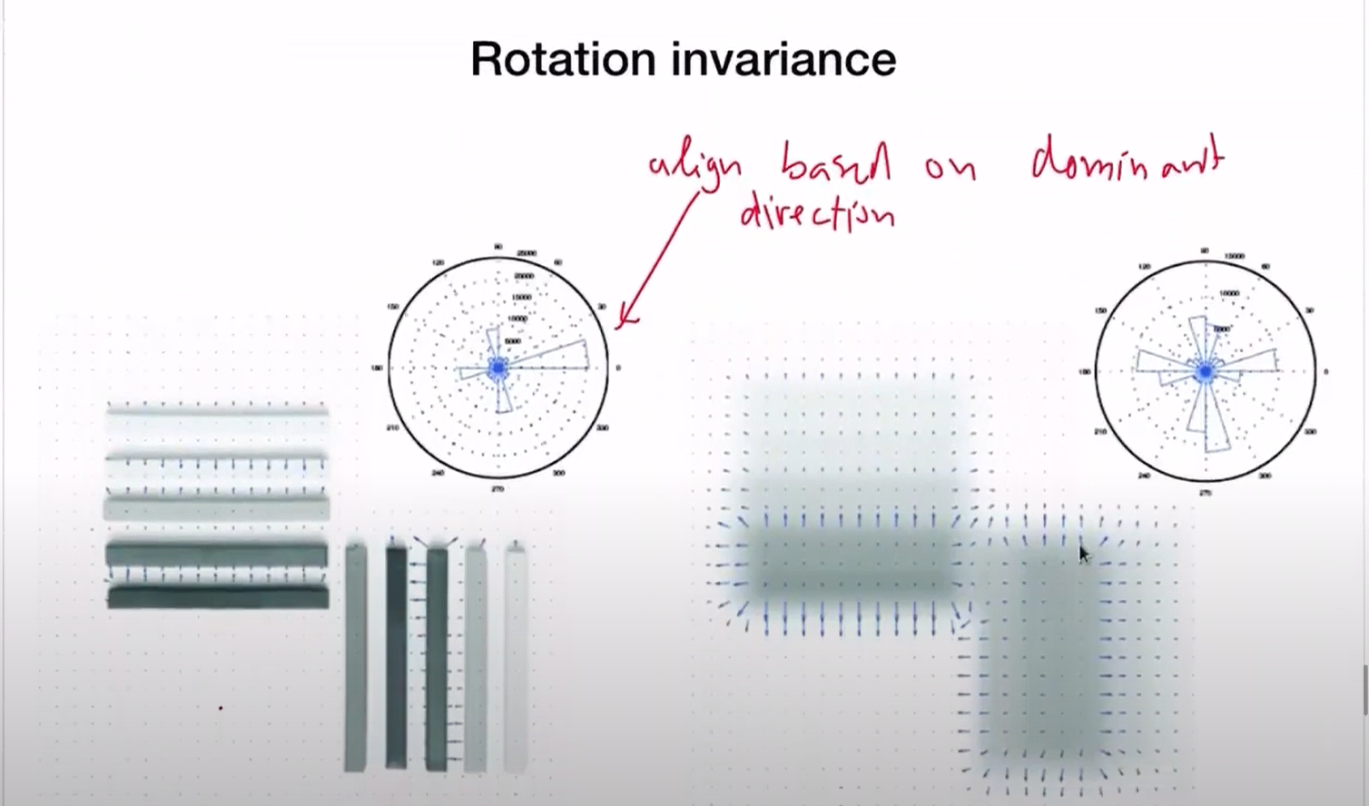

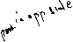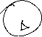

Scale invariance

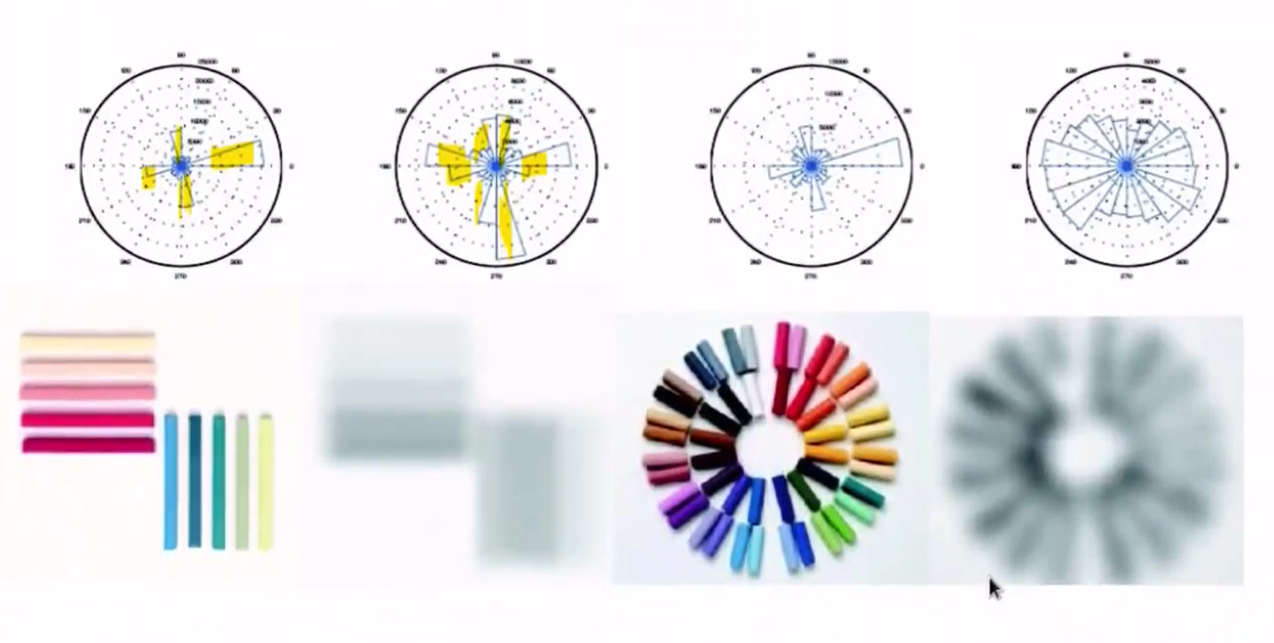

We see for each scaled image, the histogram is different

Multiple scaled images needed for definition of scale invariance

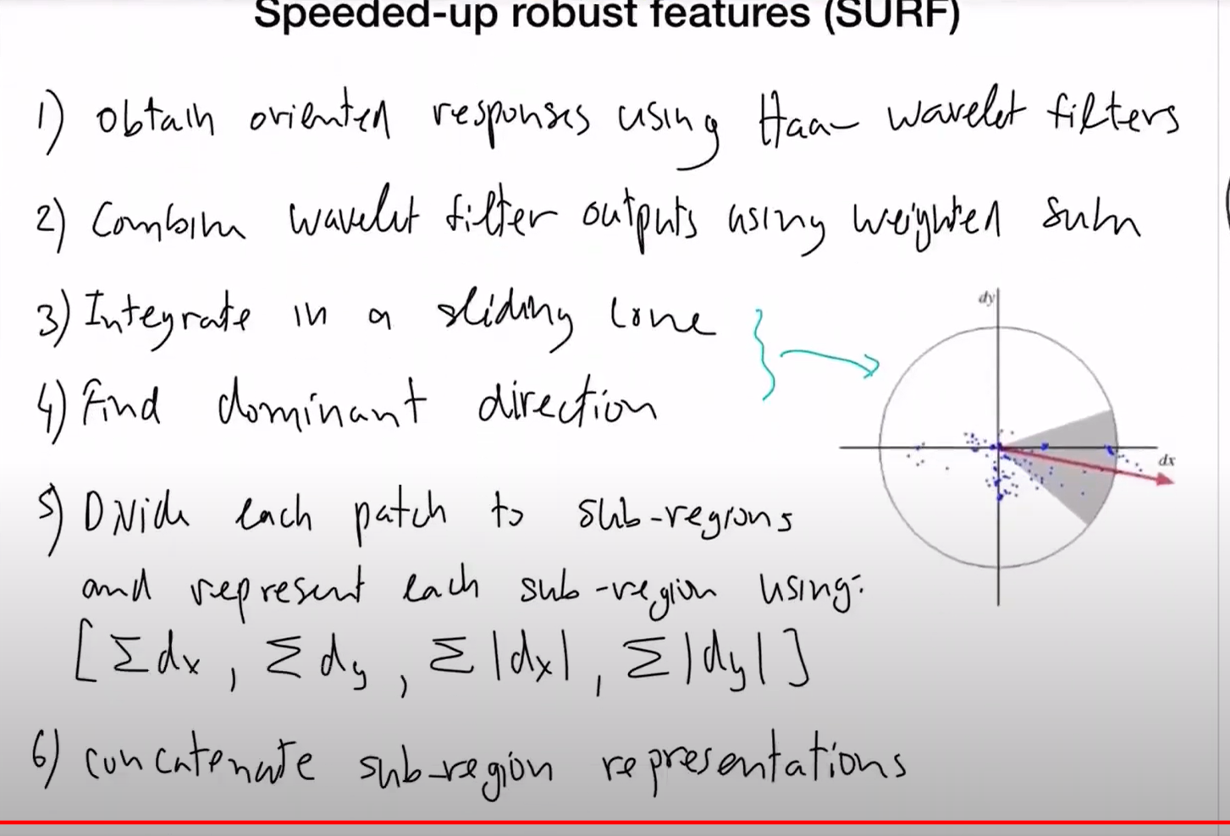

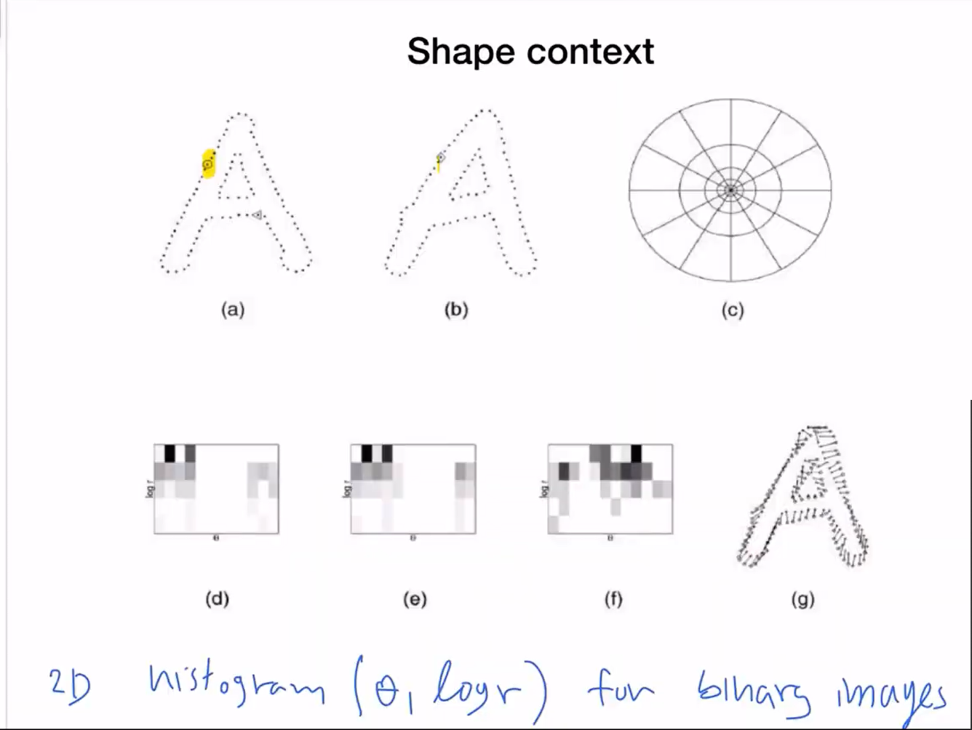

To find the shape, place a circle arougd each point and draw thehostogram around it counting the number of black points inside that circle .

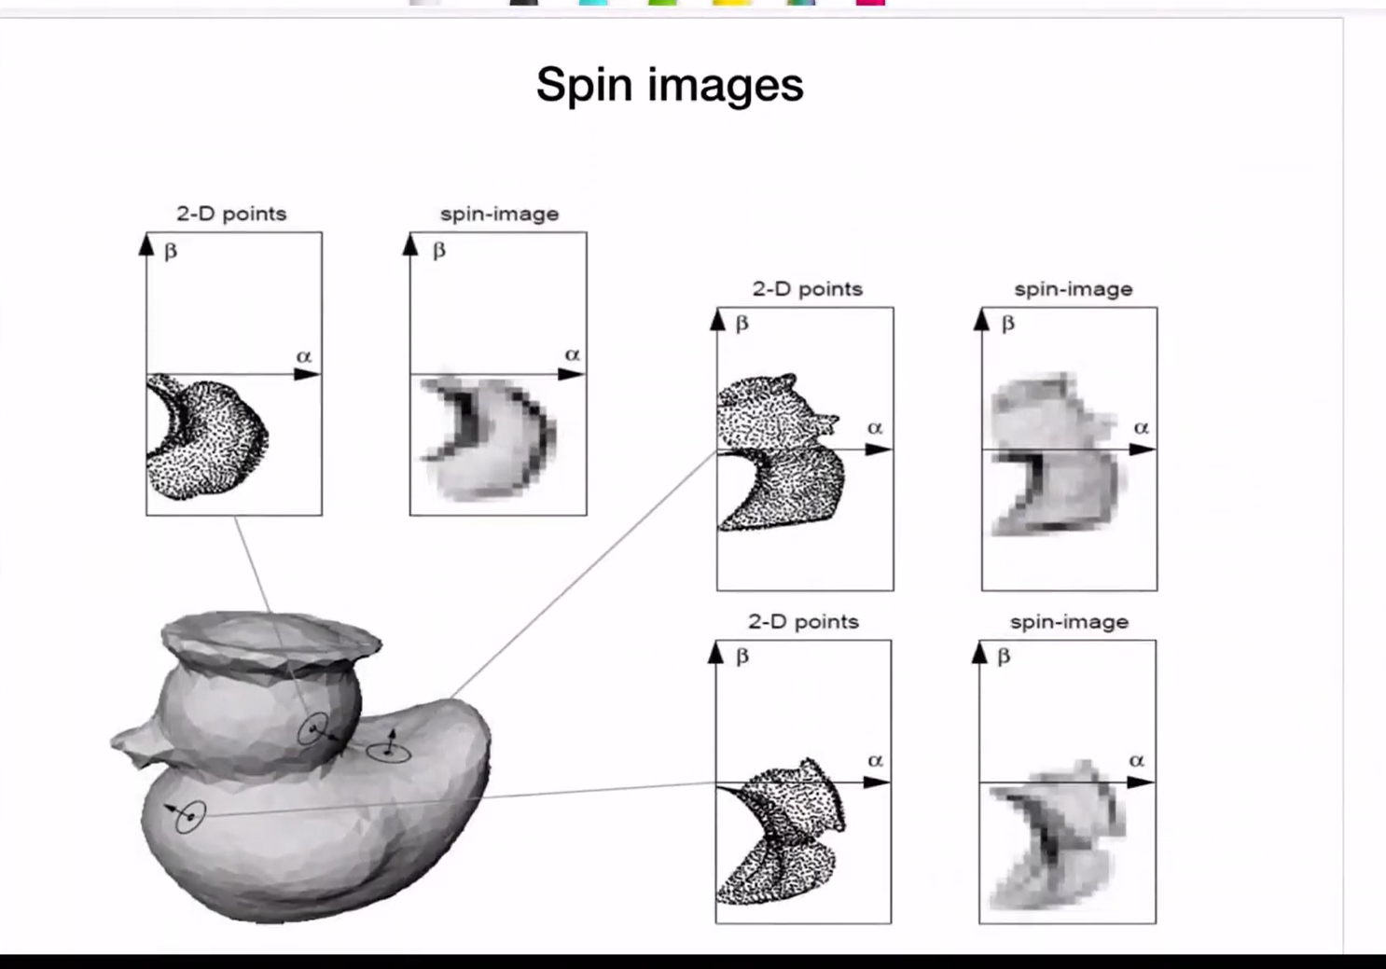

Used for 3D objects,histograms

Notes 7 – Lecture 9

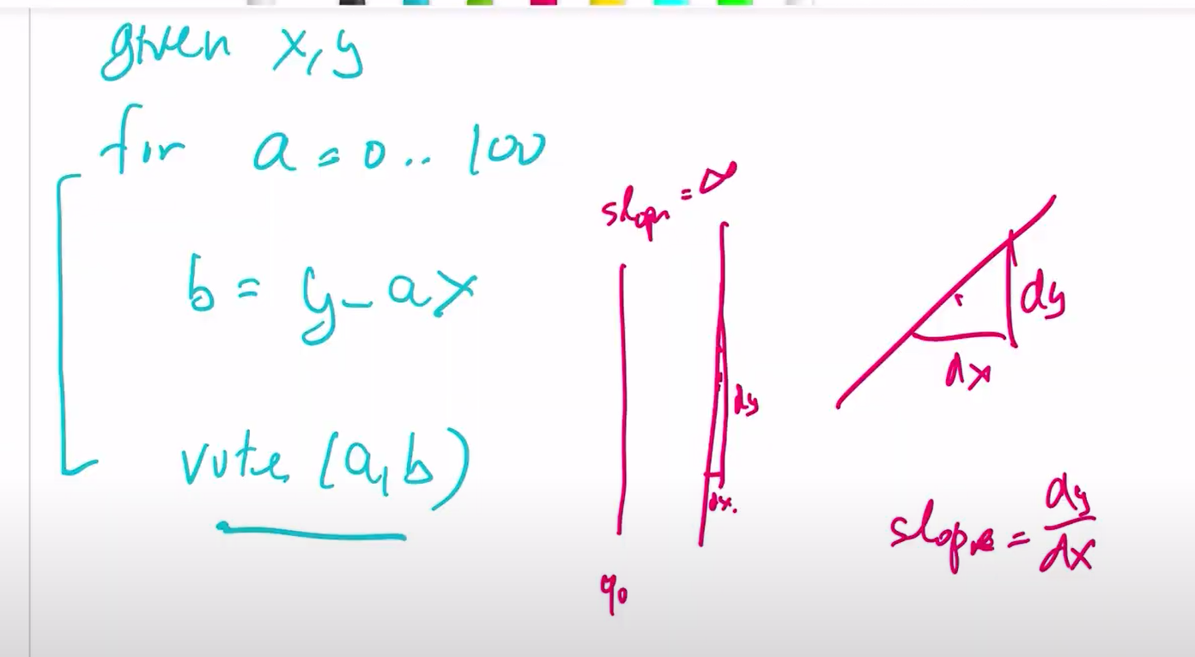



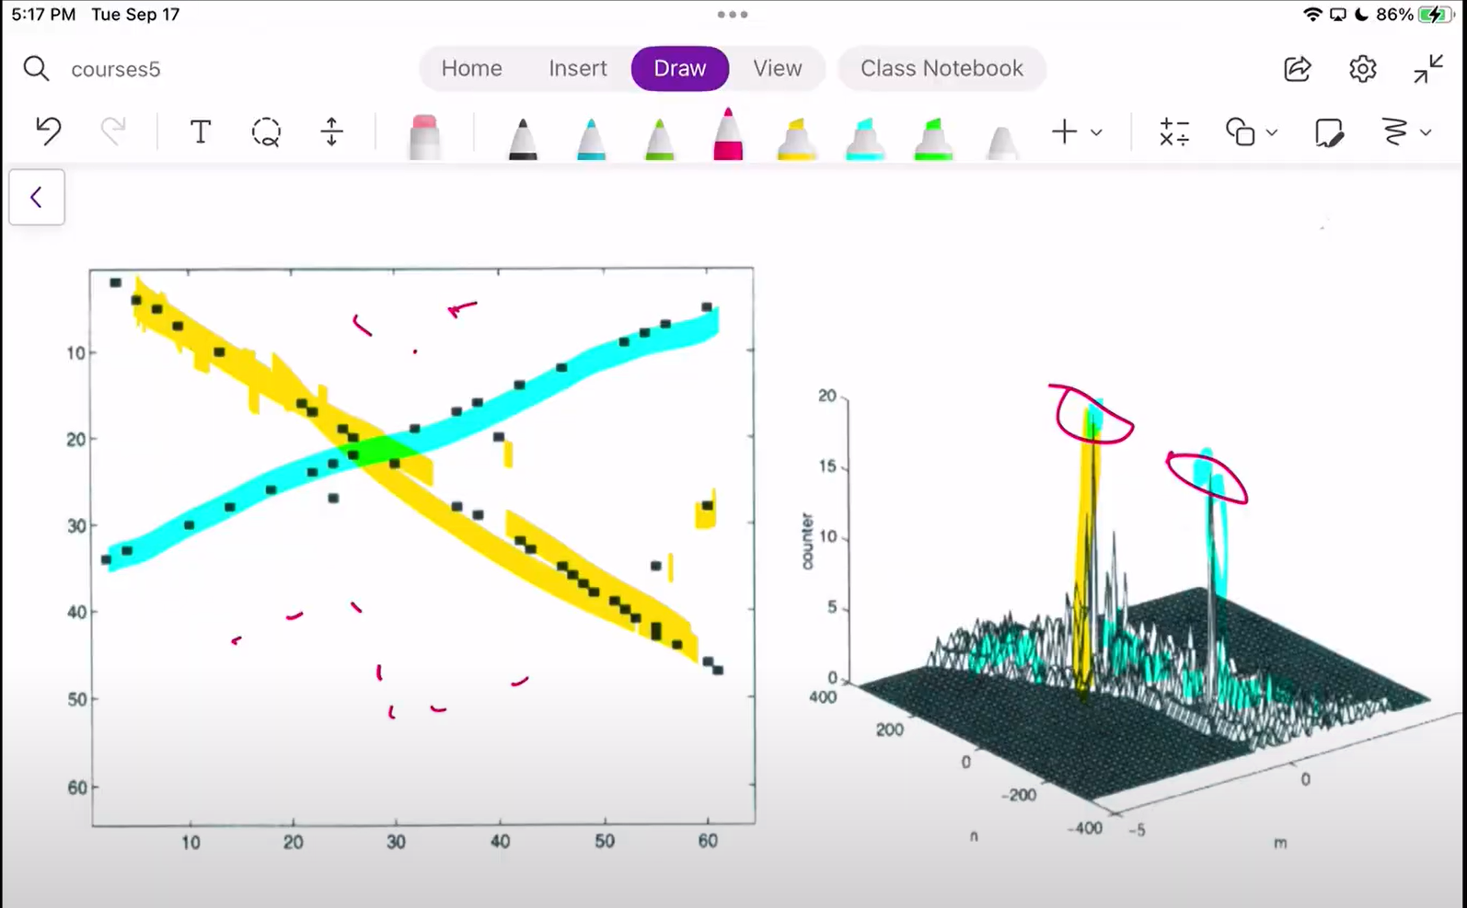

2 peaks corresponding to 2 line of points in the image.

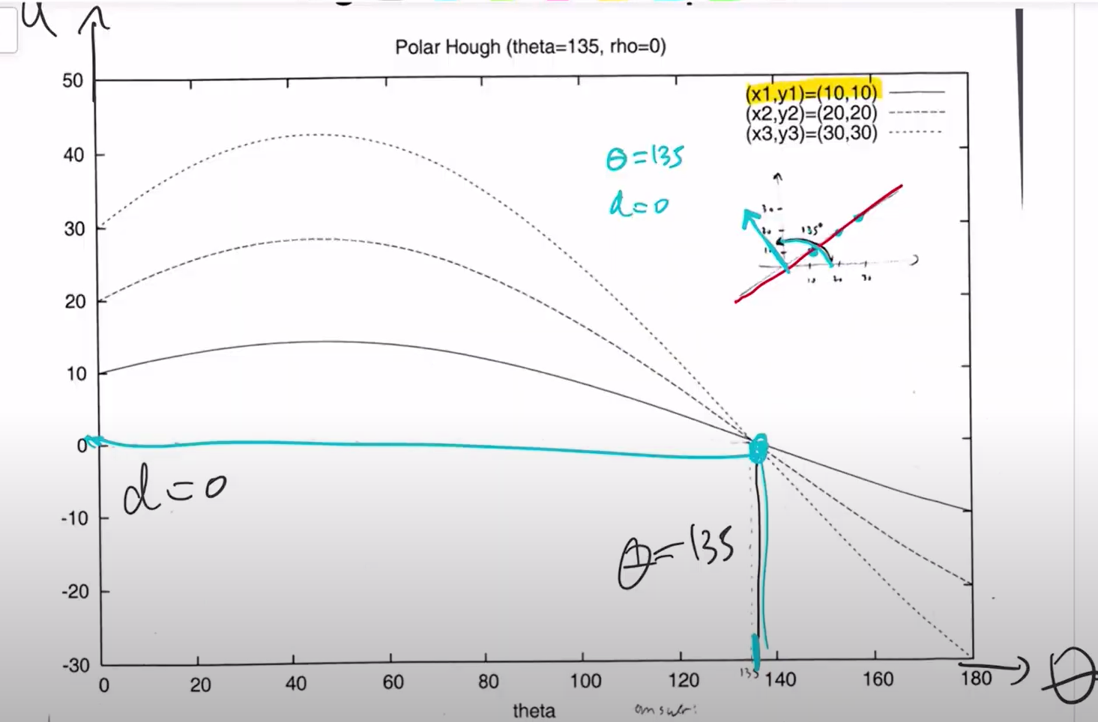

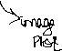

Each curve above corresponds to points (x1,y1), (x2,y2) and (x3,y3)

The intervals a which the theta values are taken matters -🡪which means the cell size…

Range of theta 🡪180 is good enough

If we take too small intervals 0,1,2…180….we will get accurate values of the curve and we can find the perfect point of overlap and hence the fitting line.-->But, this is too expensive and in case, the curves don’t actually overlap accurately, we will not be able to find the approximate point of peak votes at all….if we could have zoomed out the cells by taking larger intervals, we can find such points and the larger intervals are efficient in calculation as well.

Small interval (cell size) -> accurate representation if points 🡪expensive

Large intervals 🡪 efficient calculation 🡪 approximation

Its hard to extend it to an arbitrary shape.. of ellipses, etc…(not sure what this actually mean)

Geometric vs Algebraic distance:

Goal is to find the distance between the point in question and the curve.

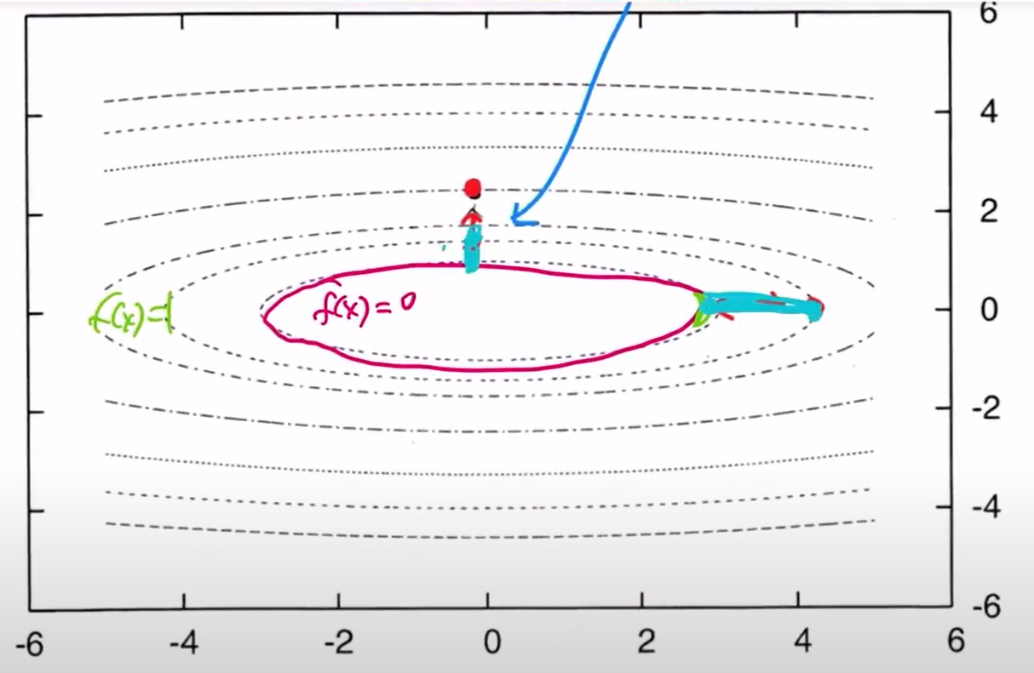

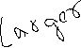

Consider the red curve is the original ellispse curve f, where f(x)=0, the further dotted lines are those with f(x)=1……we see that the algebraic distance between 2 curves is 1. But geometrically, not all the points in f(x)=1 are at the same distance from the original curve(f(x)=0).

Trying to fit with the use of algebraic distance alone would not fit it well which is why geometric distance is needed.

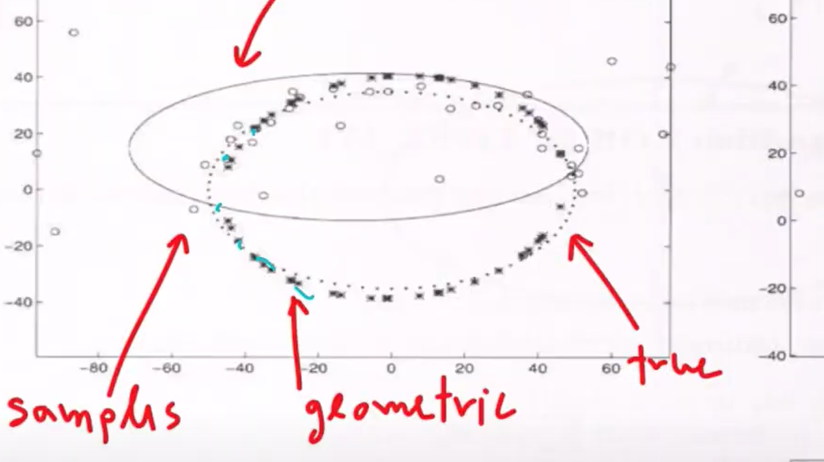

Lecture 9 notes - /lecture 10 video

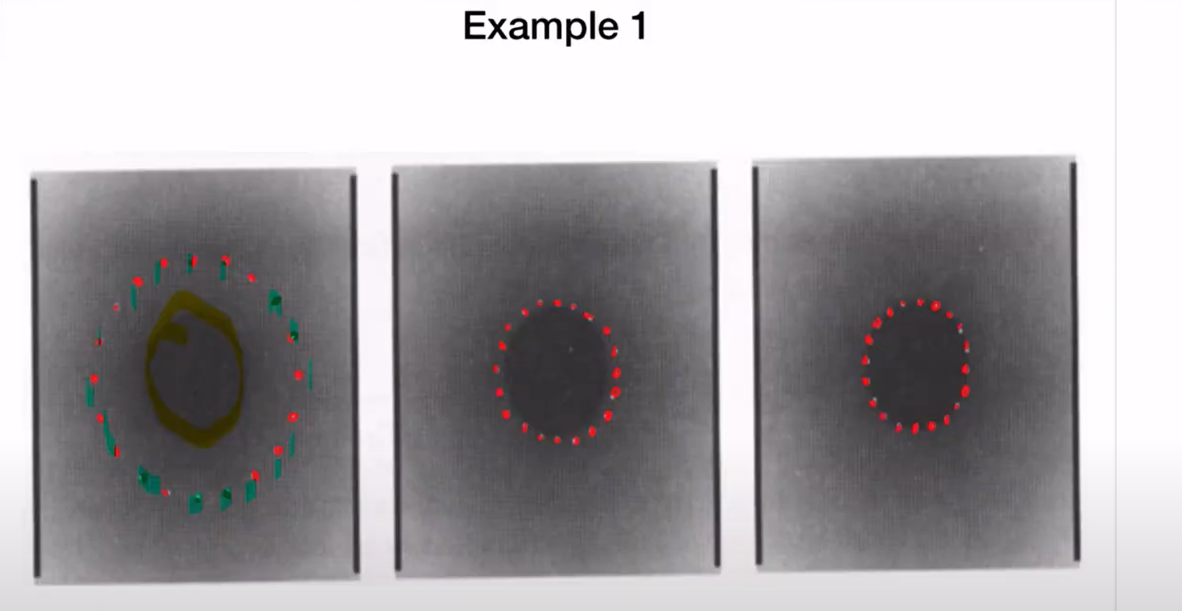

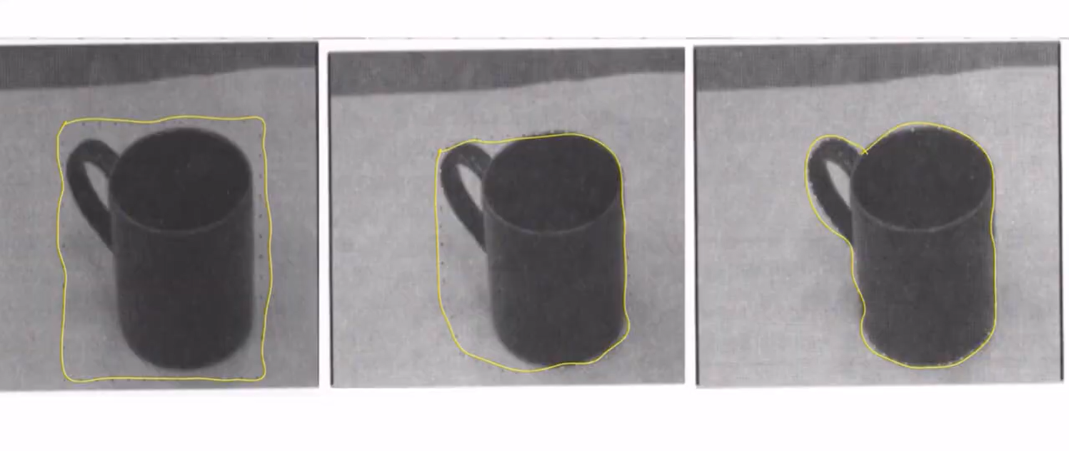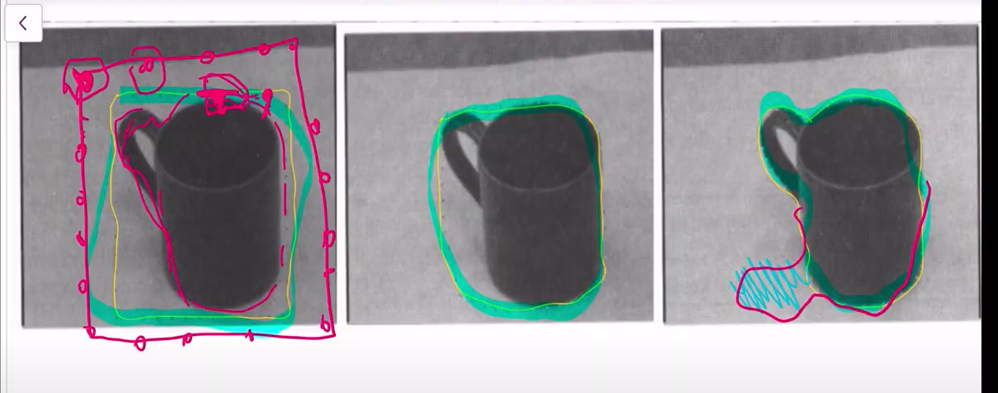

Weakness:

In above approach of finding the shape of the object, the initial guess of the points/curve matters a lot. Because only if it is closer to the object(eg-green line above) , when we look around the neighborhood to see where to place the points next (if there is any change in the intensities). If the initial guess is a far curve(eg-red curve), then when we look around, the neighborhood is a uniform area and so the algorithm cannot find a valid point to move next and it converges as if the result is reached.

If the object had a shadow due to illumination , then there is high chance we misinterpret that as part of the object shape and gives wrong result.

Lecture 10

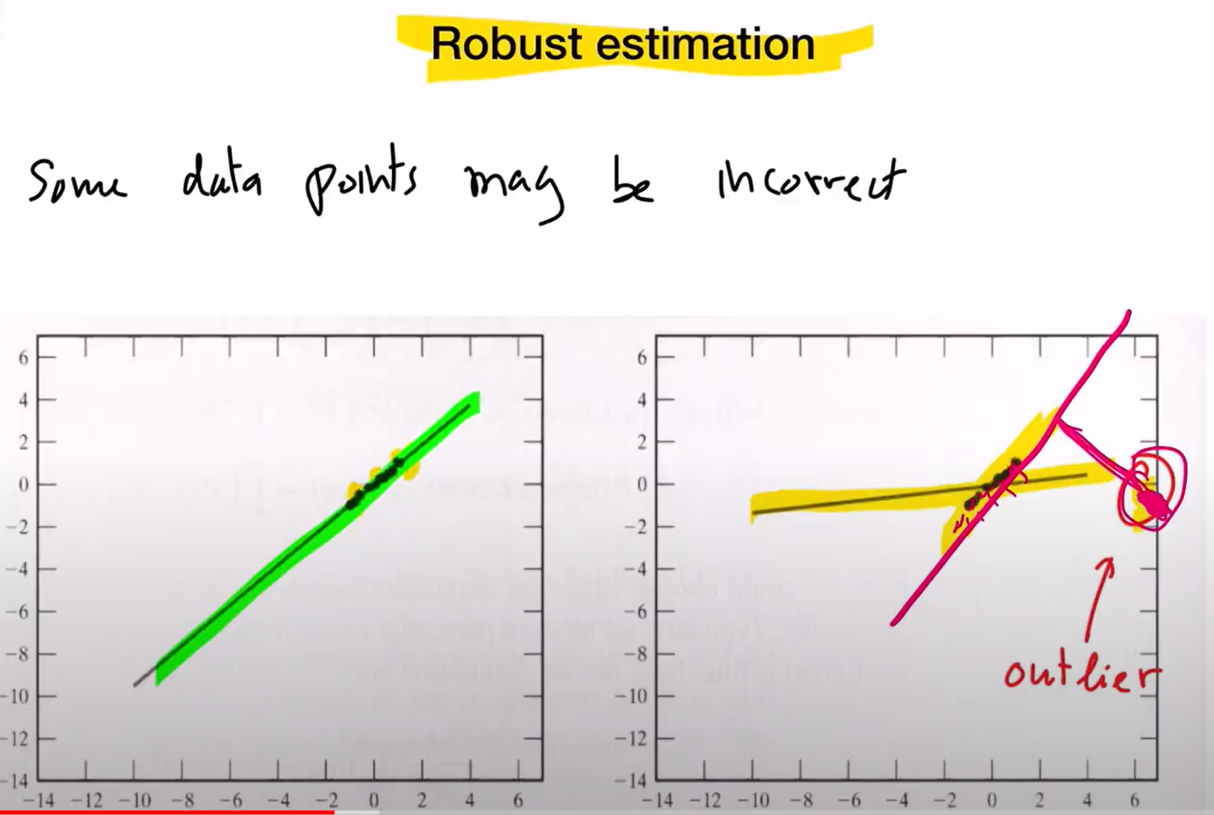

Below is used for neural n/w

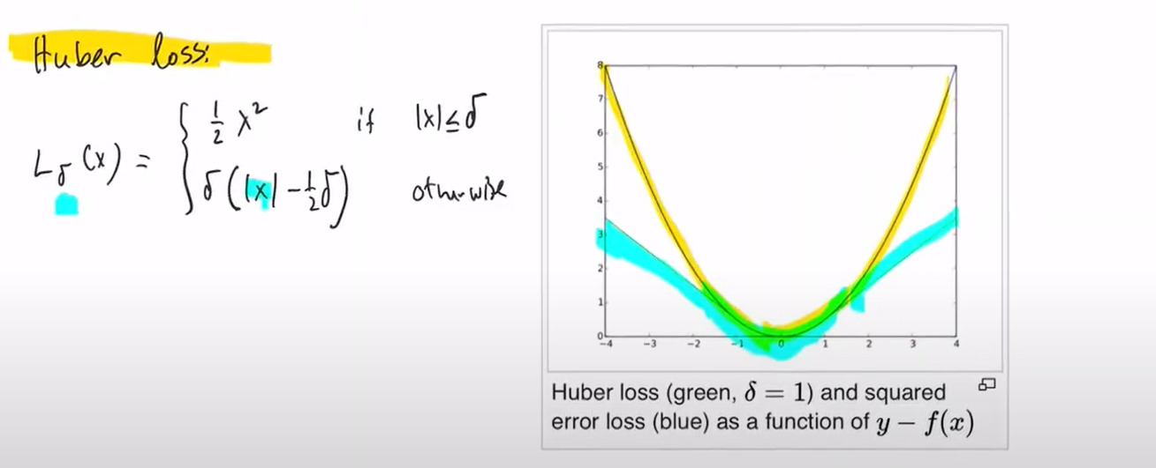

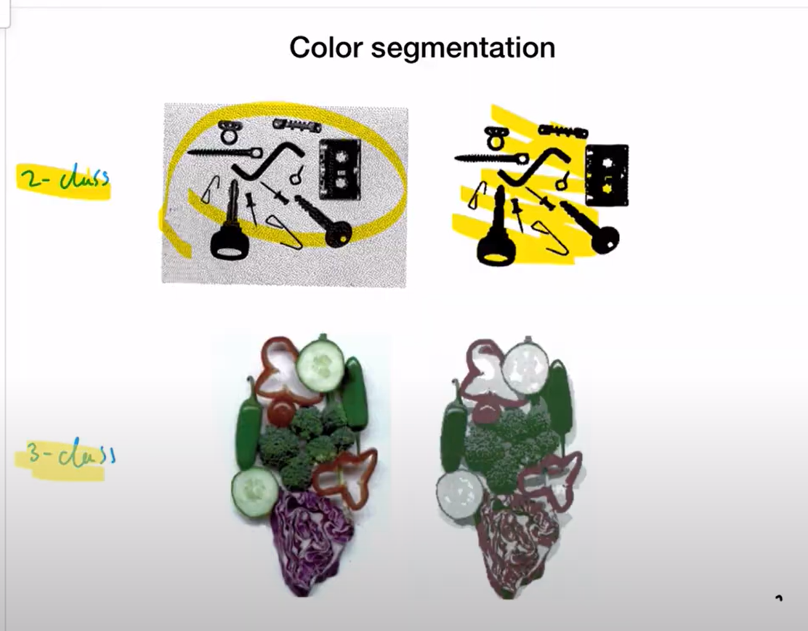

2-class- separating foreground and background 🡪black vs white



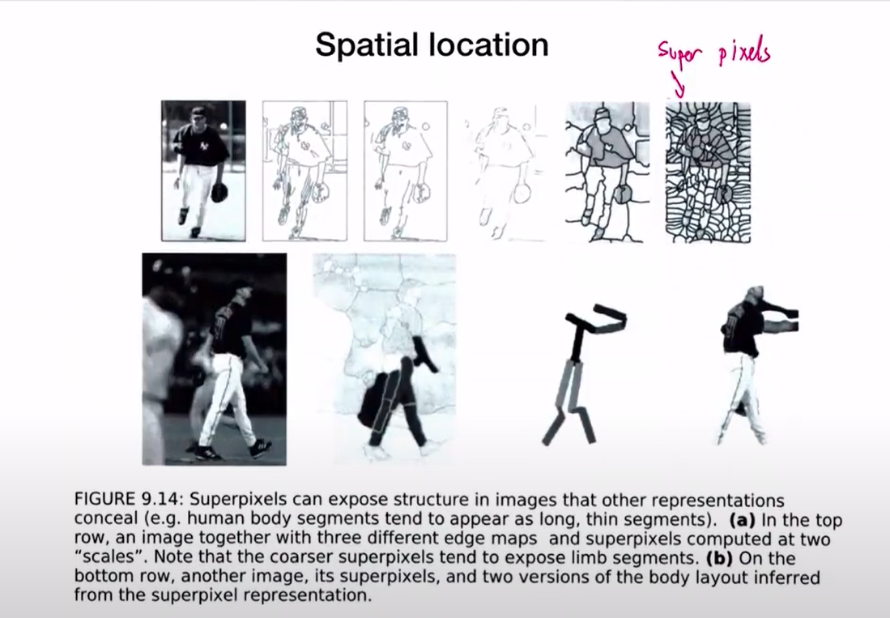

Based on the similarity of pixels in the same space

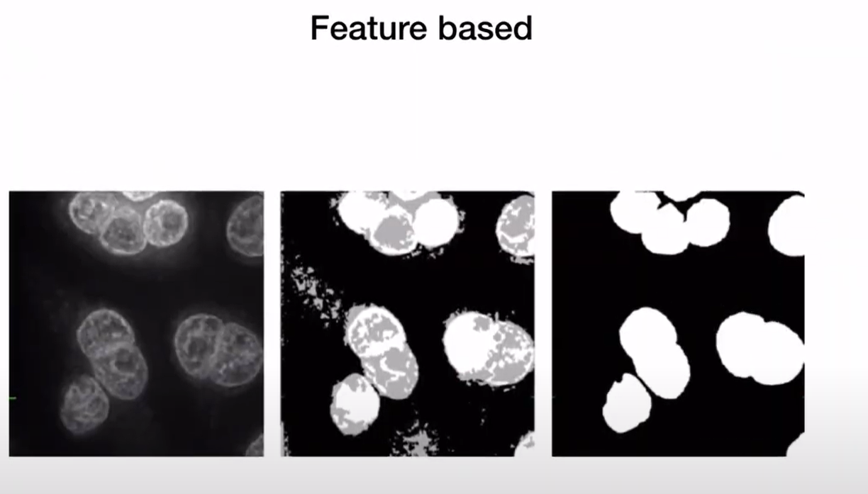

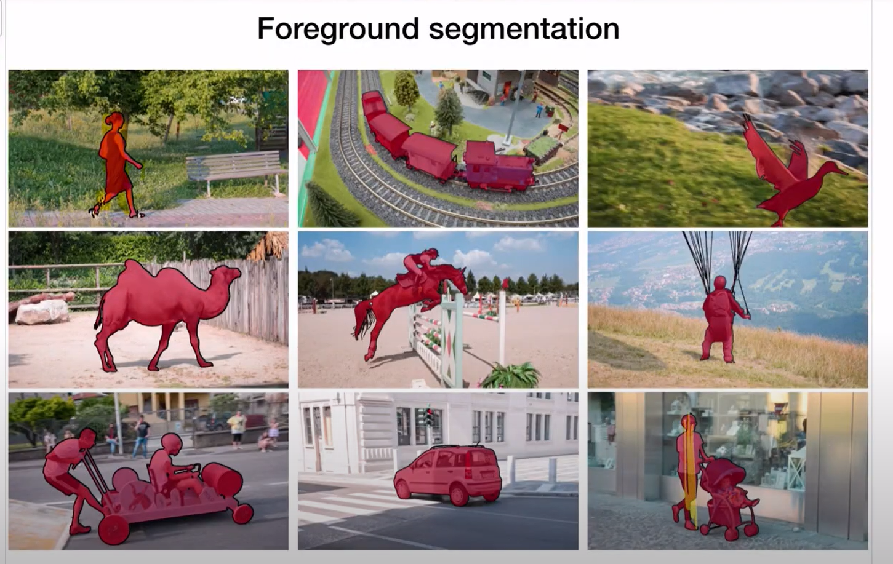

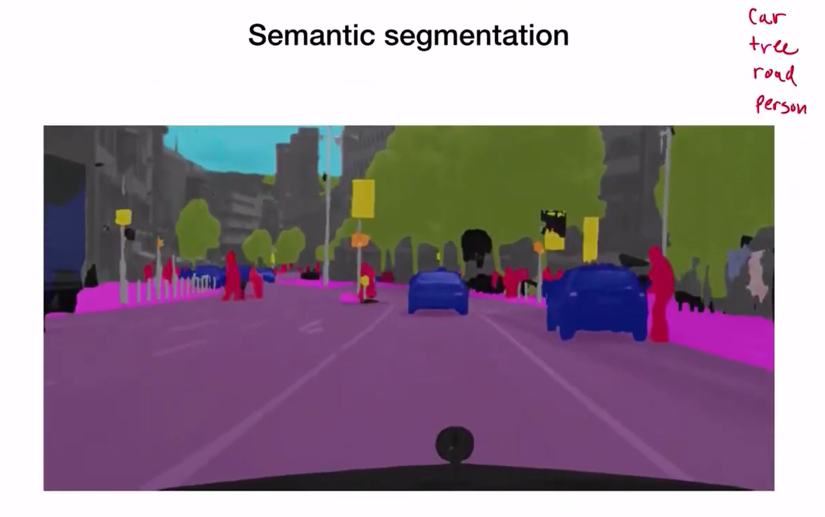

Each group of object is given a color as and when identified………even if the cars are of different types/some other vehicles of diff colors, it is still one group….so, they are grouped not based on the color---that is y it is called semantics – segmentation (labellling everything in the image ot particular to object alone or backgournd alone)

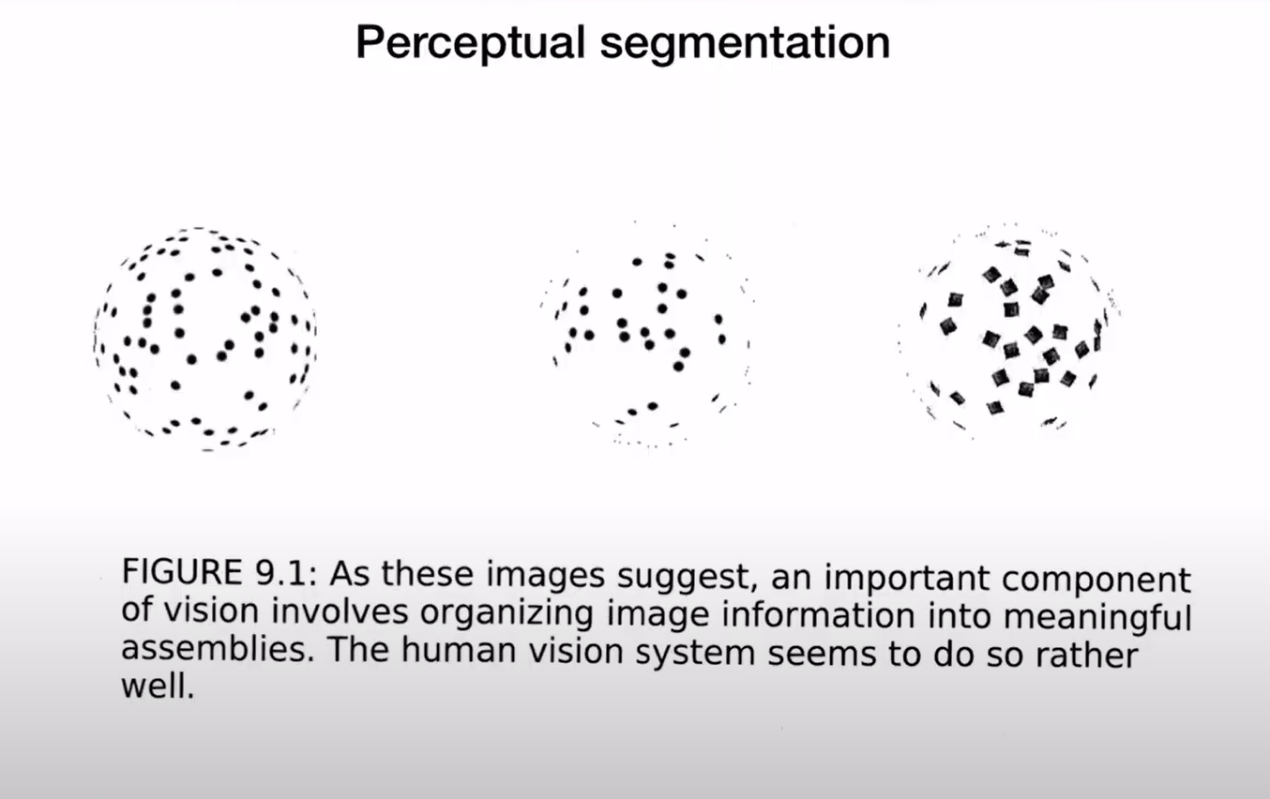

As a whole, it is a sphere🡪complex problem as it cant be easily understood by pixel by pixel info

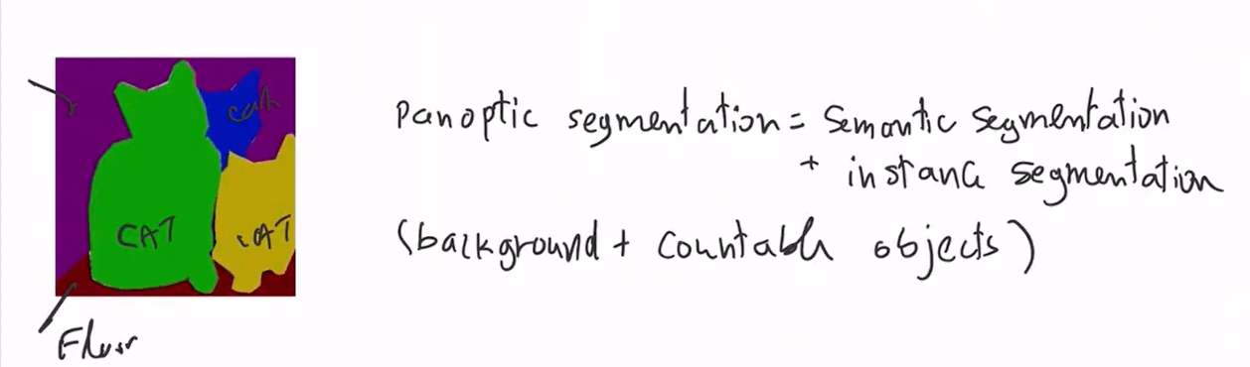

Notes 11

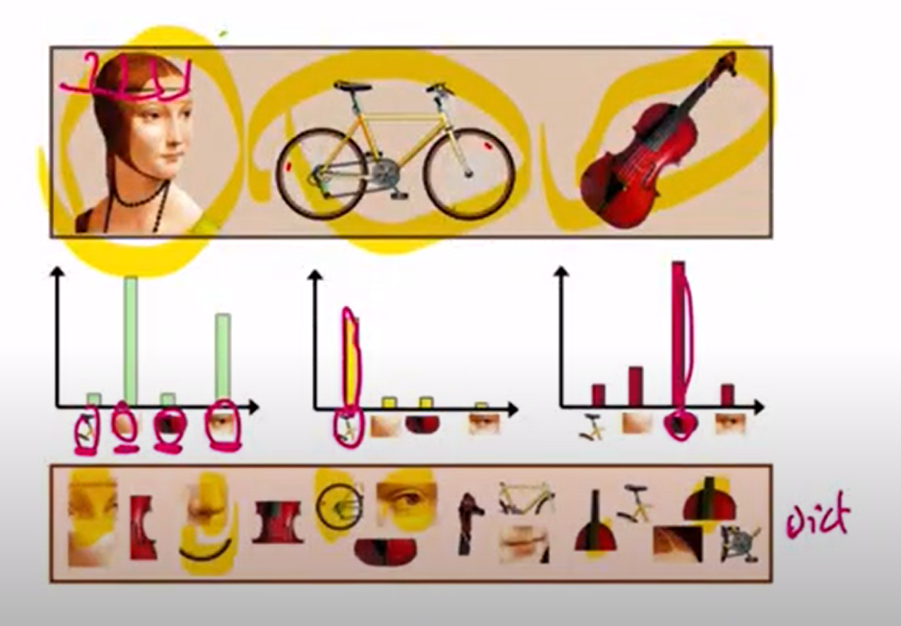

From above, we see that even if it is not the complete structure of the face and is only parts of the image, it is still receognized to that object which is not true. It doesn’t understand the context or relationshio/position of the parts f the same label

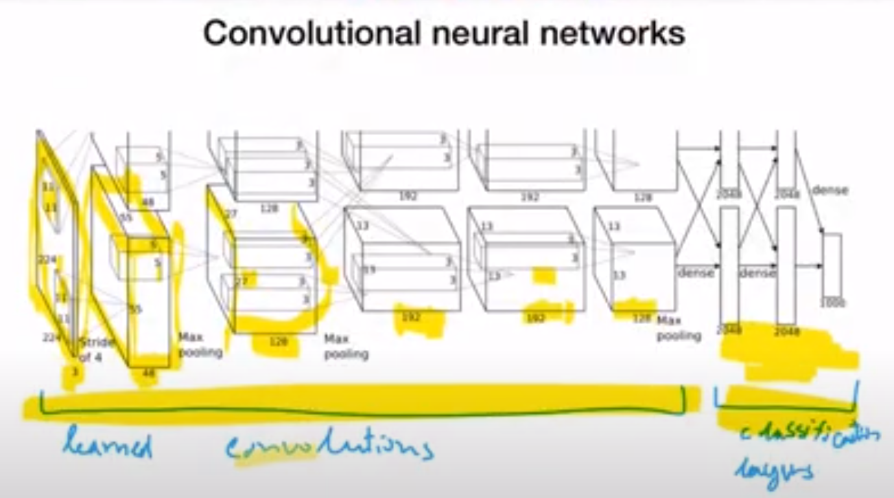

The convolutions are learnt and are not mentioned by user. Mostly the filters are learnt are also the same how a user would have specified,…they are mostly directional derivatives with diff orientation and scale.

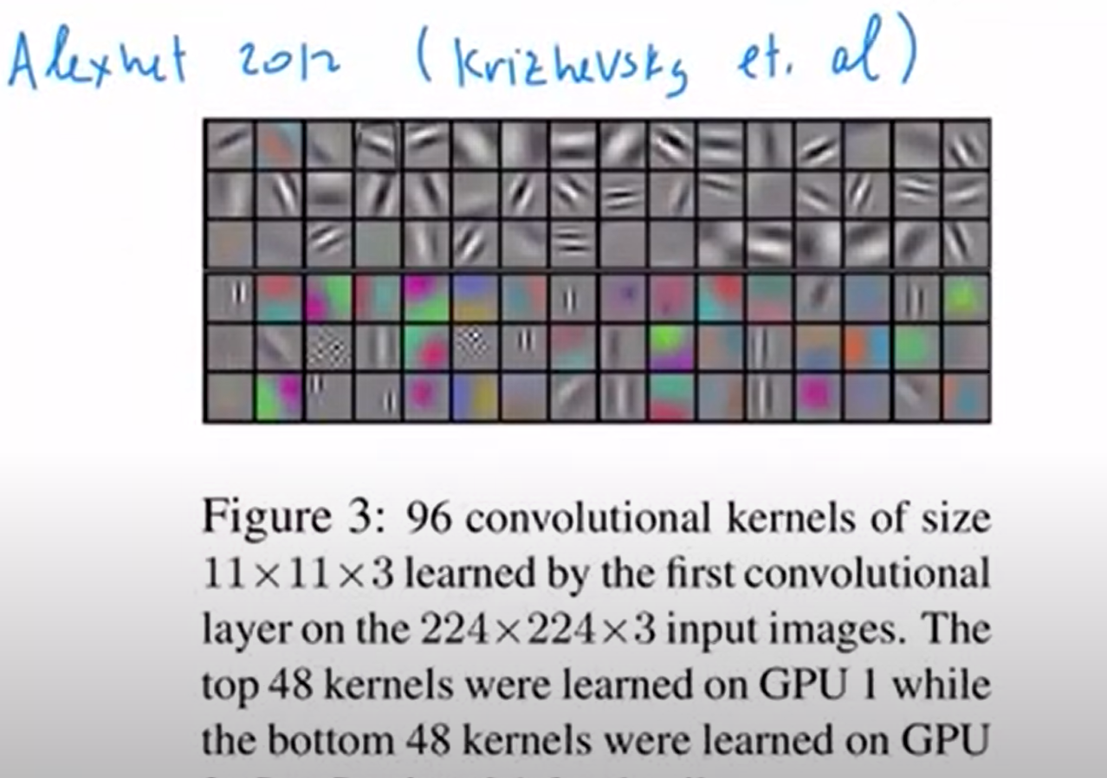

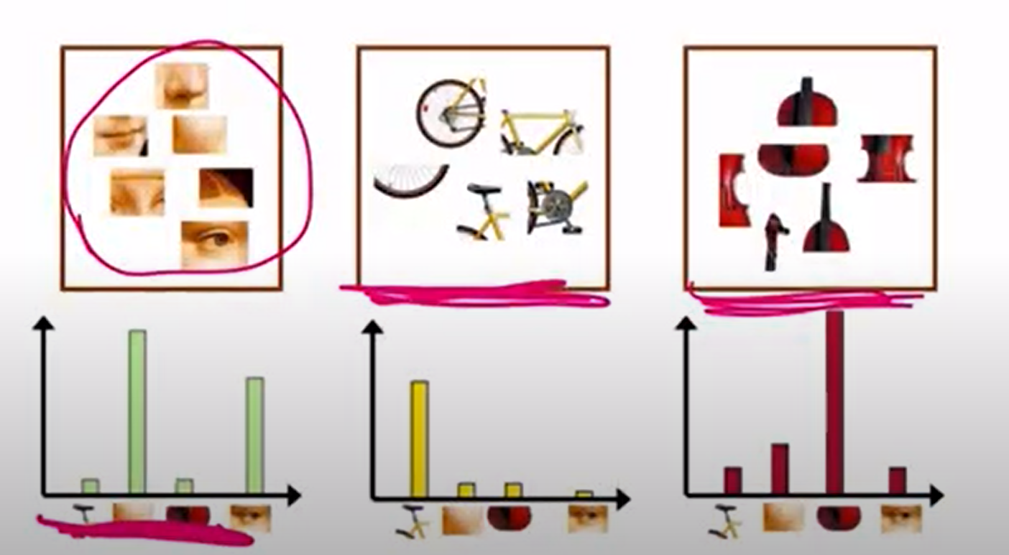

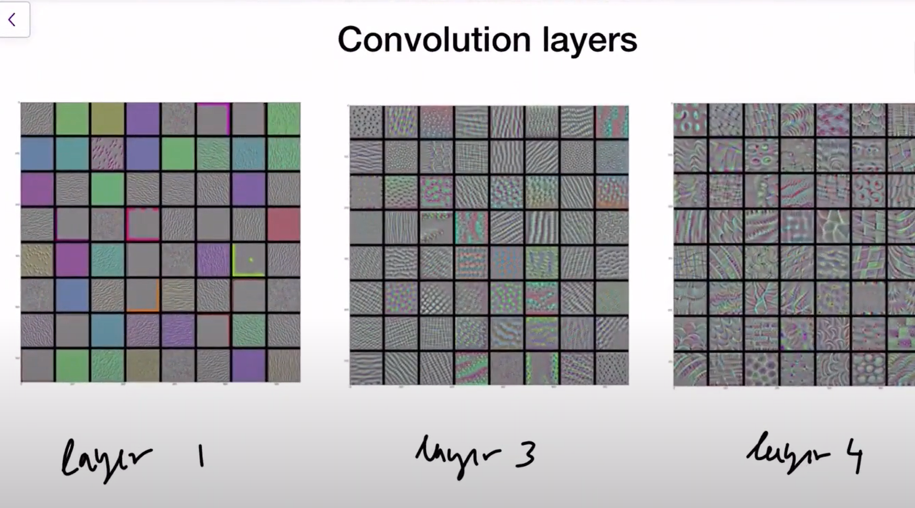

As we go deeper the filter detect more pattern like even texture

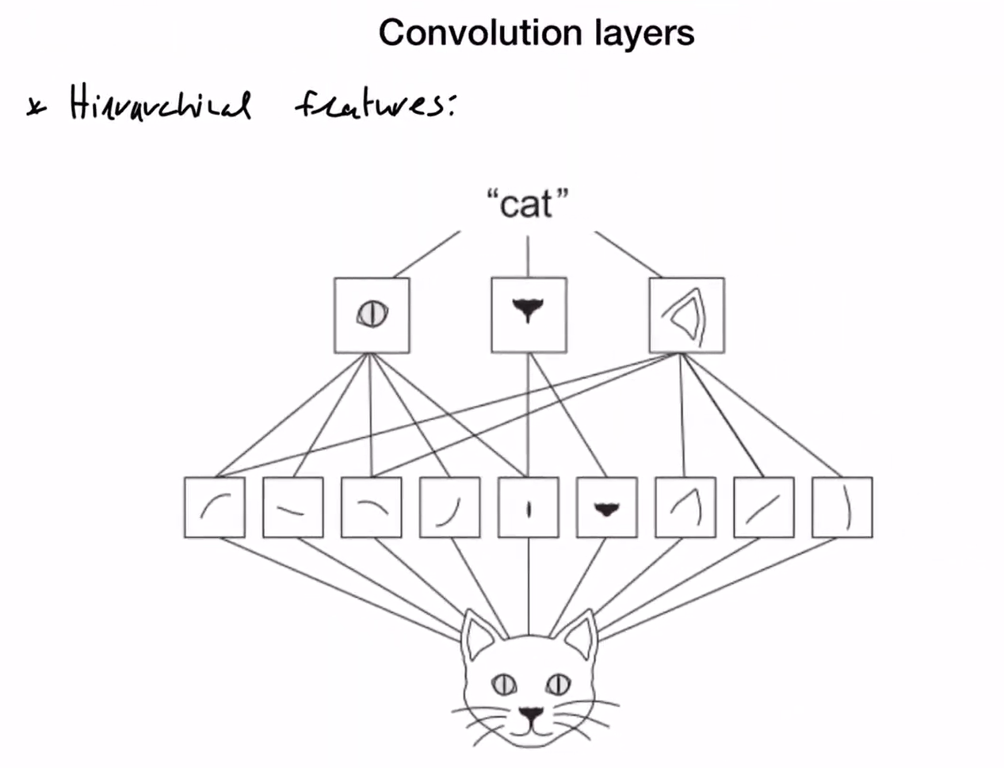

The first few layers capture the basics like the derivatives and then later multiple outputs are combined to understand the complex feature if the image and then classify.

Incase of problems where we don’t have much data to train the model to extract the features, we can use the feature extraction layer weights of a diff model and use it here . we should take the early layers and not the later ones as they may be more specific to the original image understanding.

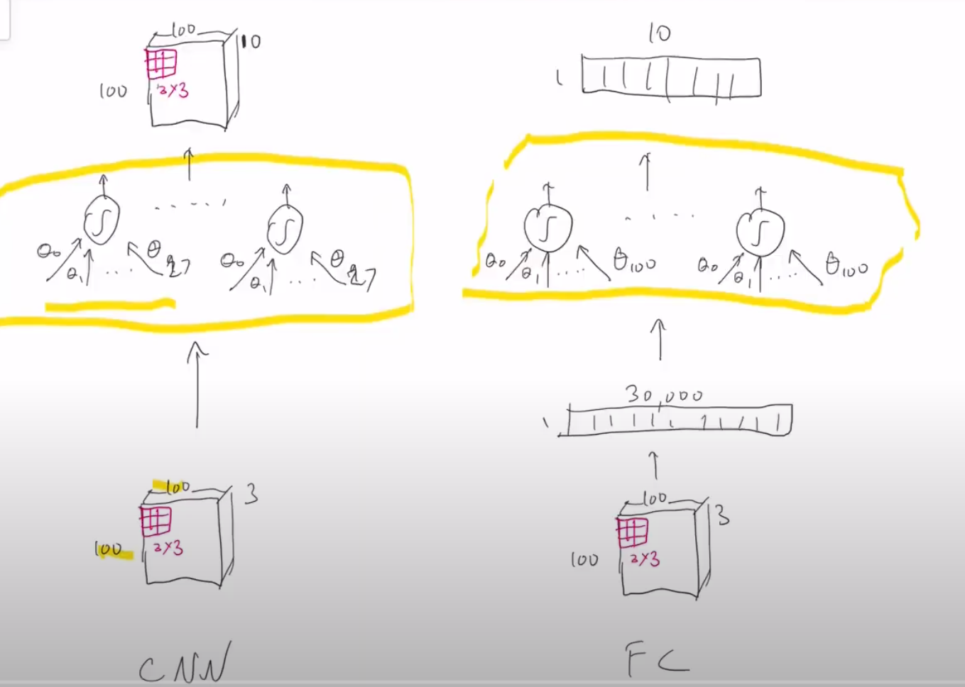

CNN – 1 3x3 filter across 3 channels🡪27 parameters -🡪10 filters-🡪270🡪depth(10) and 100x100

Full connected layer – flatten the image (100x100x3) and then 10 filters each of size 100🡪1x10🡪

1 output for every filter

Notes 11

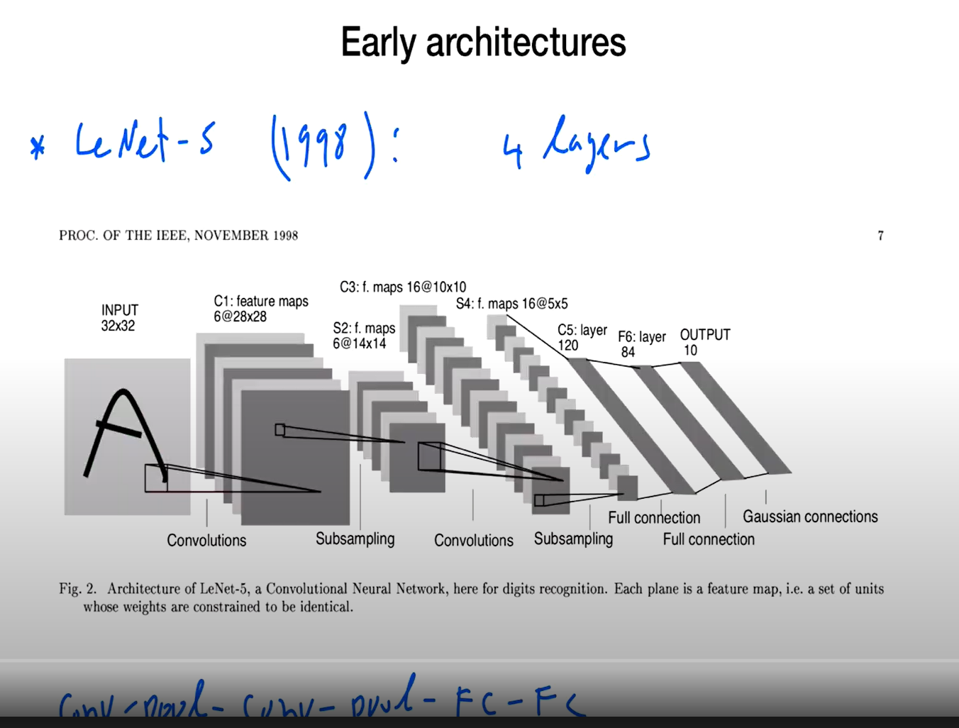

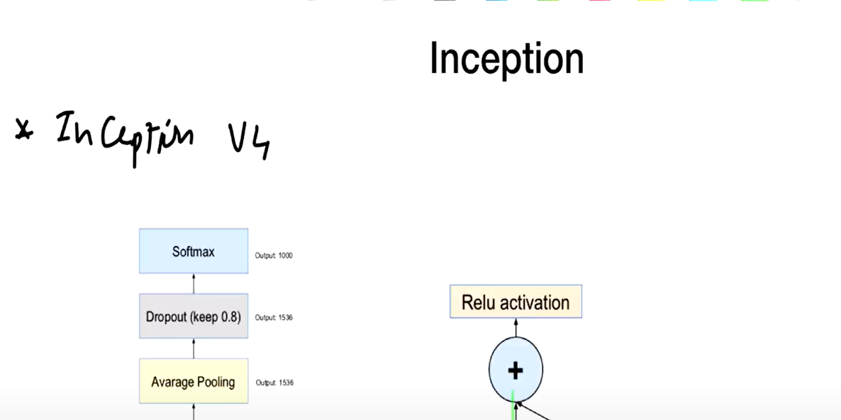

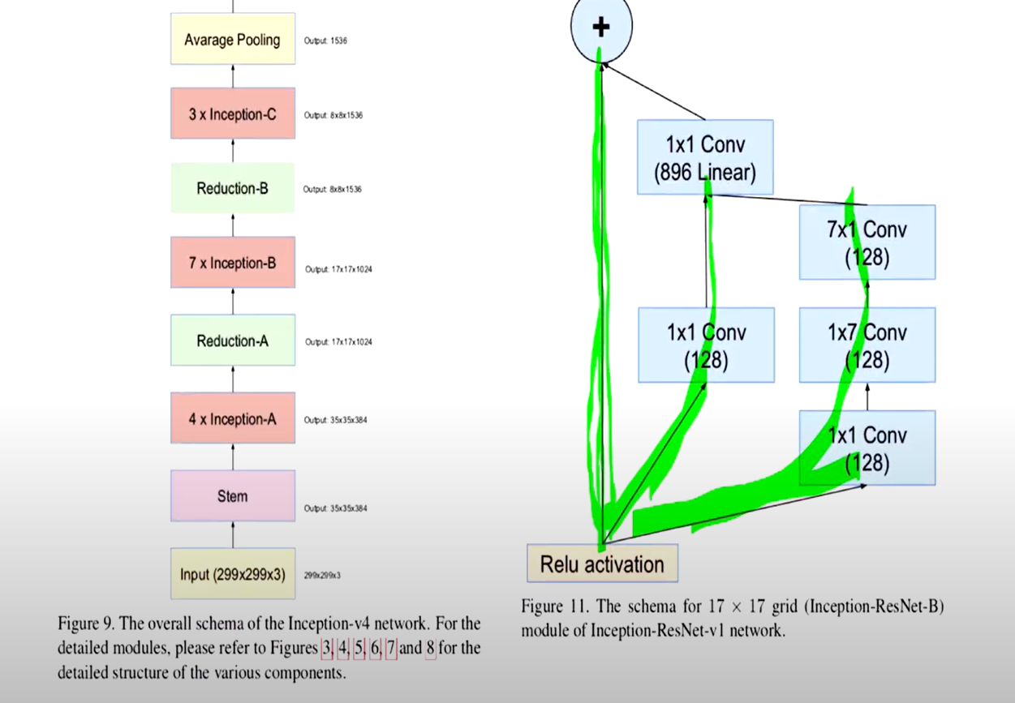

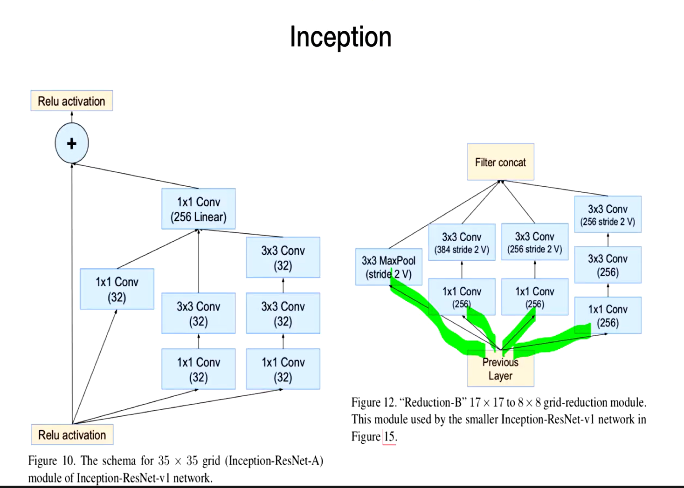

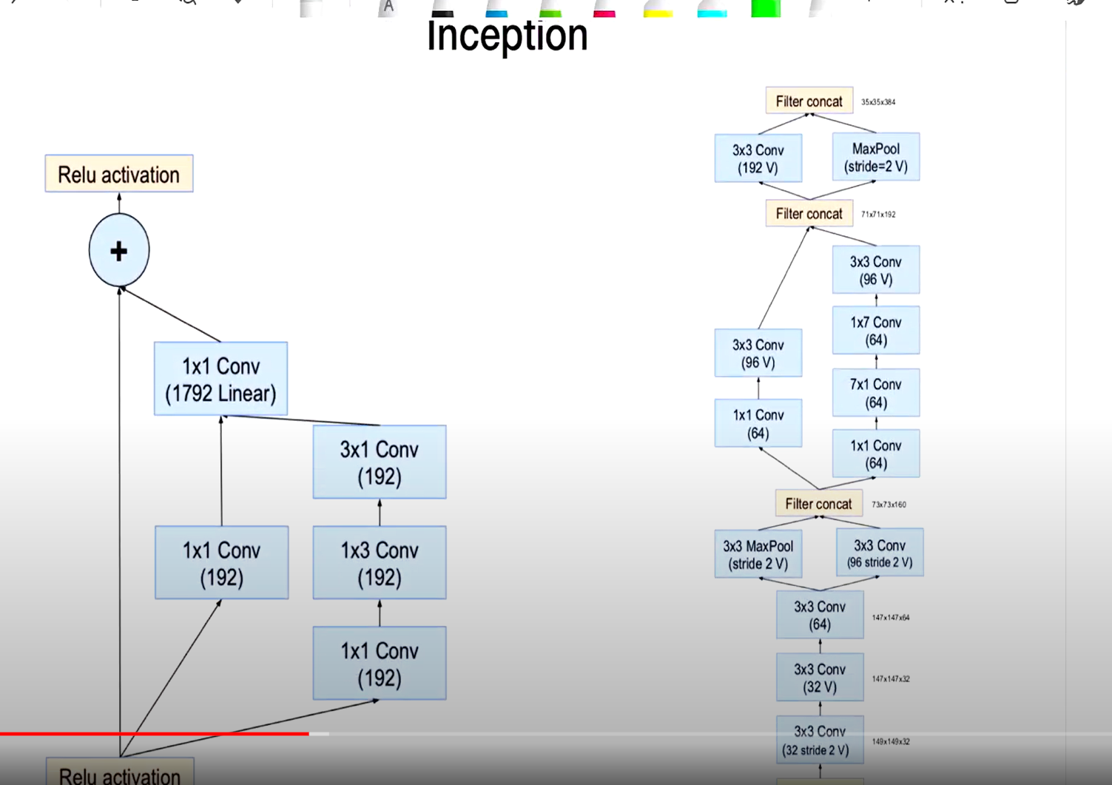

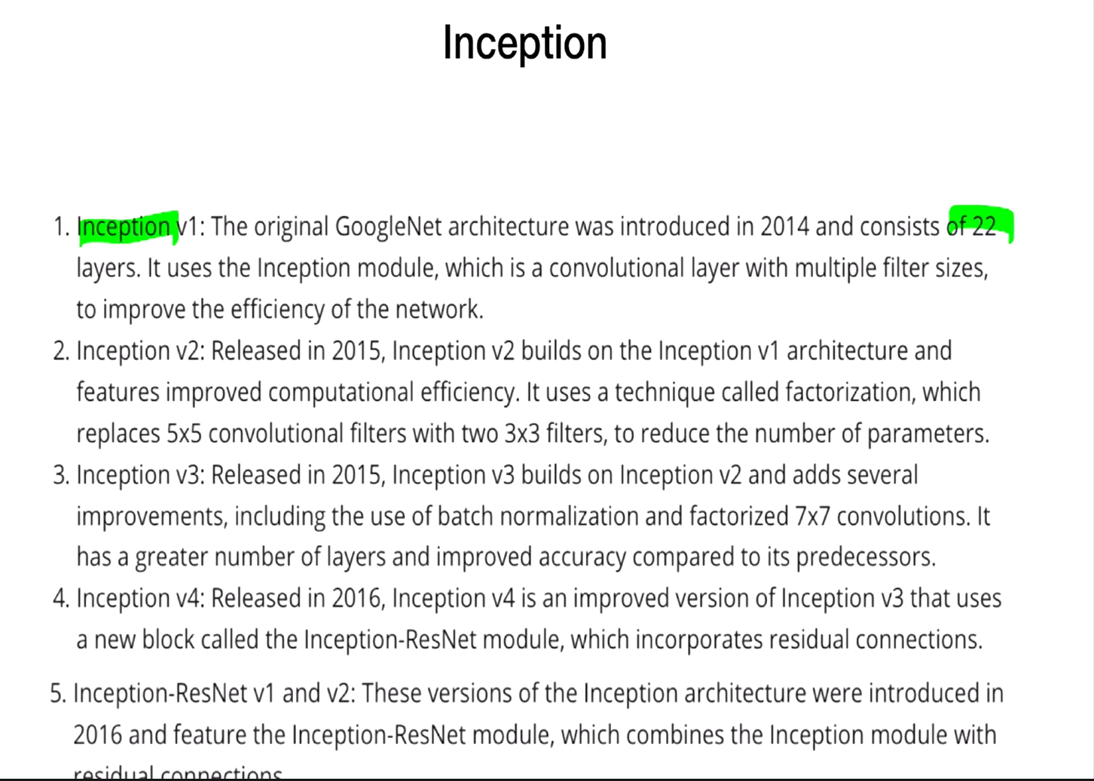

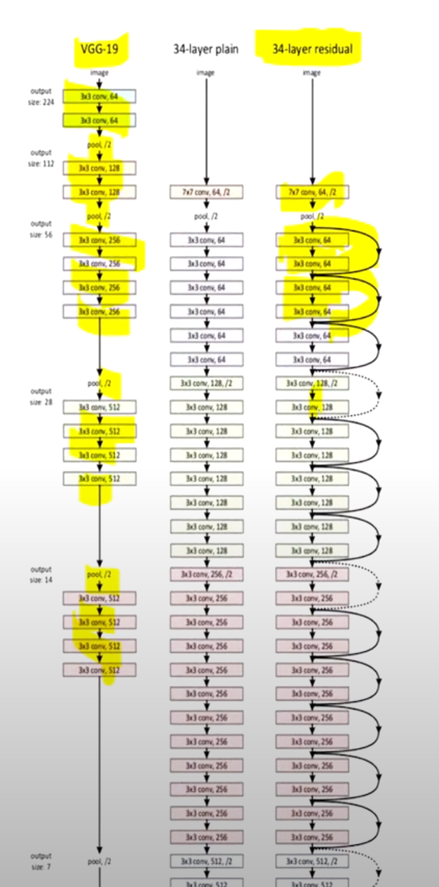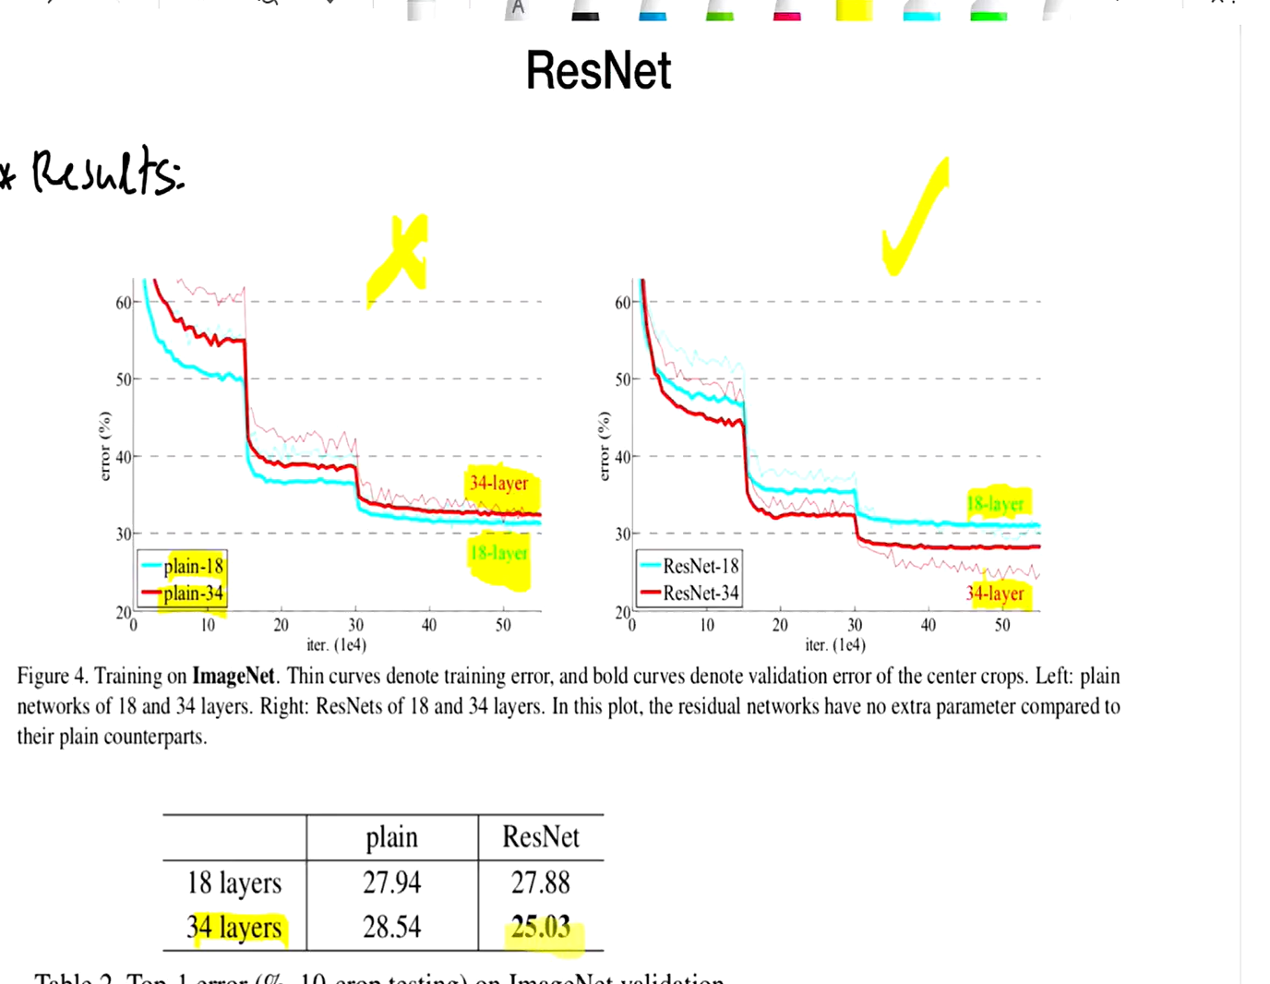

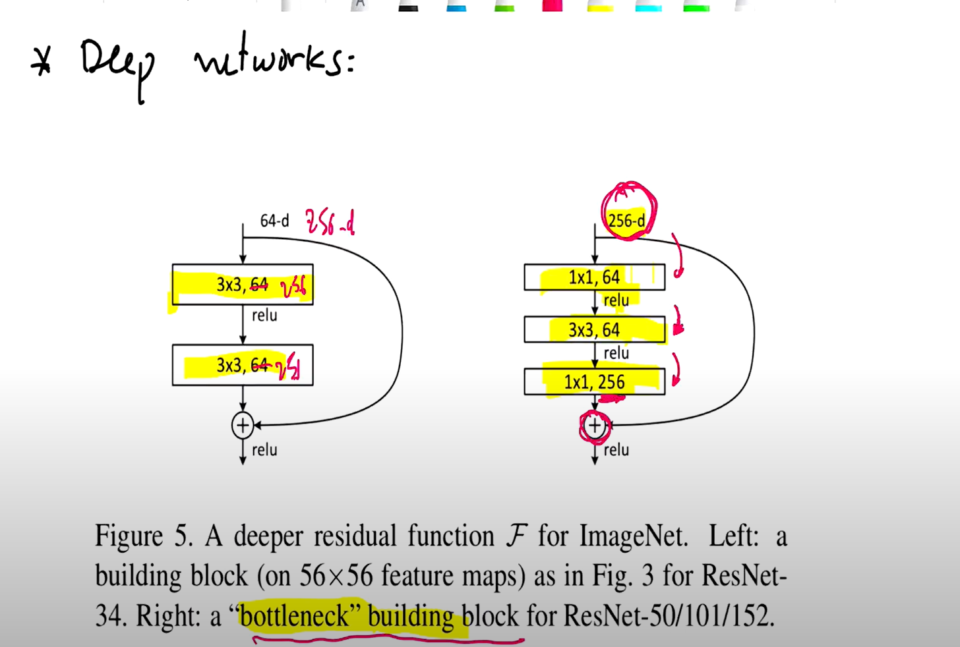

We need the output to be of the same dimension 256 from the block , but we wanted to perform less operations while convolution..this is achieved with the help of 1x1 conv like the one implemented on the right.

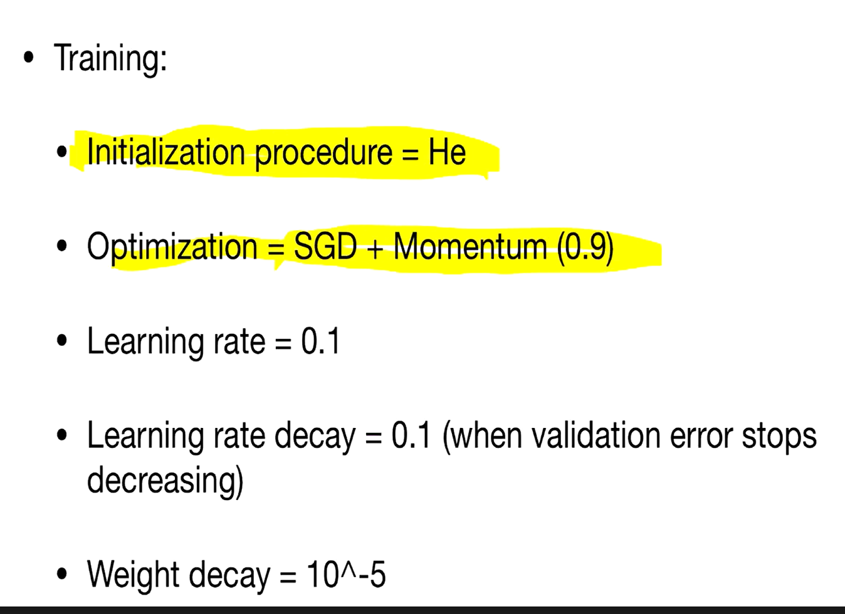

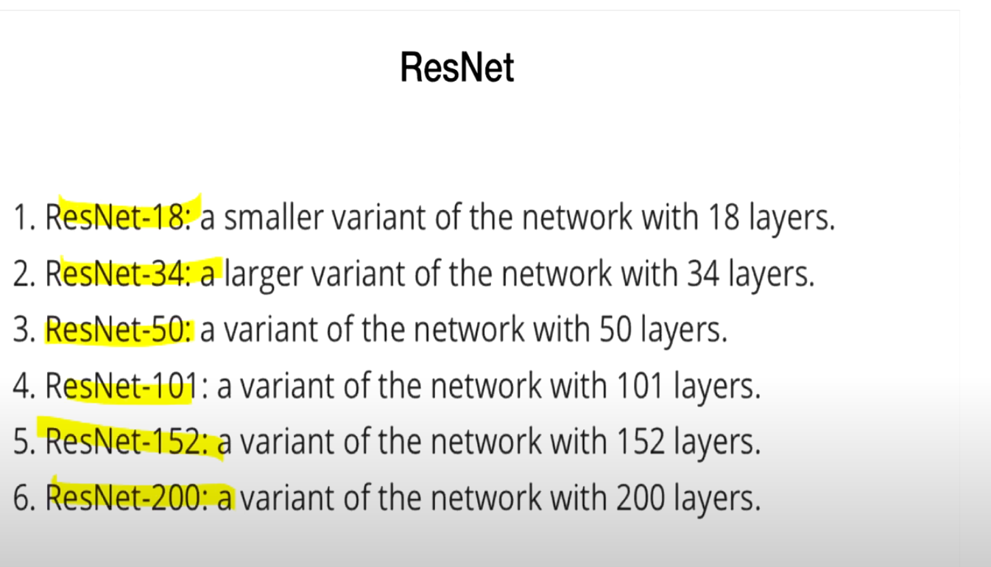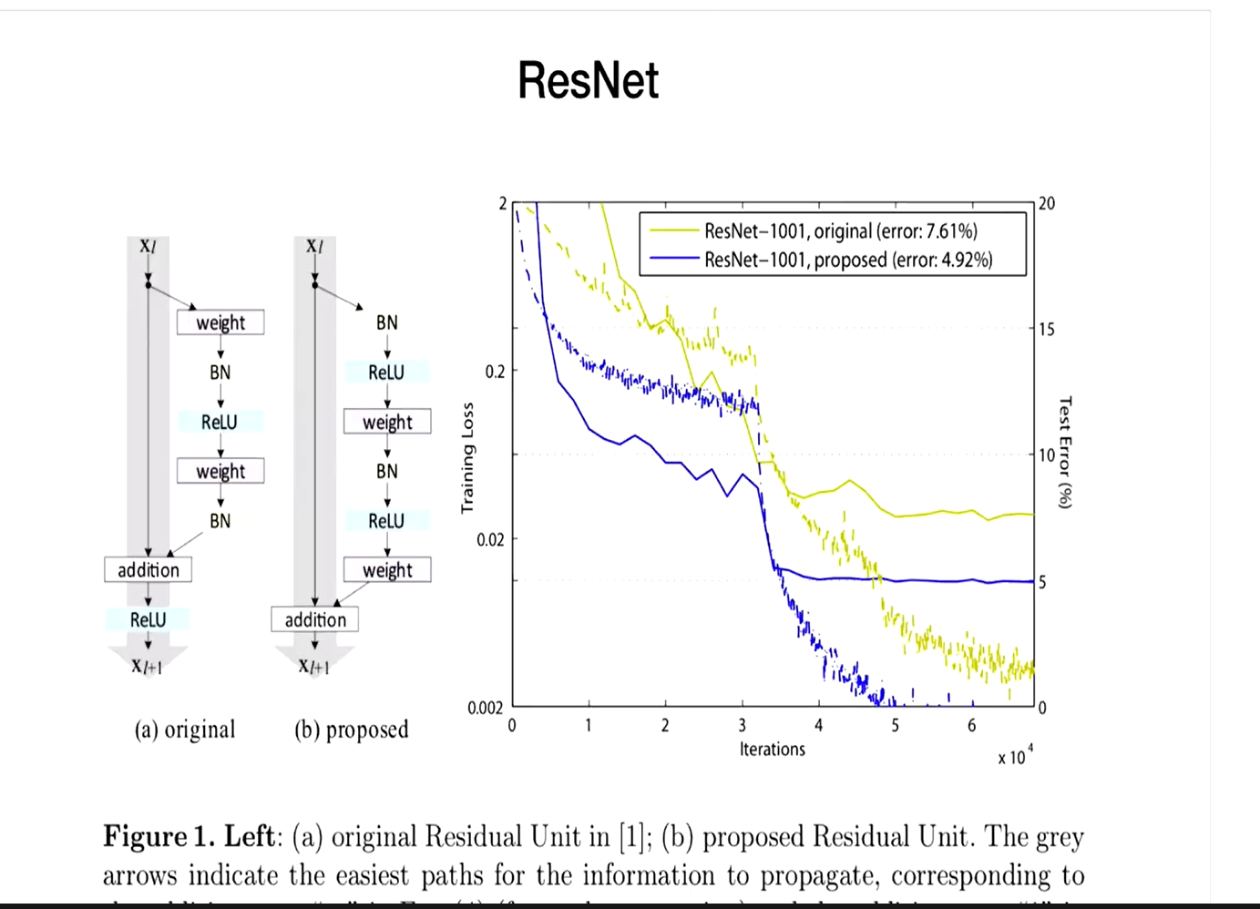



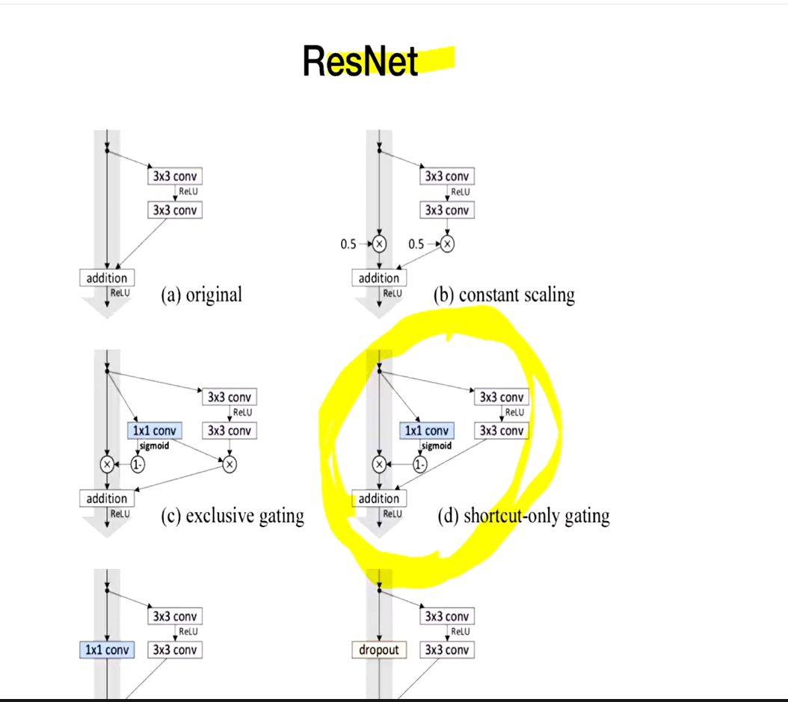

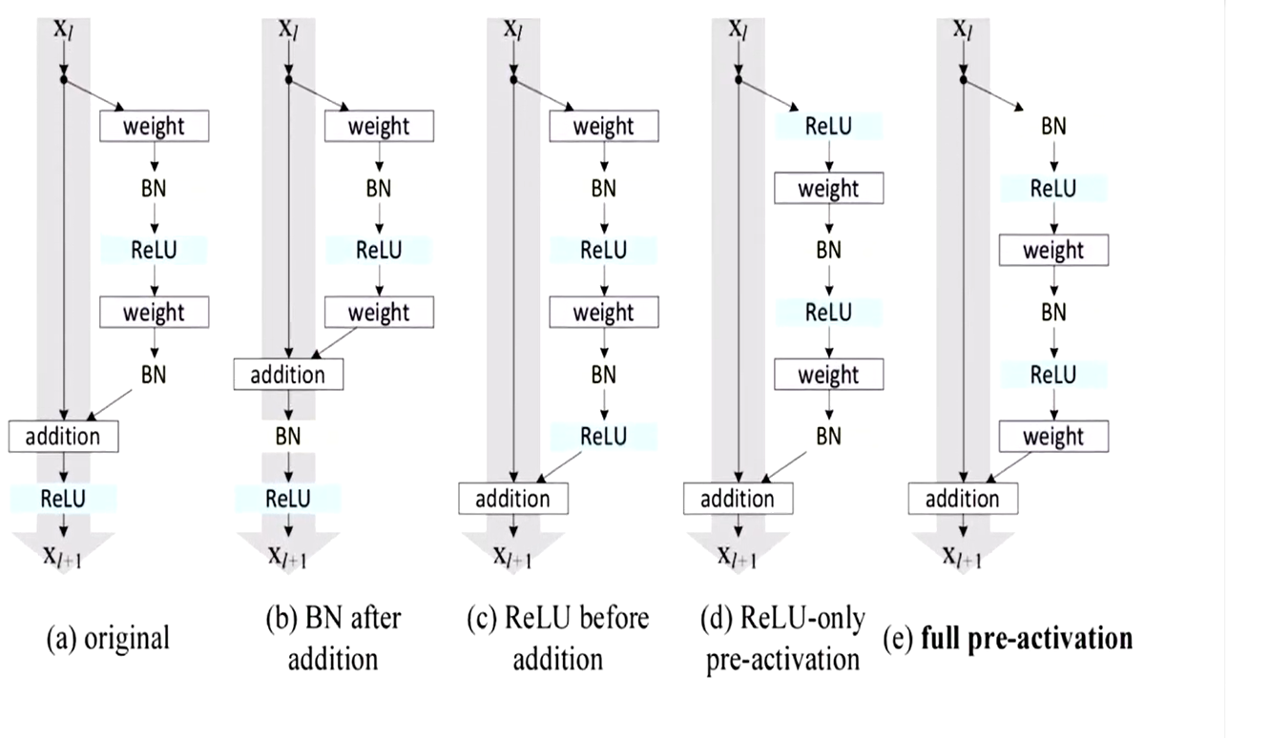

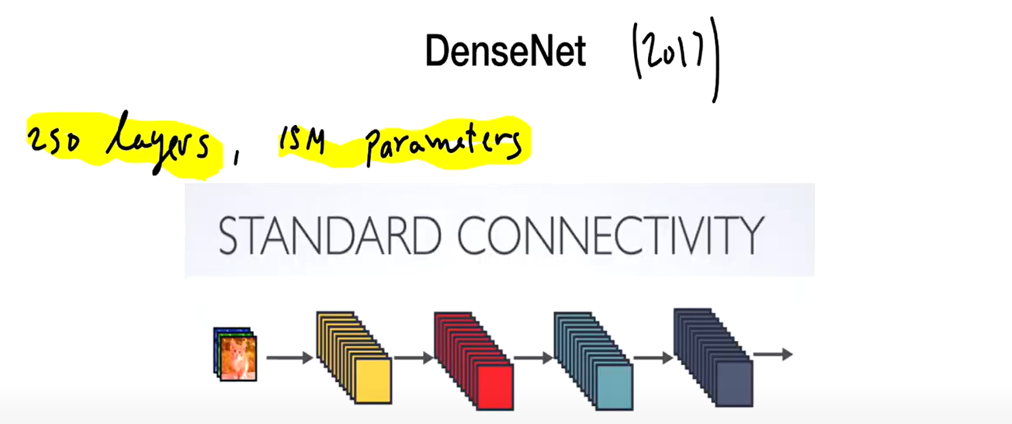

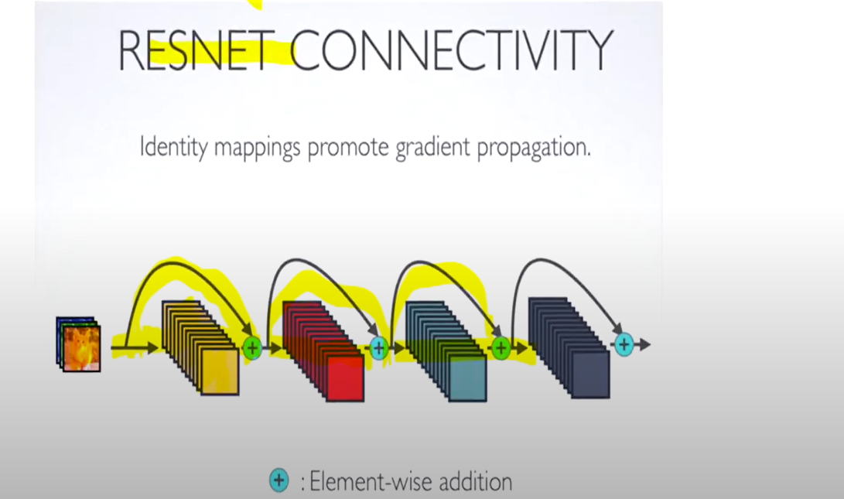

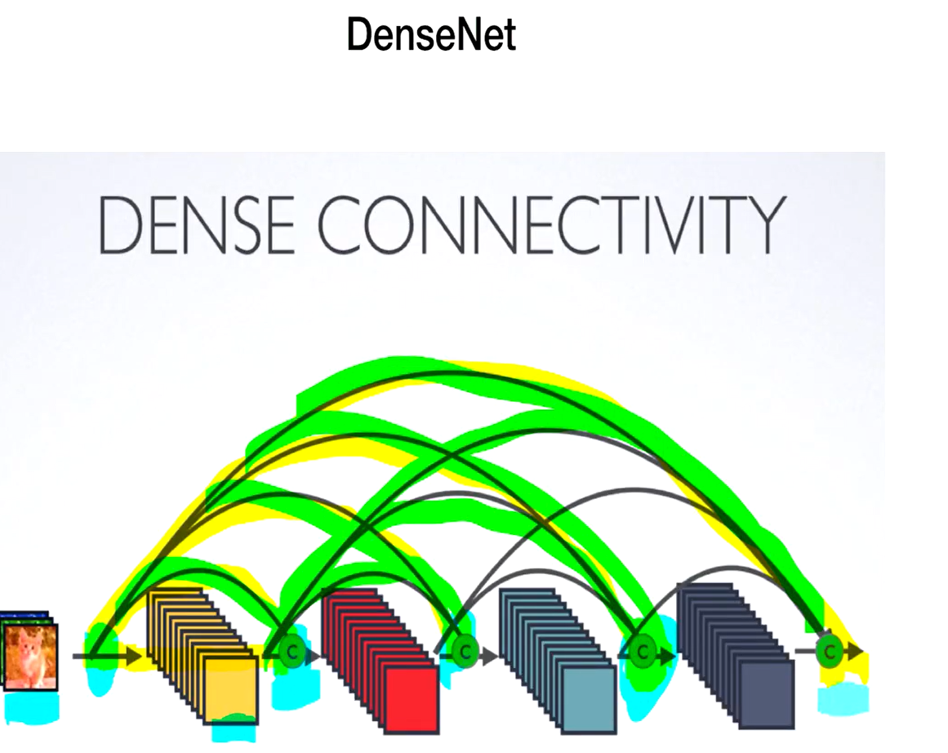

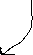

Adv - Feature here becomes the combination of the features from different levels due to skip connection

Disadv --number of channels explode as it adds up from all the front layers

We wshould limit the number if channels

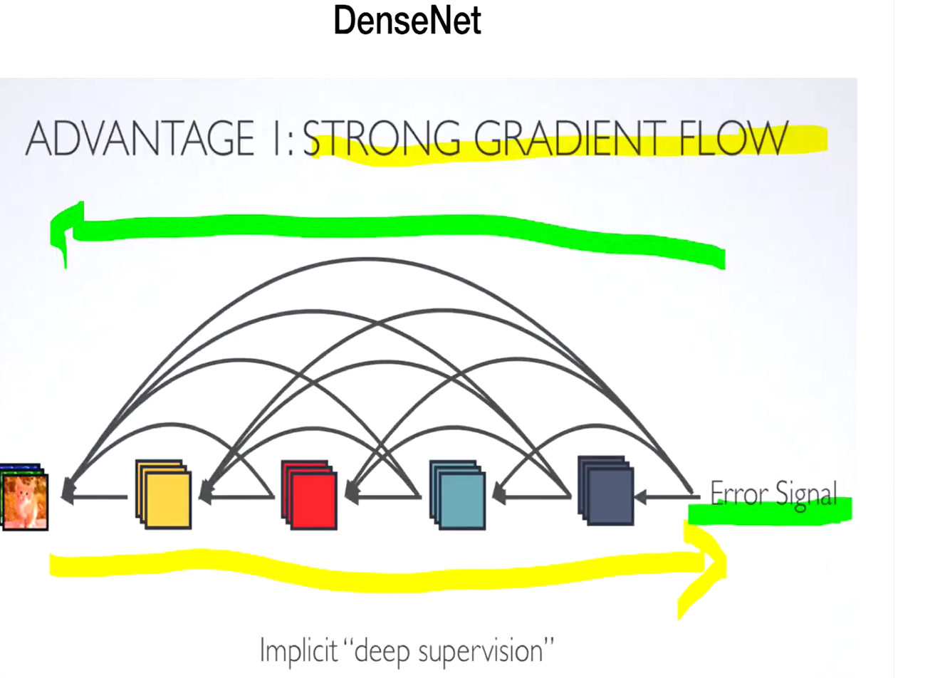

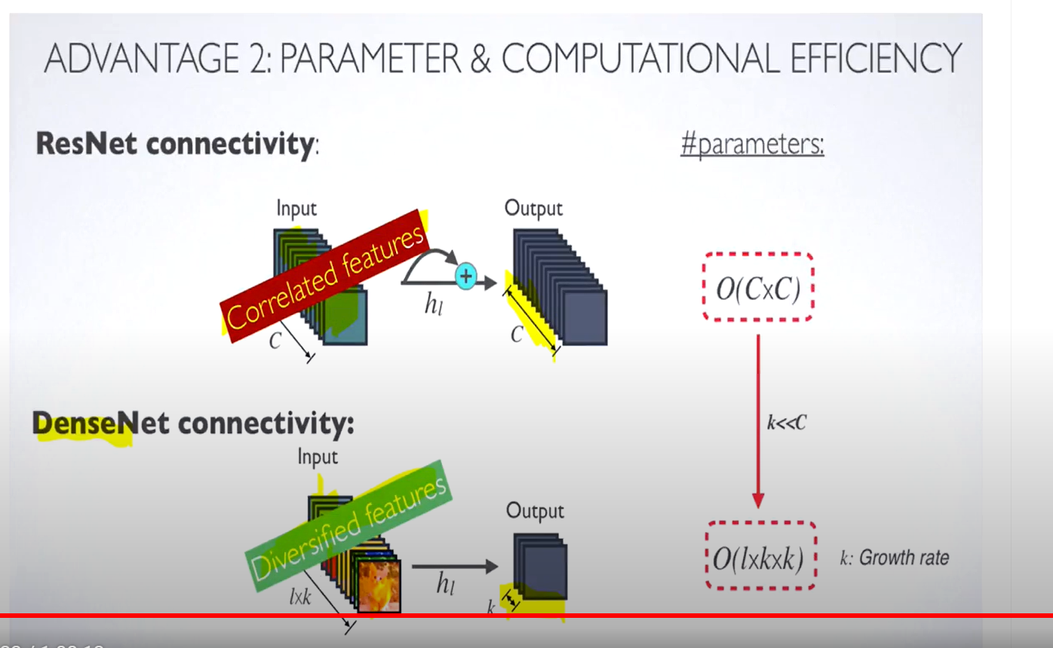

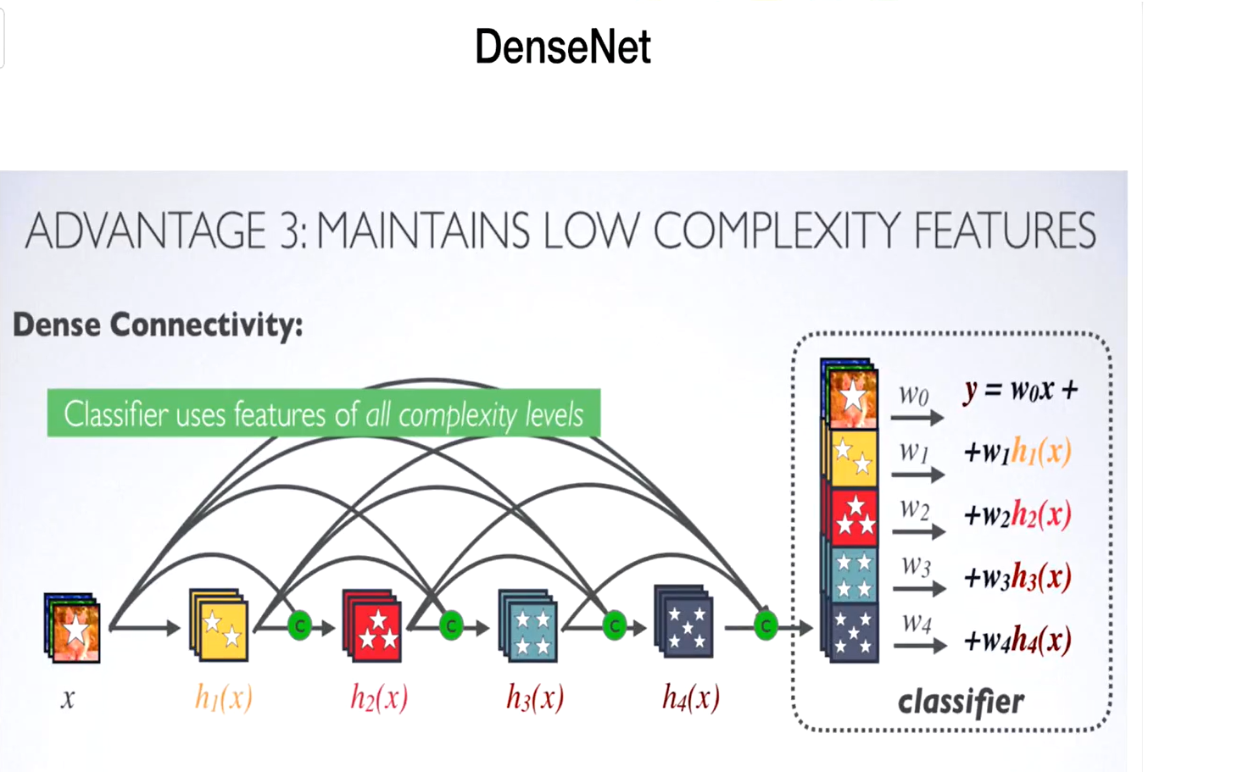



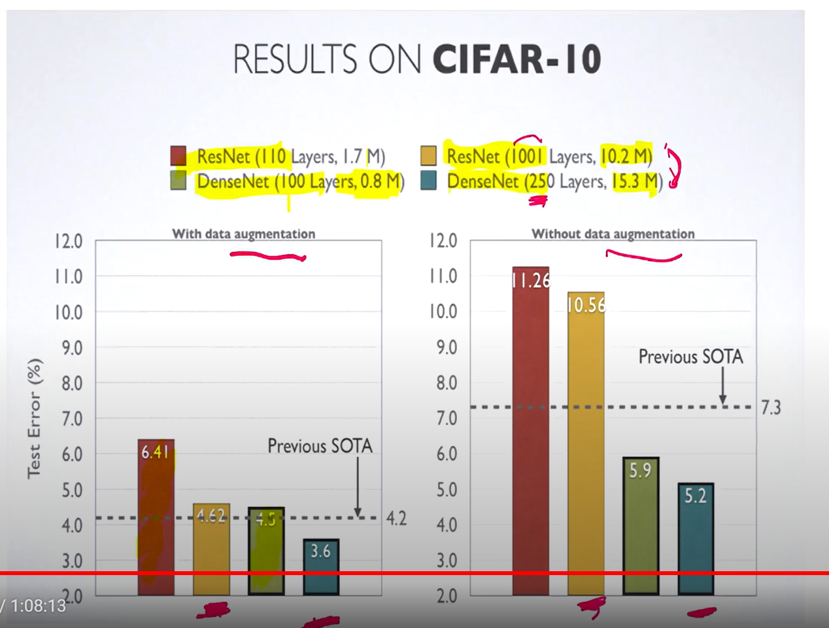

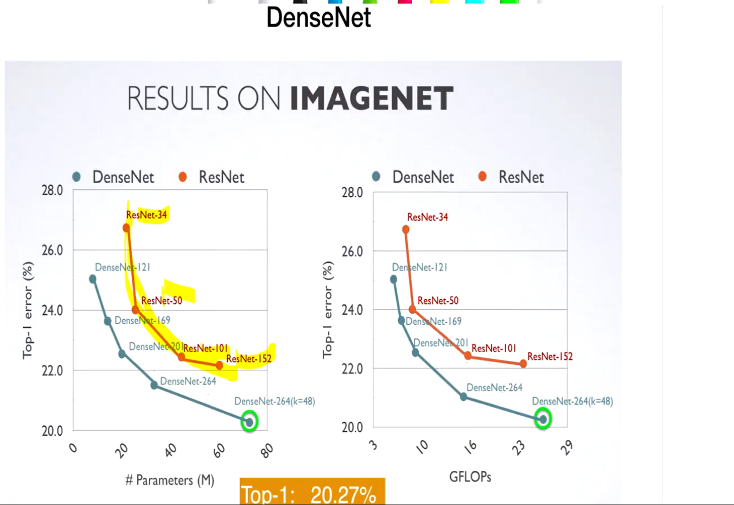

We can use more layers in densenet for the same number of parameters that would be needed for much less number of layer itself for resnet

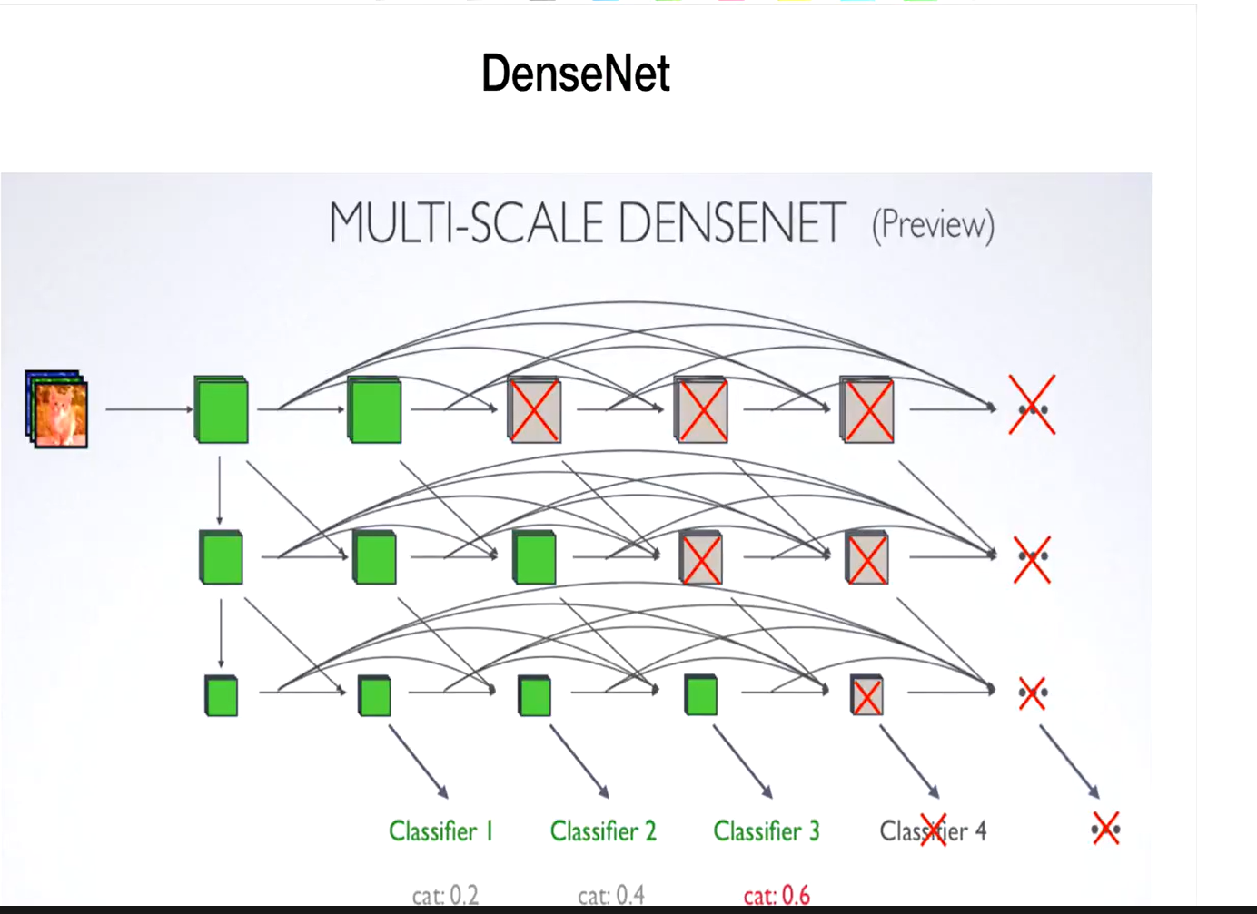

Skip connections to different resolution stages

L14 – Notes 12

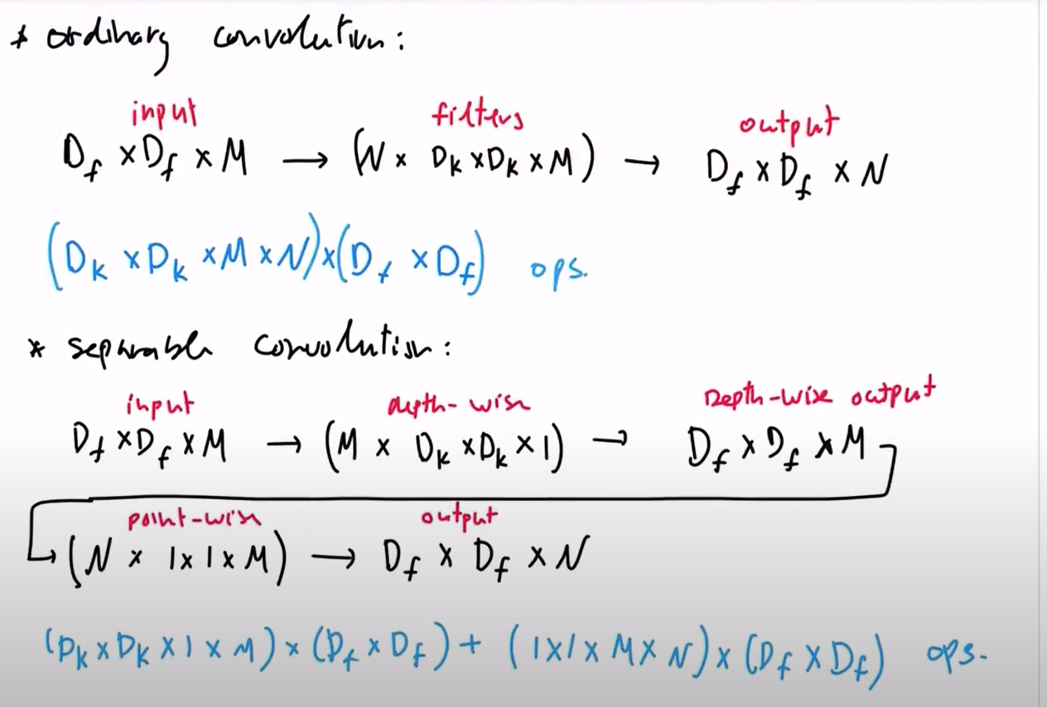

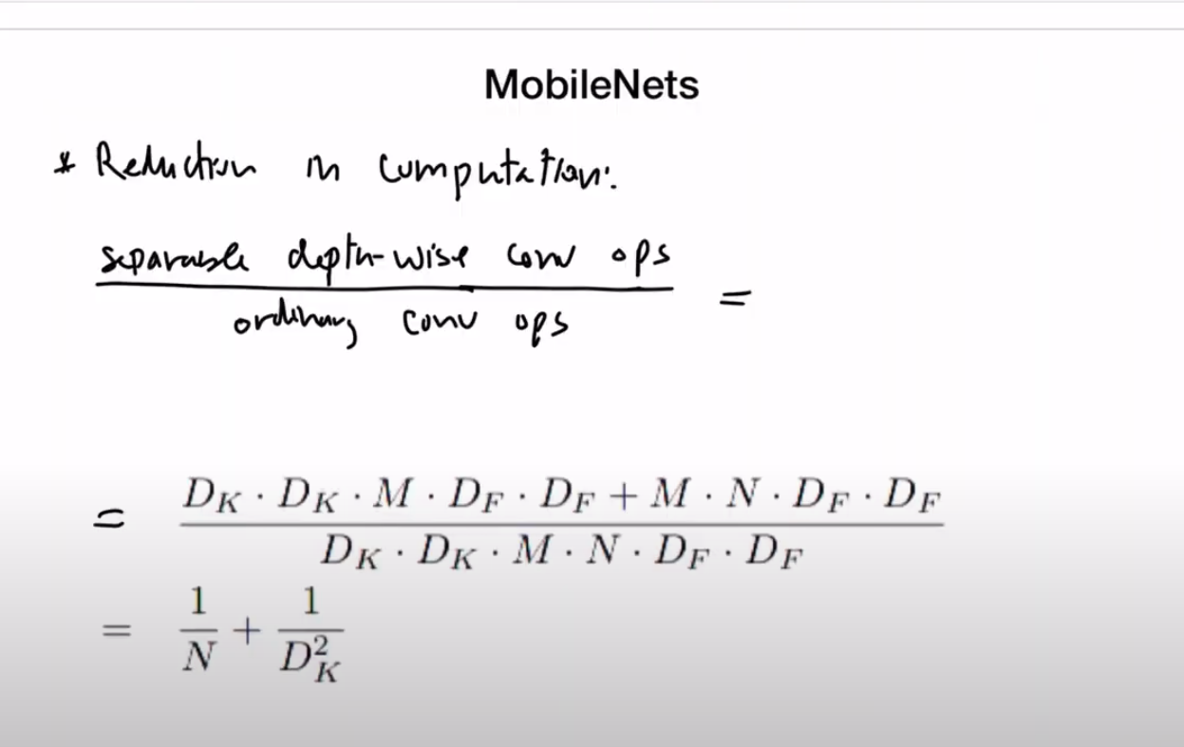

N is no.of filters and Dk is the size of the filter, Df is the input size..M is the no.of input channel

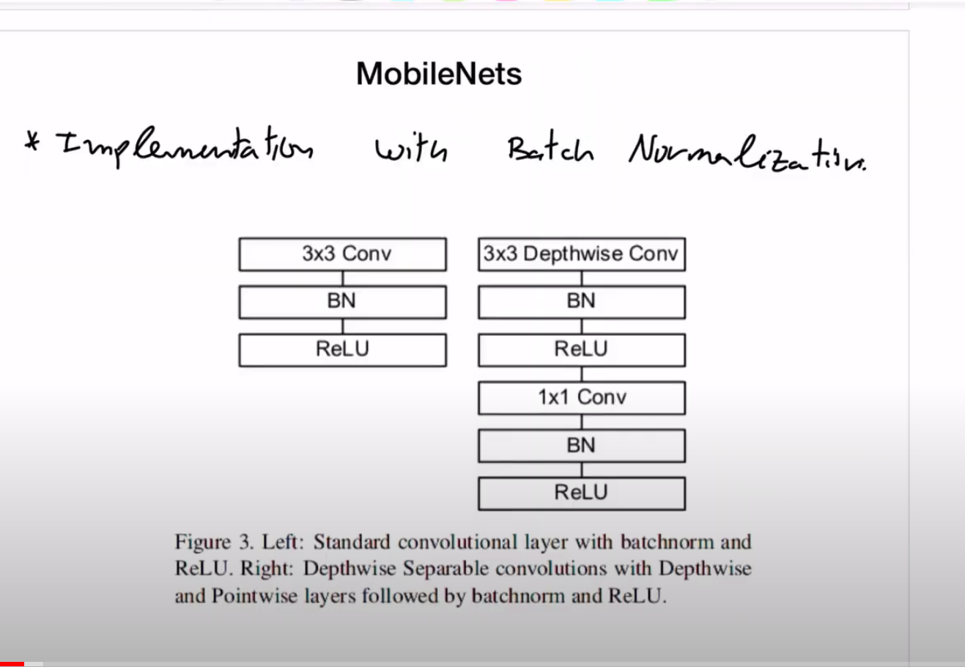

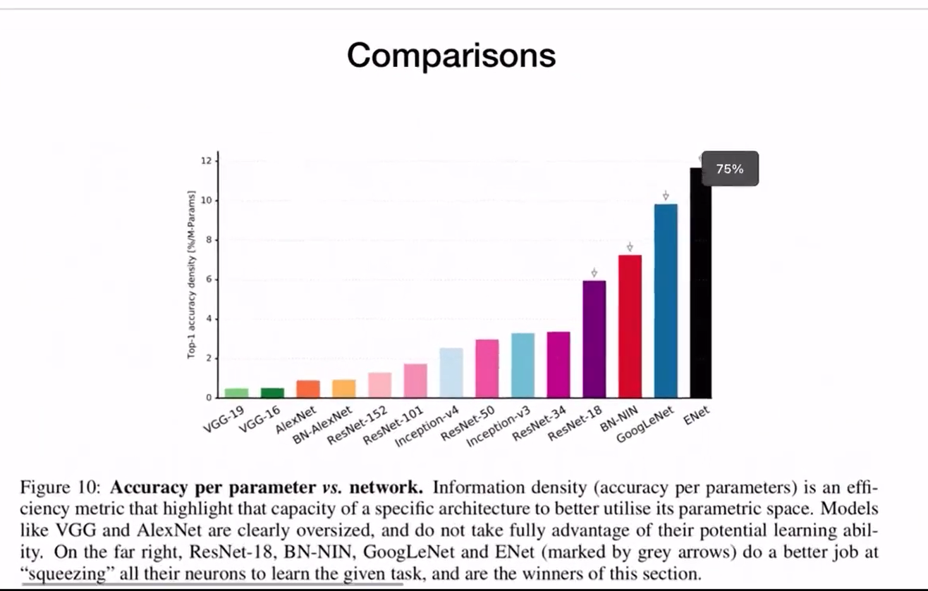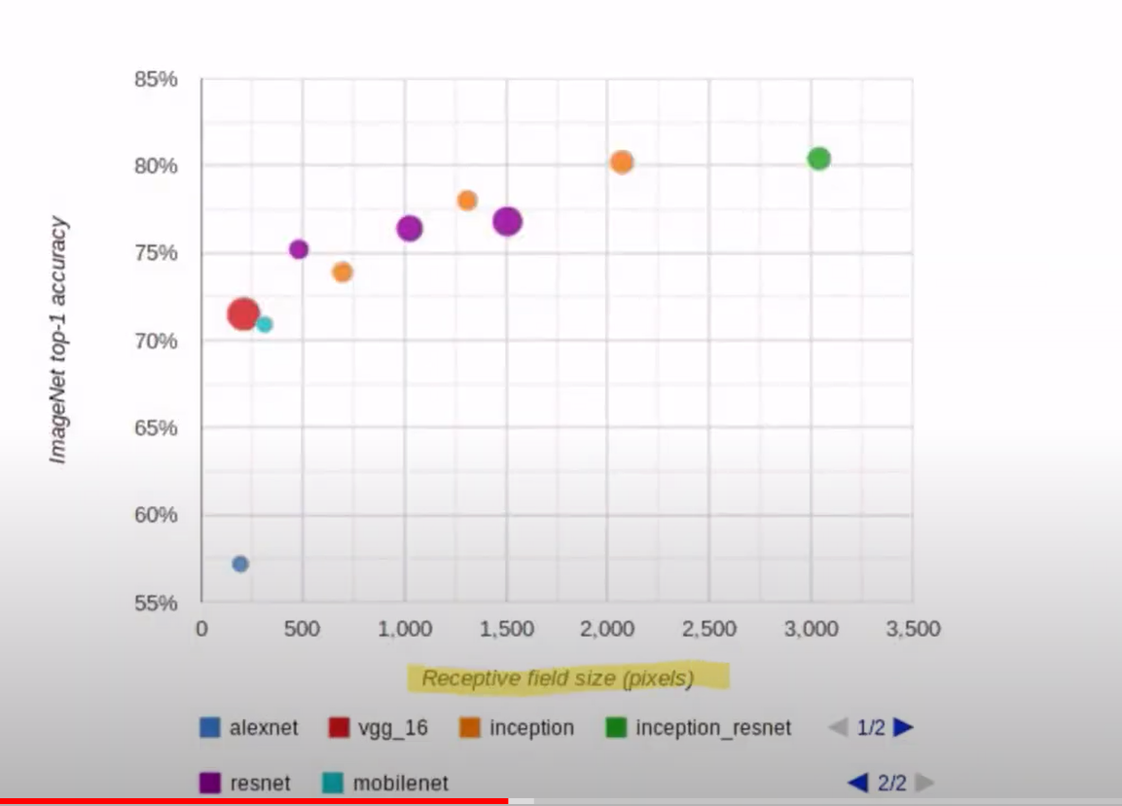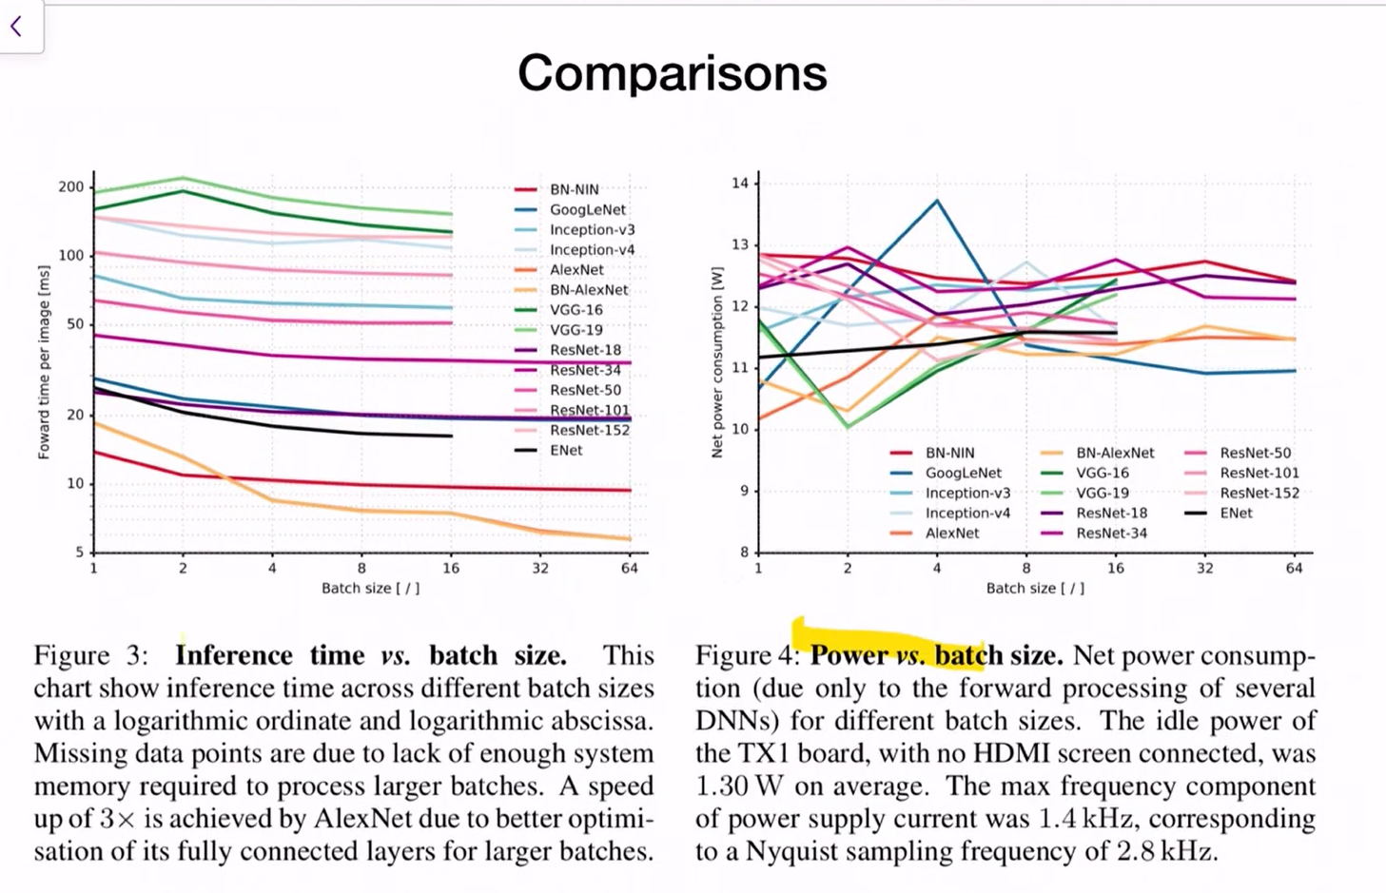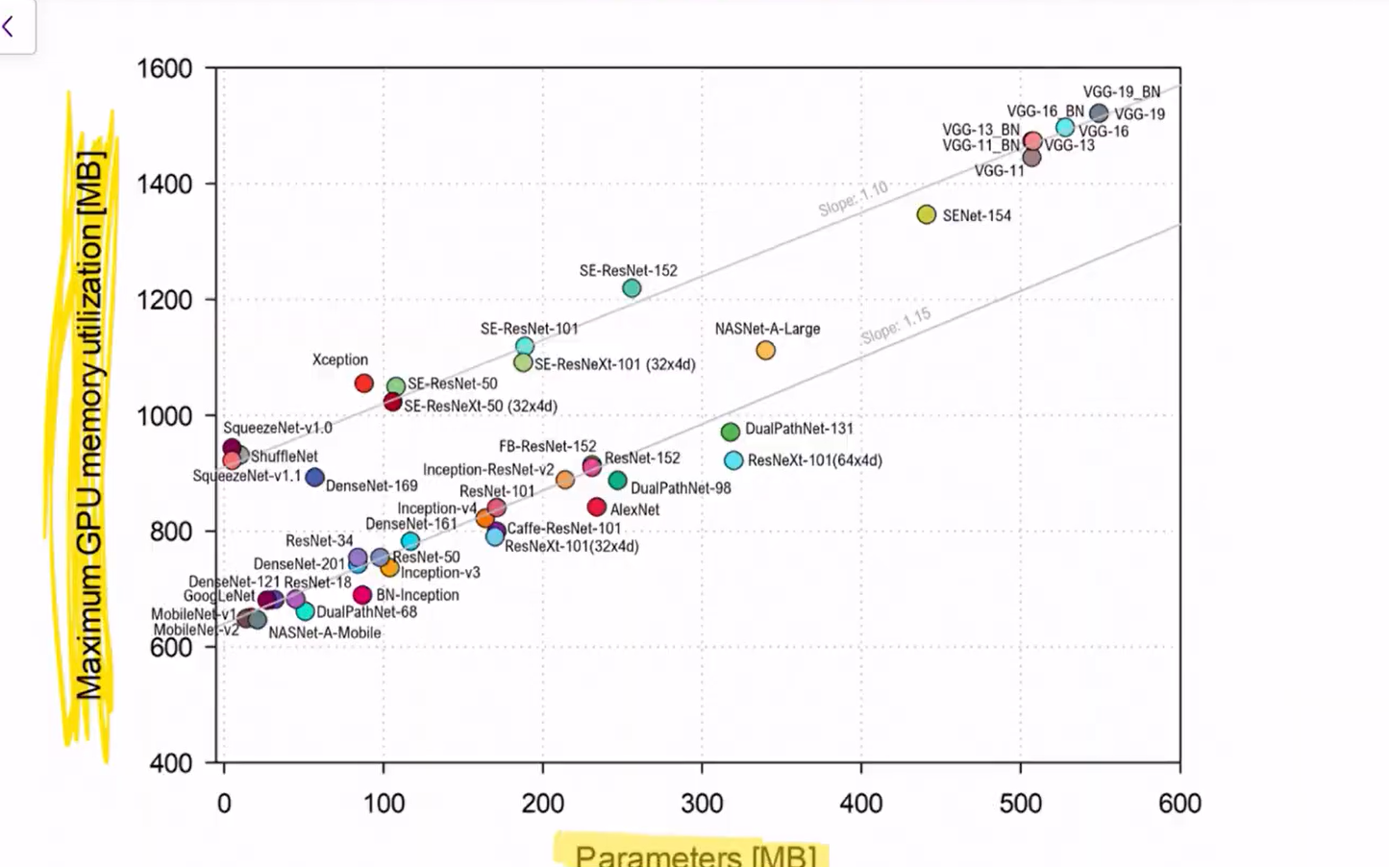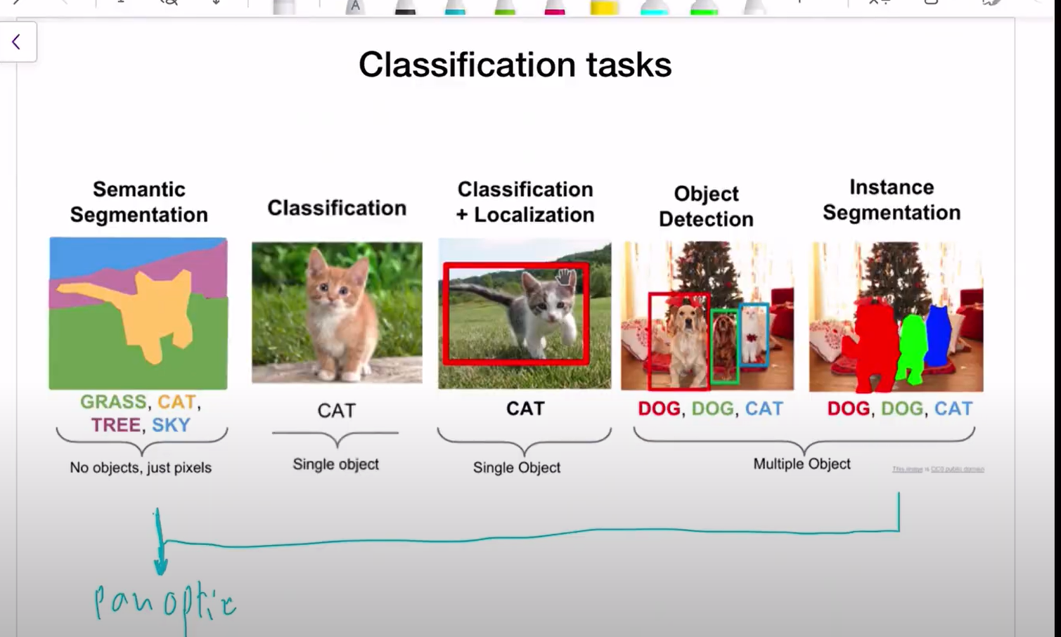

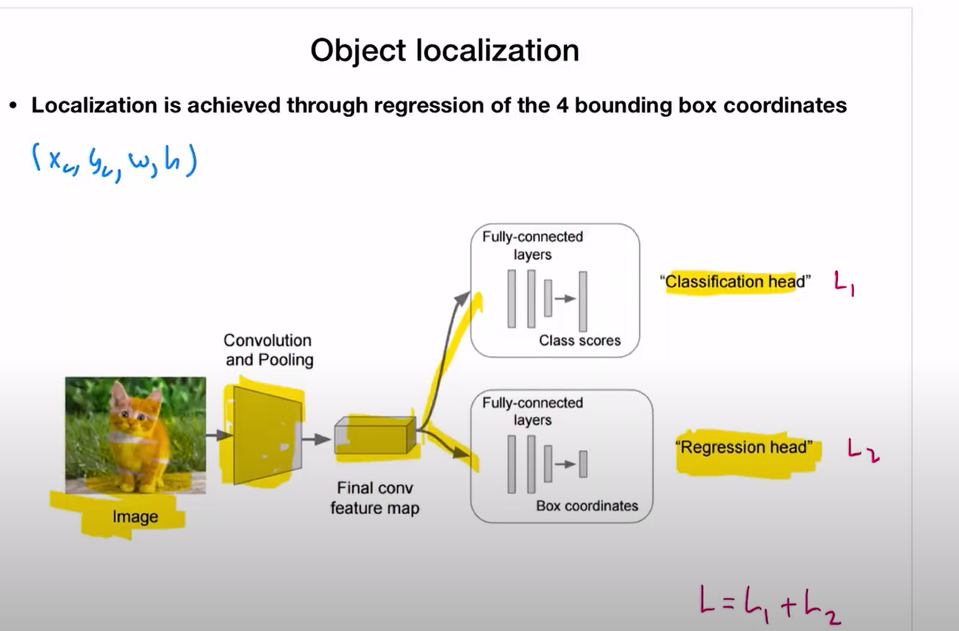

Regression head gives the values of the bounding box…the center, height and width. It is called regression because it is the numbers…

Total loss,L=l1+l2

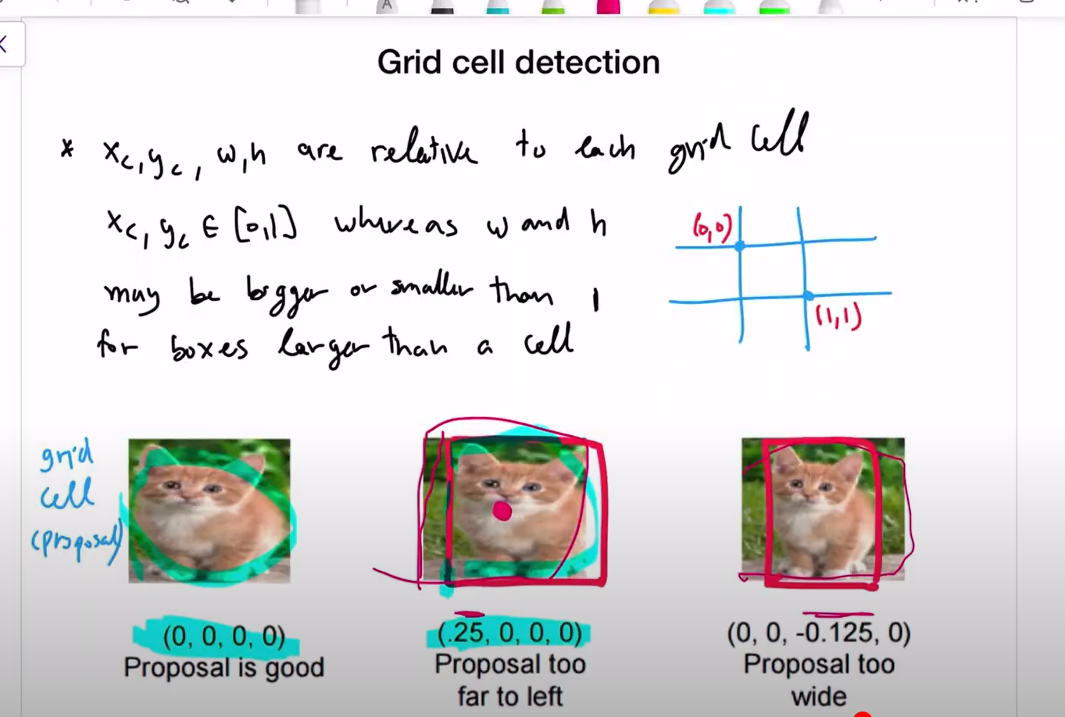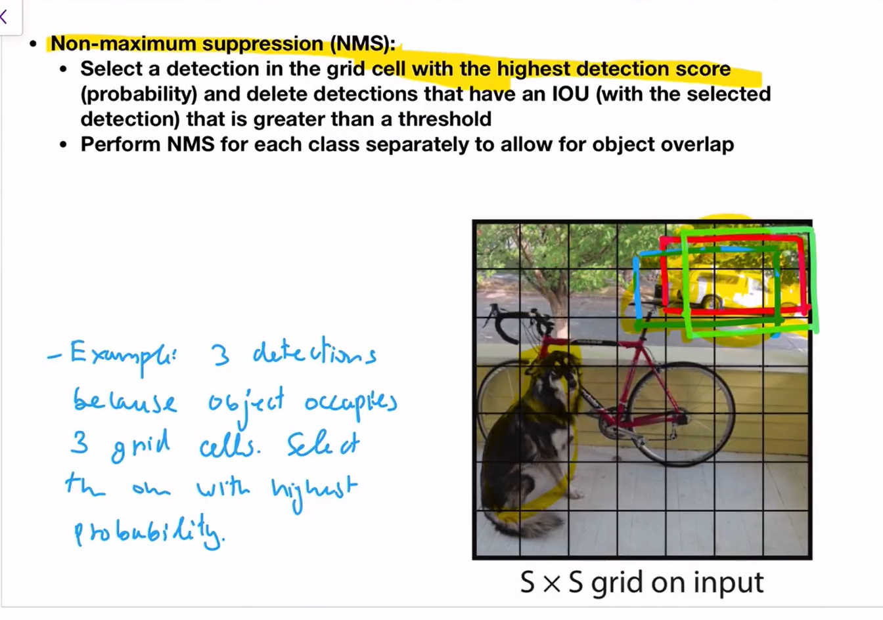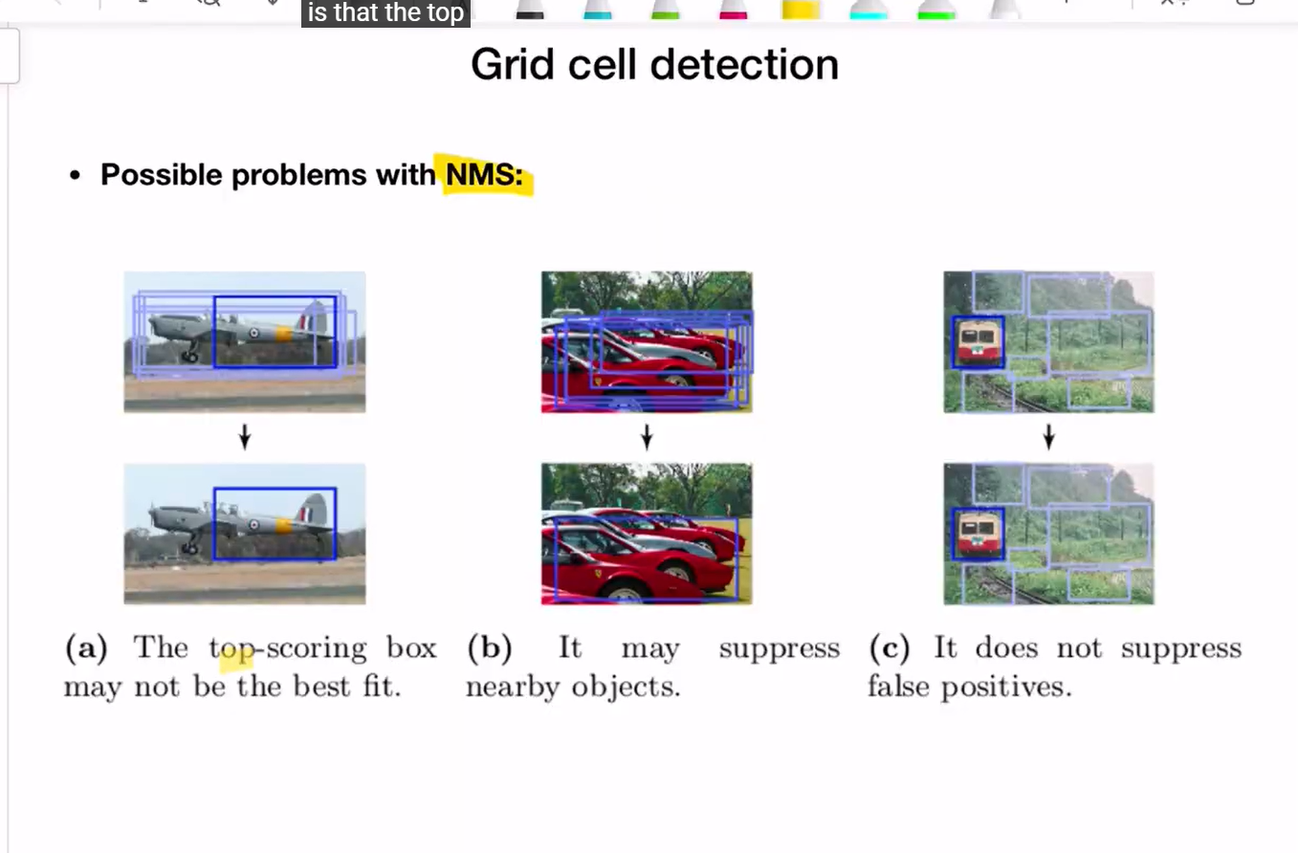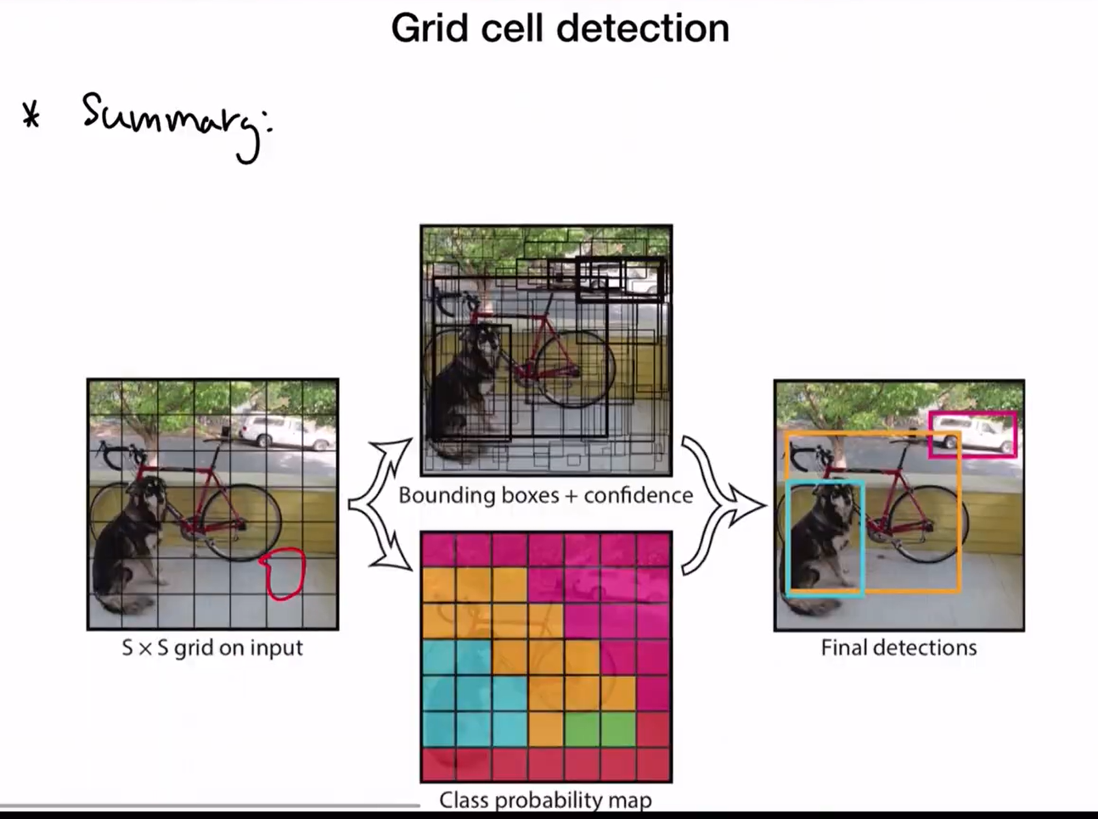

Lecture 18

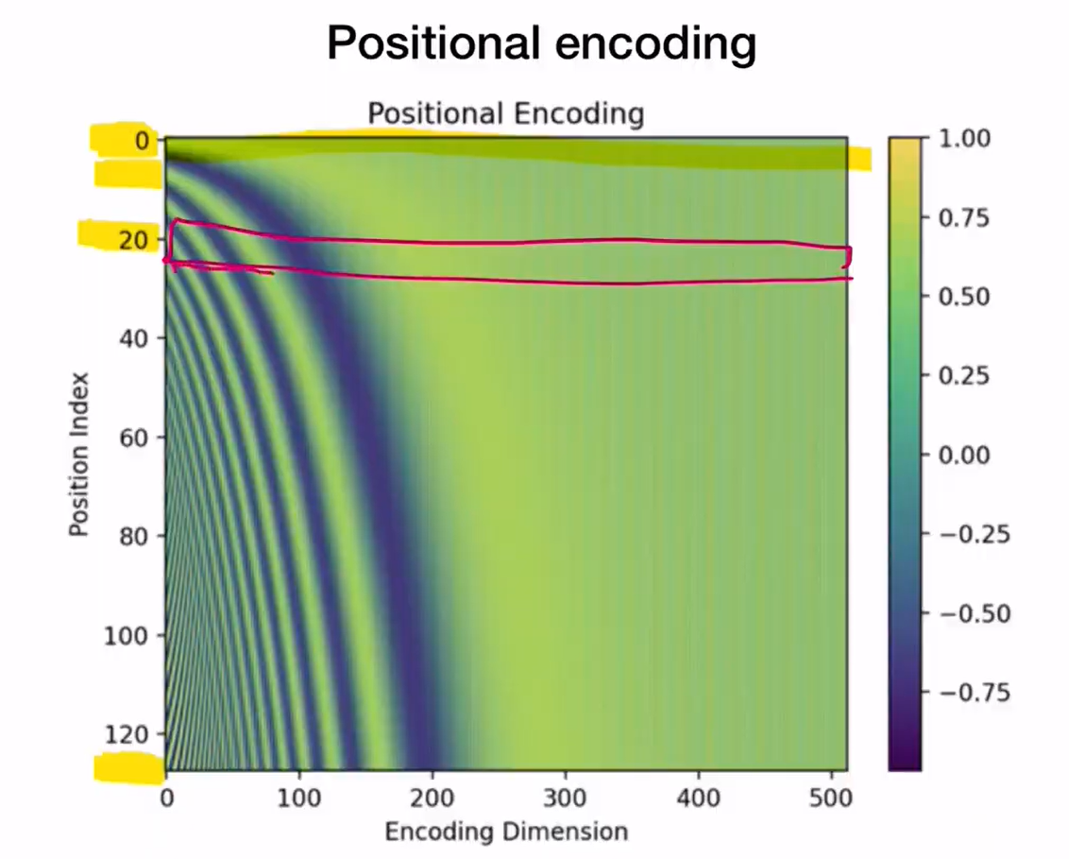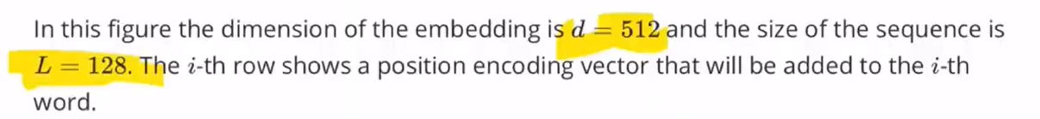

Notes 18

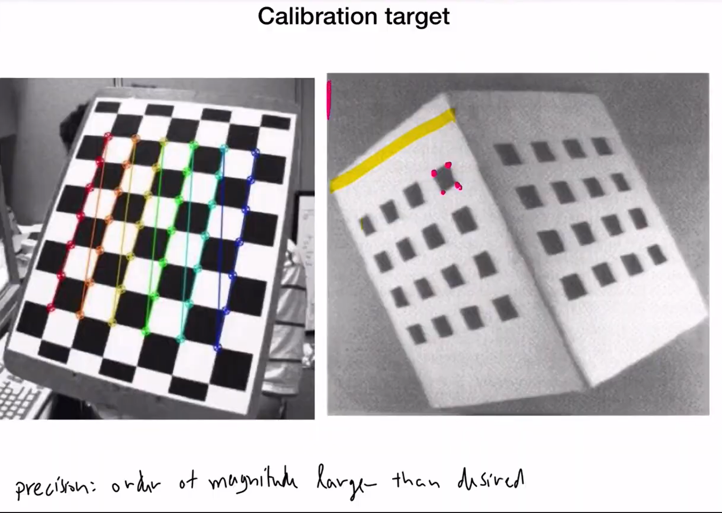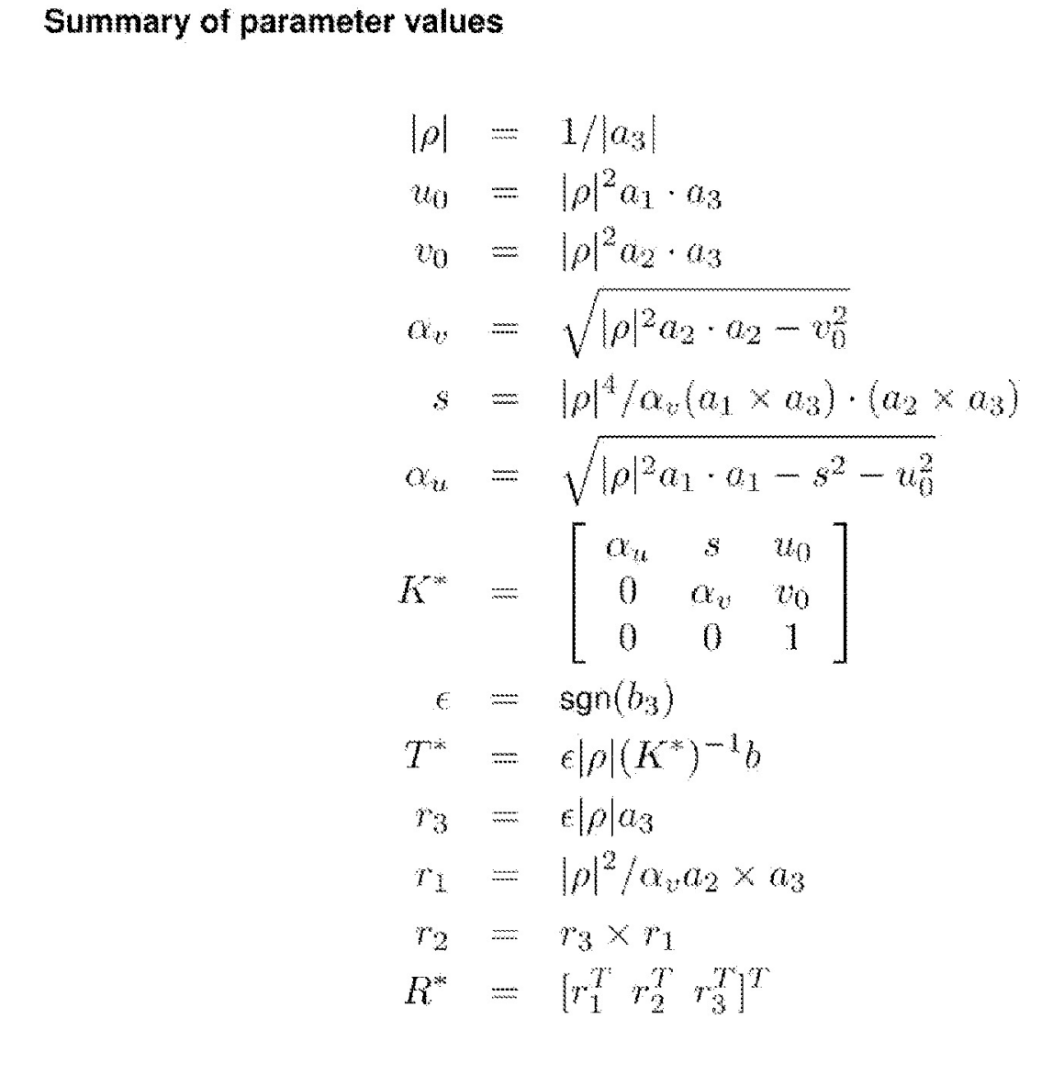

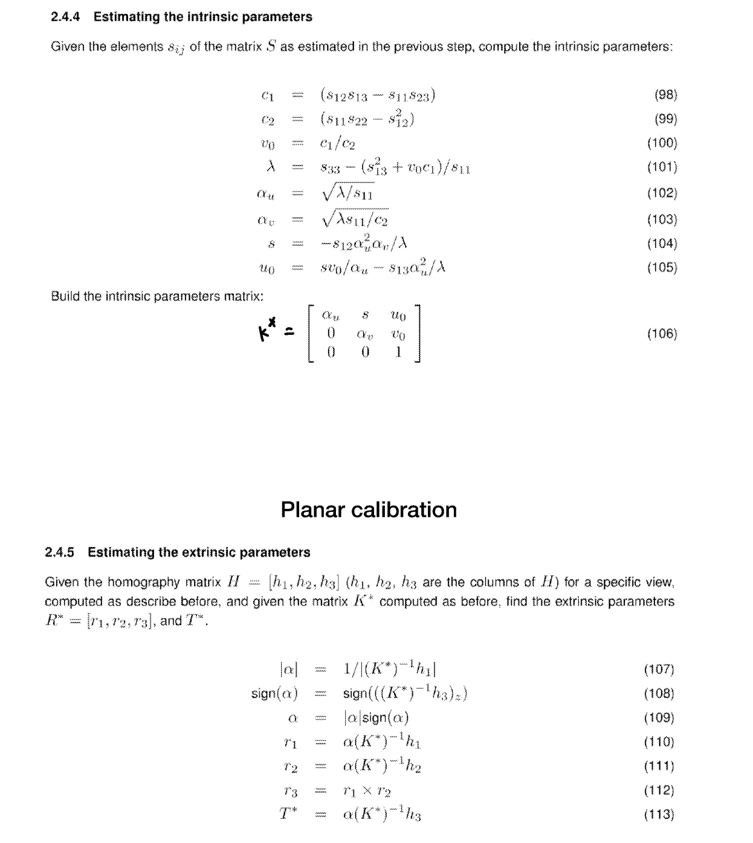

Lec 21

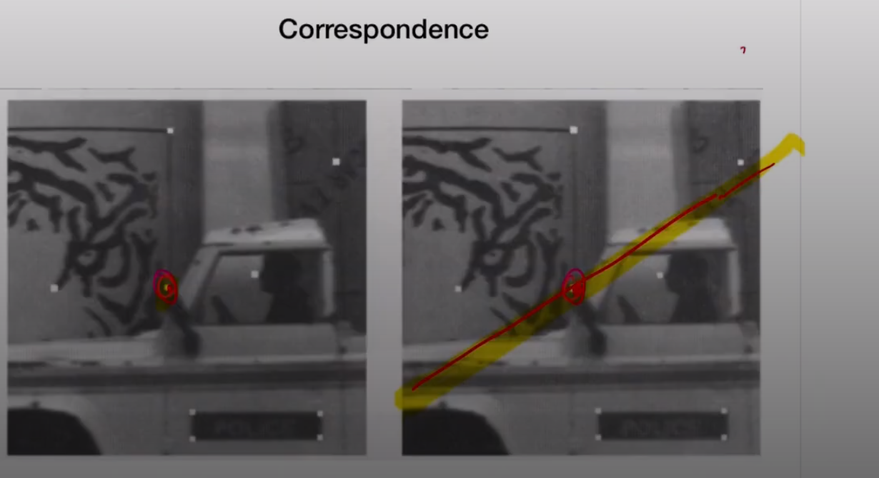

Epipolar lines

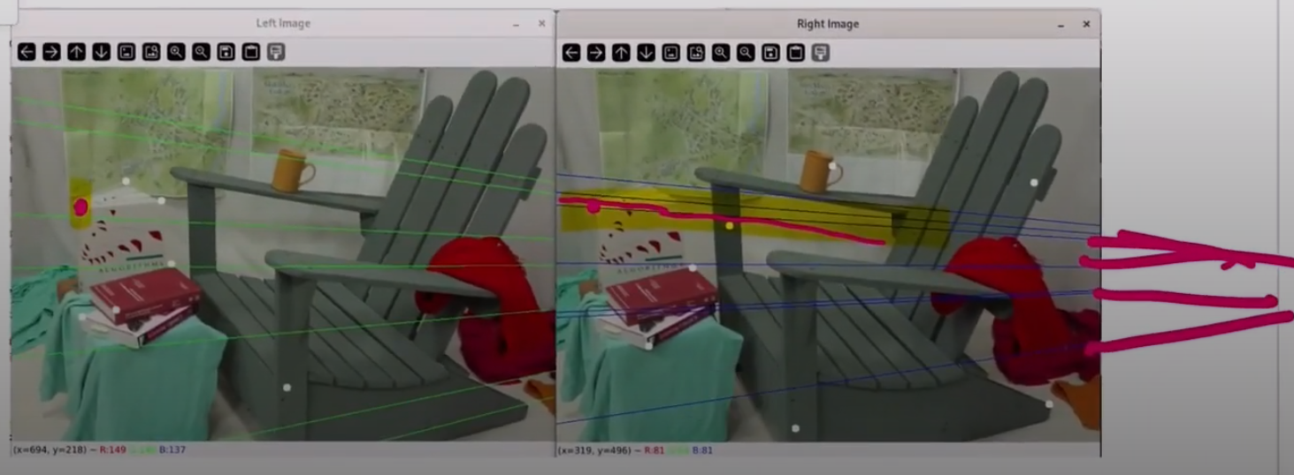

Lec 23

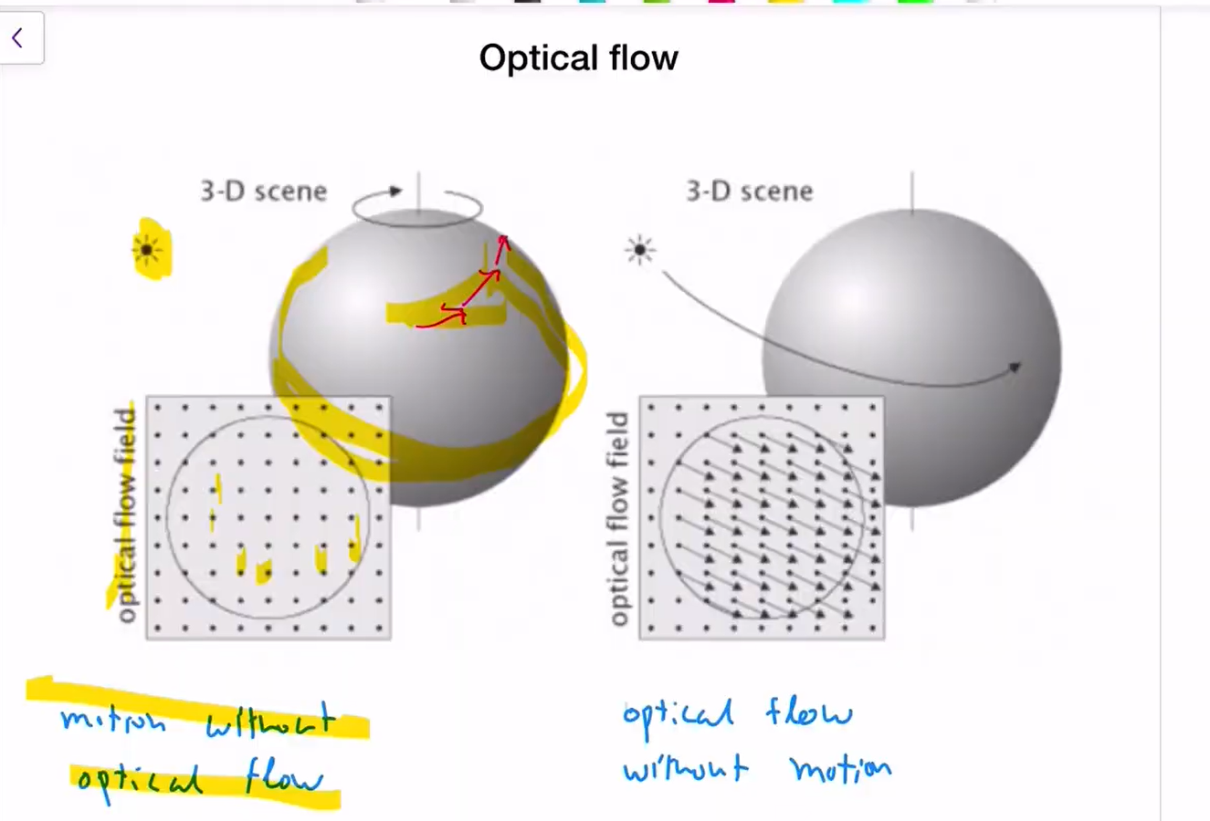

First one-Light source staic, sphere moes…but no optical flow bcz the sphere is smooth and no change in intensity

Second one – light souce moves, sphere contasnt, but moving source makes the sphere change intensity/shades/shadows at some point and shows like sphere moved and there is optical flow